SUNDAY | MONDAY | TUESDAY | WEDNESDAY | THURSDAY | FRIDAY | SATURDAY
www.scschool.ca  follow us on  Food Menu will be posted on facebook every Friday for this month. If you do not have facebook feel free to call the office and Holly can update you. |  |  |  |  | 1  Unveiling of Monument | 2
3 | 4 | 5 | 6 | 7  Traditional hemp & sage picking  gr. K-3 | 8  Terry Fox Run  1:30 pm | 9
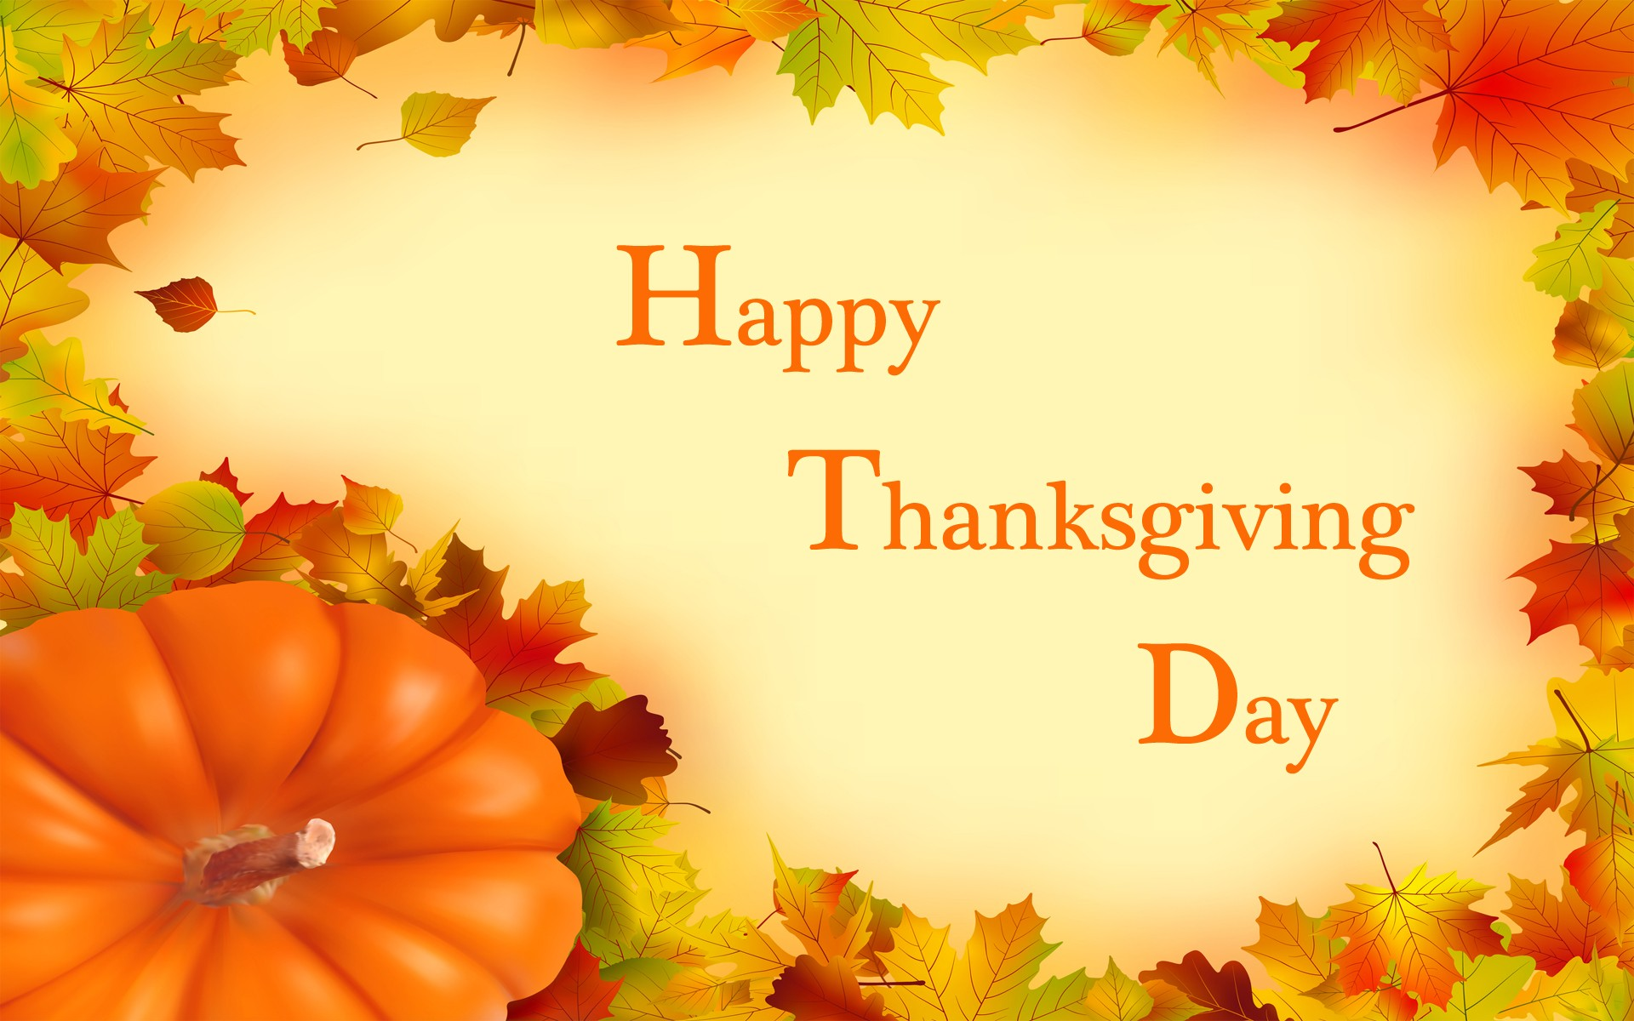  10 | 11  Thanksgiving  No School | 12 | 13  11 a.m. – 2:45 p.m. Fun Factor Gr. 6-7 & k-1 | 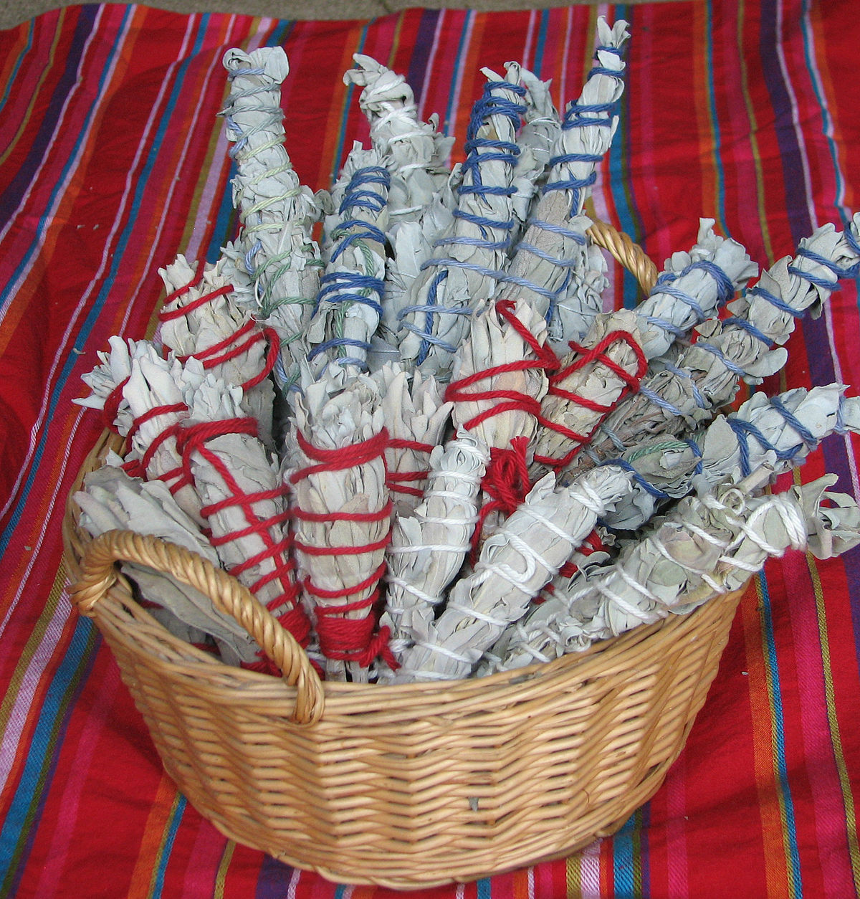  14 | 15  Tacky Tourist Day | 16
17  DIBELS testing will be held from Oct. 18 – Oct 29.  Attendance is critical for your child’s testing, these 2 weeks. | 18 | 19  Co-Hi Program with QHS K-3 | 20 | 21 | 22  Pro-D  No school | 23
24 | 25 | 26 | 27 | 28 | 29  Halloween at school | 30
275 Deadman-Vidette Road Phone: 250-373-2420
Box 178 Principal: 250-373-2421
Savona BC Fax: 250-373-2429
V0K 2J0 E-Mail: sibprincipal@skeetchestn.ca

