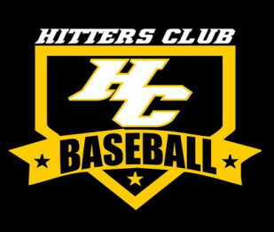

Future Stars Baseball Clinic

This clinic is designed for the younger player, ages 6-8, that is looking to improve their skills in all aspects of the game. Throwing, catching, hitting, fielding, base running, and much more will be covered throughout the
6-week clinic. Led by 12-year pro and former Long Island Duck Randy Leek, your child is sure to improve his skills in each hour long session. The low athlete to coach ratio will ensure your child receives the utmost in high quality instruction and continues to develop a love for the game of baseball.

Dates: Every Friday from Feb 26 – Apr 1

Place: Hitters Club
127 C East Carmans Road
Farmingdale, NY 11735

Time: 5:00-6:00 PM

Cost: $125 for all 6 weeks, or $25 per day

*Enrollment is limited

*Sign up by February 19th to reserve your slot

Cut here and return bottom portion ******************************************************
Make checks payable to: Hitters Club Inc. 6-8 Year Old Clinic
Send to: 127C East Carmans Road
Farmingdale, NY 11735

If you have any questions, call Randy at (631) 845-7650 or email randy@hittersclubinc.com

Name:___________________________ Phone:______________________ Age: _________

Address:_________________________ Town:______________________ Zip:__________

Email address:________________________________________________________________

