Oral health risk assessment & care plan
Clients full name: Known as:

Clients date of birth: Address/Room no:
Please circle relevant answer
 |  | Assessment |  |  | Suggested action for care plan
 | 1. | Does the person have any natural teeth?  Do they need help cleaning their teeth?  Type of support needed... | Yes No  Yes* No  Yes No |  | If yes get prescription for high fluoride toothpaste prescription from dentist  Explore support needed to clean twice per day with soft toothbrush and pea sized amount of toothpaste
 | 2. | Does the person have dentures?  Do they need help cleaning their dentures?  Are the dentures labelled | Yes No  Yes* No  Yes No* |  | If yes encourage cleaning morning and night. Clean mouth with moist gauze, rinse dentures after meals, Leave out at night & soak in water overnight.  If no-label dentures
 | 3. | Cleaning teeth  Preferred toothbrush & toothpaste |  | Consider whether adapted toothbrush or specialist toothpaste is needed
 | 4. | Routine:  Preferred time  Location  Have previous mouth care routines been discussed with residents/ relatives?
 | 5. | Is the person experiencing any problems? e.g.  pain, difficulty eating, loose dentures#, ulcers, bad breath* |  | Circle any issues  Dry mouth - saliva substitutes, fluorides,  support with cleaning
 | 6. | Looking at the person’s mouth can you see any problems?  dry mouth#, redness at corner of lips, dirty teeth, red gums or mouth, ulcers*, bleeding gums, poorly fitting dentures, broken teeth#.  Photo where possible
 | 7. | Cognitive/ behavioural issues | Yes* No
 | 8. | Relevant medical history  e.g. smoking, medication, alcohol, speech & language, dietetics* | Yes* No
 | 9. | Name and address of dentist  Next appointment due….  Do they need to pay for treatment |  |  | If unsure about payment help them to complete a HC1 form
Care Plan: # Red Underlined issues - contact dentist * Blue Italics - additional care needed

Signed: Job title: Date:
NB: Assessment to be reviewed on a 3 monthly basis or sooner if any changes are noted.

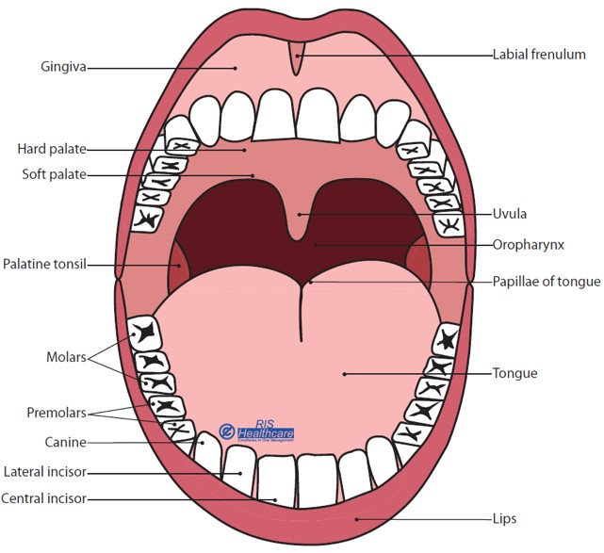

Graphic reproduced with kind permission from RIS Healthcare

