REGULAR MEETING

OCTOBER 5, 2015

A Special Meeting of the Town Board of the Town of Hampton, County of Washington and the State of New York was held at the Town Hall, 2629 State Route 22A, Hampton, New York on the 5th day of October, 2015.

PRESENT: David K. O’Brien------------Supervisor

Tamme Taran---------------Councilwoman

David Jensen-----------------Councilman

Donald Sady-----------------Councilman

Andrea Sweeney------------Councilwoman

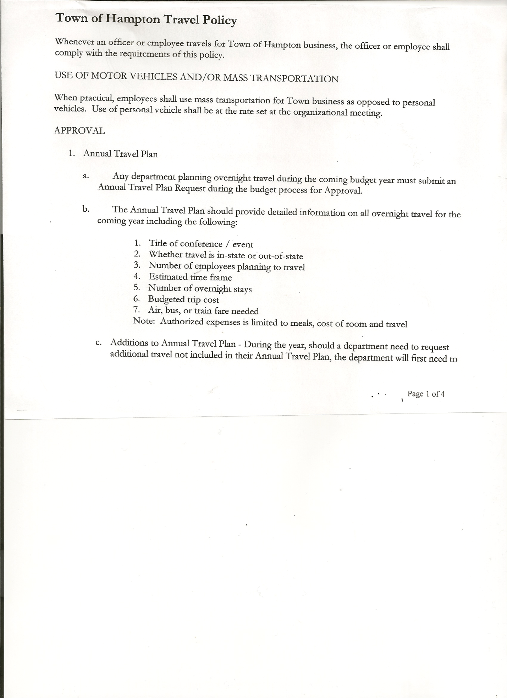 Rebecca Jones---------------Town Clerk

Camilla Shaw----------------Tax Collector/Deputy Town Clerk

Herbert Sady, Jr. ------------Highway Superintendent

Also present: Joe Mead, Justin Perry, Artie Pratt, Matthew Pratt, Leonard Reed, Matthew Sears, Roger Weeden, Kim Perry, Bookkeeper came at 7:25pm and Patricia Panebianco came at 7:55pm

The meeting was called to order by Supervisor O’Brien at 7:00pm followed by the Pledge of Allegiance. Locations of Fire Exits were given.

Supervisor O’Brien handed out a Resolution regarding Hampton Cemeteries to be considered and discussed at next regular board meeting.

**RESOLUTION NO. 65-2015**

**PUBLIC HEARING ON HAMPTON FIRE PROTECTION DISTRICT NUMBER 1**

On a motion of Councilman Sady, seconded by Councilwoman Taran, the following resolution was ADOPTED Ayes 5 O’Brien, Taran, Jensen, Sady, Sweeney

Nays 0

RESOLVED, to set the Public Hearing to discuss the proposed contract between the Town on behalf of the Town of Hampton Fire Protection District Number 1 and the Hampton Volunteer Fire Co. for October 21st, 2015 at 7:20pm.

**RESOLUTION NO. 66-2015**

**PUBLIC HEARING ON HAMPTON FIRE PROTECTION DISTRICT NUMBER 2**

On a motion of Councilman Sady, seconded by Councilwoman Taran, the following resolution was ADOPTED Ayes 5 O’Brien, Taran, Jensen, Sady, Sweeney

Nays 0

RESOLVED, to set the Public Hearing to discuss the proposed contract between the Town on behalf of the Town of Hampton Fire Protection District Number 2 and the Town of Fair Haven, VT for October 21st, 2015 at 7:25pm.

TOWN BOARD MEETING

OCTOBER 5, 2015 PAGE 2

Hampton Fire Department… has had 39 calls so far in 2015,

* Whitehall Fire Dept. has donated a car to them,
* received an ENCON grant of approximately $3000.00,
* looking to purchase some Breathing apparatus from West Pawlet Fire Dept.
* working well with the Poultney Fire Dept.

Discussed plans for 2016…working on driveway repaving and extending, will be working on fundraising ideas, hoping to have another basket raffle and Chicken BBQ

Continued to review and modify **Tentative Budget.**

Training for Supervisor, Town Board, Town Clerk and Bookkeeper were discussed. Discussed and suggested to rotate training, with the bookkeeper going in 2016. Suggestion was also made to include $1000.00 to General Expenses for training.

**RESOLUTION NO. 67-2015**

**ADOPTION OF TENTATIVE BUDGET**

On a motion of Councilman Sady, seconded by Councilwoman Taran, the following resolution was ADOPTED:

By Roll Call vote: Supervisor O’Brien AYE

Councilwoman Taran AYE

Councilman Jensen AYE

Councilman Sady AYE

Councilwoman Sweeney AYE

RESOLVED, that the 2016 Tentative Budget be adopted and becomes the 2016 Preliminary Budget for the Town of Hampton.

On a motion of Councilwoman Taran, seconded by Councilman Jensen the meeting adjourned at 8:18pm. All in favor Aye.

Respectfully submitted,

Rebecca S. Jones, RMC

Town Clerk