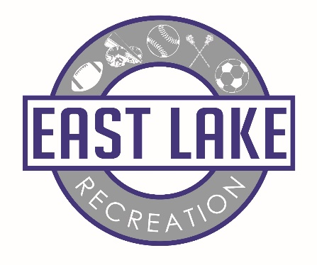

What are my tax dollars paying for and who is the guy in the trailer?

My name is Mark Sanders and I am the Director of East Lake Recreation. I am the guy in the trailer. I have been asked many times from coaches and parents, “what exactly are my tax dollars paying for?” Before I answer that question I would like to give you a little background.
The East Lake Sports Complex was built (for the most part) and run by private funding and volunteers. East Lake Youth Sports Association (ELYSA) ran the facility for over 30 years. This group was headed by a board of directors that made decisions about policy, financials, operation, etc. This group worked diligently to provide a quality athletic experience for the youth of East Lake. As time passed and the facility started to show its age, it became more and more difficult to pay for repairs and maintenance. Higher participation fees were needed to help offset the cost. ELYSA found the need for financial help to maintain the complex, lower the participation fees, and add fields for the increasing needs of the East Lake Community. ELYSA approached the County Commissioners to approve a special tax district that would provide funds to help ELYSA operate and expand. Busloads of parents and little leaguers in uniform attended the Board of County Commissioners meeting in support of the vote. The vote passed and East Lake Recreation was created and began receiving tax dollars in October of 2014. It then became the fourth entity of Palm Harbor Community Services Agency (PHCSA). This agency is an arm of the County that manages the Palm Harbor Library, Palm Harbor Park and Recreation, East Lake Library, and now East Lake Recreation. I was hired as the District’s first Director and started February 9th, 2015.
From the beginning, ELYSA and the three primary user groups, East Lake Little League, East Lake Youth Football and Cheer, and the West Florida Flames, have strived to keep overhead as low as possible. They felt that keeping the volunteer aspect and management of their programs was key to an effective and money saving model. As such, East Lake Recreation has only one employee, me. Instead of hiring staff and buying equipment, we outsource services to maintain the complex. As the Director I manage all the services and vendors for the main complex, fields, parking lots, and common areas. Each user group is responsible for its own facilities and operating expenses but no longer pays a user fee to ELYSA. The District in turn is able to use its revenue to focus on larger, more costly infrastructure related projects. This model allows each sports group to keep participation fees at a rate that is comparable to surrounding communities and manage their programs as they see fit.
In the initial budget presented to the county by ELYSA, they identified the need for operating expenses and capital projects. Capital projects include field lighting replacement at the main complex, irrigation replacement at the main complex, an additional parking lot at the main complex, and adding another field at the Meadows. All of these projects are high ticket items that will require time to fund. The Ad Valorem dollars we receive come in 12 monthly installments and not one lump sum. Approximately 60% of our budget is for operating expenses (mainly field maintenance) and we are trying to bank the remaining dollars to tackle these projects as soon as possible. In the meantime it was important to meet some immediate needs of the complex. We have made repairs to the electrical and lighting systems, replaced lamps and ballasts on all of the fields, replaced many circuit breakers, installed new GFI’s throughout the complex, repaired irrigation, added a video security system, installed a new motorized roll gate at the Meadows, fixed pot holes and seal coated parking lot, added safety bollards in parking lot, added shell to football parking area, fixed broken fencing, and added a concrete walkway/swale between baseball fields 2 and 3. A big part of our budget goes to maintaining our fields. Mowing, fertilization, weed and insect control, airification, top dressing, verti-cutting, etc. are important to keep our field’s safe and looking good. We have implemented a turf care plan that we believe will keep our fields some of the best in Southwest Florida. We are currently making much needed upgrades to the Meadows parking lot by adding a concrete drive. This project will hopefully be completed by the end of May. We are also working on phase one of our field lighting project that will begin with the football fields.
Our ELYSA Advisory Board meets the second Wednesday of each month in the trailer at 7 PM. The PHCSA Board meets every third Wednesday of the month at 7 PM. The location of that meeting rotates between the PH Library, PH Park & Rec, and EL Library. Both meetings are open to the public if you wish to attend. I am around the fields Monday through Friday if you wish to stop in or have any questions. Our website address is www.eastlakerecreation.org where you can find links to all of our sports and additional information.
See you at the fields, Mark
Mark Sanders
Director
East Lake Recreation
727-938-4300

