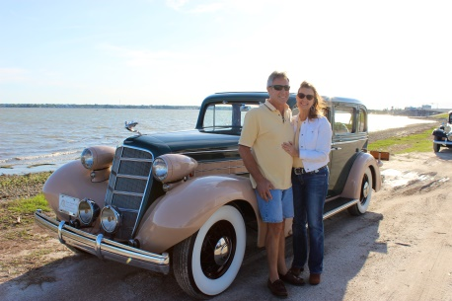
Real Restorations
By Pistorius Collectible Autos

One thing most car collectors have in common is the ongoing need for restoration. Is it ever really 100% complete? Rarely. Is it cosmetically where you want it? Maybe. Is it running like the day it came out of the showroom. Unlikely. But one thing is certain, the desire to get the old car looking and running the way you need it to so you can enjoy the ride.
Before embarking on a restoration project, determine the realistic amount of work you can do yourself. Then get some help with areas you need help with. Do not underestimate the savings of having the job done right the first time.
Before the first bolt is removed, take as many photos as possible. And better yet, video the process of breaking it down. Where and how every bracket, linkage, coil, connector, etc., was originally installed, before you started this project, is the most important information you will have once you have restored the individual areas of your vehicle, and the time comes to put it all back together. You will not remember, we repeat, you WILL NOT remember where everything was. You will end up with the dreaded “extra parts” and lost parts.
In our shop we are currently restoring a 1965 Ford Thunderbird. Our client followed the important guidelines of photographing the car very thoroughly, while it was intact. Unfortunately, more than a thousand photos later, there was no flow from beginning to end with all of those photos. Once the time comes for re-assembly, referencing these photos out of sequence became a much larger task than was anticipated.
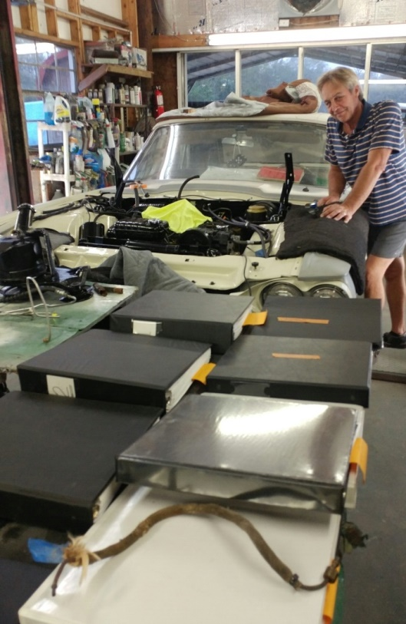
One example is, there were not enough detailed photos taken of the engine before stripping. We could have saved time with sequenced photos or video showing the pipe reticulation going from point A to point B. In restoration work, saving time is saving money, especially when you are using a professional for restorations. Of course we can figure it out, but at an hourly cost to you.
Most restorers want you to drive away loving your “new” old car. We want you to love the way she sounds when you open the door and close it with a solid click. We want you to turn her on and hear her purr (or roar depending on your particular classic). We want the suspension to ride solid, and the horsepower to get you in and out of merging traffic as you take her on tour or down to the cruise-in. We want your spouse to hop in and smile when you go out for a meal in this classic beauty. Yes, we even want the people at the stop light to give you a “thumbs up”. We want your biggest worry to be those folks taking videos while driving down the highway aside your cool car.
We will bring you more real restoration tips, because we want you to get those cars on the road. Cars were built to be driven. Let’s see you drive yours with pride.
Brando & Joanne Pistorius

