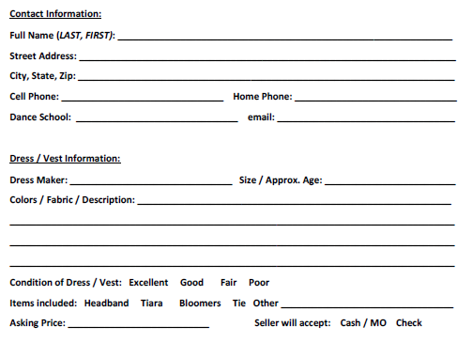
Waiver:
I agree to allow the CNY Feis Volunteers to show my property at this event. Any volunteers or committees involved in the CNY Feis are not responsible for loss, theft or damaged to items left in its care. If your items are left in the designated area at the feis, you agree to have them shipped to your home at your expense.

