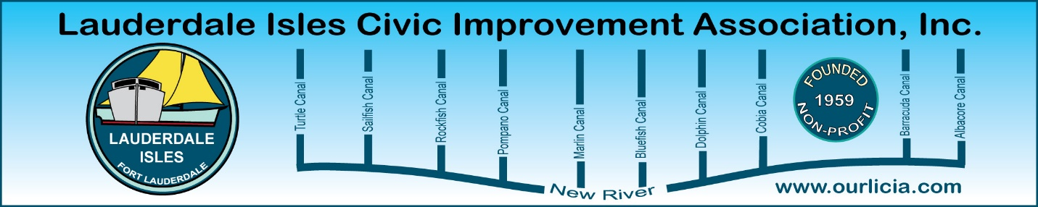
Minutes of the Lauderdale Isles Civic Improvement Association Board Meeting Zoom call June 20, 2024
The meeting was called to order by President Earl Prizlee at 7:05pm.
Roll call was taken.
Present: Earl Prizlee, Geoff Rames, Karen Rames, Diana Steeger, Dick Cahoon, Dawn Hannah, Aynsley Geramanis, Andrew Silverman, Julie Gordon, Glo Knowles and Joann Kratky.
April Treasurer report: Dick made the motion to approve, Geoff seconded the motion and we all approved.
May Treasurer report: Andrew made the motion to approve, Joann seconded the motion and we all approved.
Proposed budget: Diana discussed the proposed budget. Dawn made the motion to approve, Joann seconded the motion, and we are all in favor of approving this year’s budget.
January 2024 minutes: The correct January 2024 meeting minutes were sent. Dawn made the motion to approve, Geoff seconded and all approved.
April 2024 minutes: Diana made the motion to approve, Joann seconded the motion and we all approved.
May 2024 minutes: Dawn made the motion to approve, Diana seconded the motion and we all approved.
FLPD report: Officer Jackson advised there was 1 Part 1 crime on May 25 on Marathon Lane. A trailer with 2 jet skis was stolen from the driveway.
Dawn asked who to call when she is out of town and her Ring picks up something suspicious. Officer Jackson said to call the Fort Lauderdale non-emergency phone number.
Earl said there is radar data from the speed signs available. The data will be reviewed and shared.
Code Compliance: Marco Aguilera was promoted to Senior Inspector and will no longer be handling our area. A new inspector has been hired and is undergoing training. Manny Garcia was also promoted and will be responsible for district 1 and 2. There were 3 waterway complaints about docks collapsing, and oversized vessels and liveaboards as well. The most common violation on the water throughout the city is oversize vessels.

Community Center update: Earl reported the consultant should have a project document by mid-July. Earl will continue to request monthly update meetings.
Vacation Rental Bill update: Geoff reported that Senate Bill 280 went to the Governor. He has until July 1 to veto, sign or do nothing. If he does nothing, it becomes law. We will establish a Vacation Rental Committee to closely address vacation rentals in our community.
May General Meeting: We need to set guidelines for acceptable behavior at these meetings and we all need to understand what to do if a problem arises. At registration, if someone does not sign in or pay dues, that person will be asked to step aside and will be dealt with separately. We discussed handling votes differently. Need to ask the Pastor how we turn the microphone off. Give Officer Jackson the dates of all our General Meetings and ask her to attend. If Officer Jackson is not in attendance, the unruly person will be asked to leave and call the Police as a last resort.
Support of political candidates: Geoff and Earl agreed they will stay neutral because the District 4 Commissioner sits on LIWMD with them. Board members are welcome to post a sign or support a candidate of their choice. In our individual capacity, we can do what we want. Board members cannot support or endorse a candidate and state they are an official member of the Board of LICIA.
Candidates’ night at August 15 General Meeting: All 5 candidates will be attending. We will need someone to be the time keeper during the question session. It was agreed to not have a candidates’ night for the Mayoral candidates’. Diana will confirm August 15 for the Church and we will contribute $200 for use of the Church. We need 4 people at the registration desk as we expect a large crowd. Diana, Karen, and Andrew volunteered. Karen will secure the 4th person.
Next newsletter: Geoff said the deadline is July 25 and he is working on securing ads from each candidate.
Airport Noise update: Dick said there are more turbo prop planes now and they don’t need to comply with Metroplex patterns. Jets are flying Metroplex procedures close to 90% of the time.
July 4th decorations: Earl discussed. No action taken.
New Business: Geoff recommended new meeting signs for each lane, and they need to say LICIA meeting when we order them. Geoff, Earl and Andrew to discuss and coordinate.
Julie discussed an incident at the boat ramp. Earl asked her to send him a letter detailing the event and he will send to Officer Jackson.
Motion made by Dawn to adjourn the meeting. Karen seconded and all approved. The meeting ended at 8:25 pm.
Submitted by Karen Rames, Secretary

