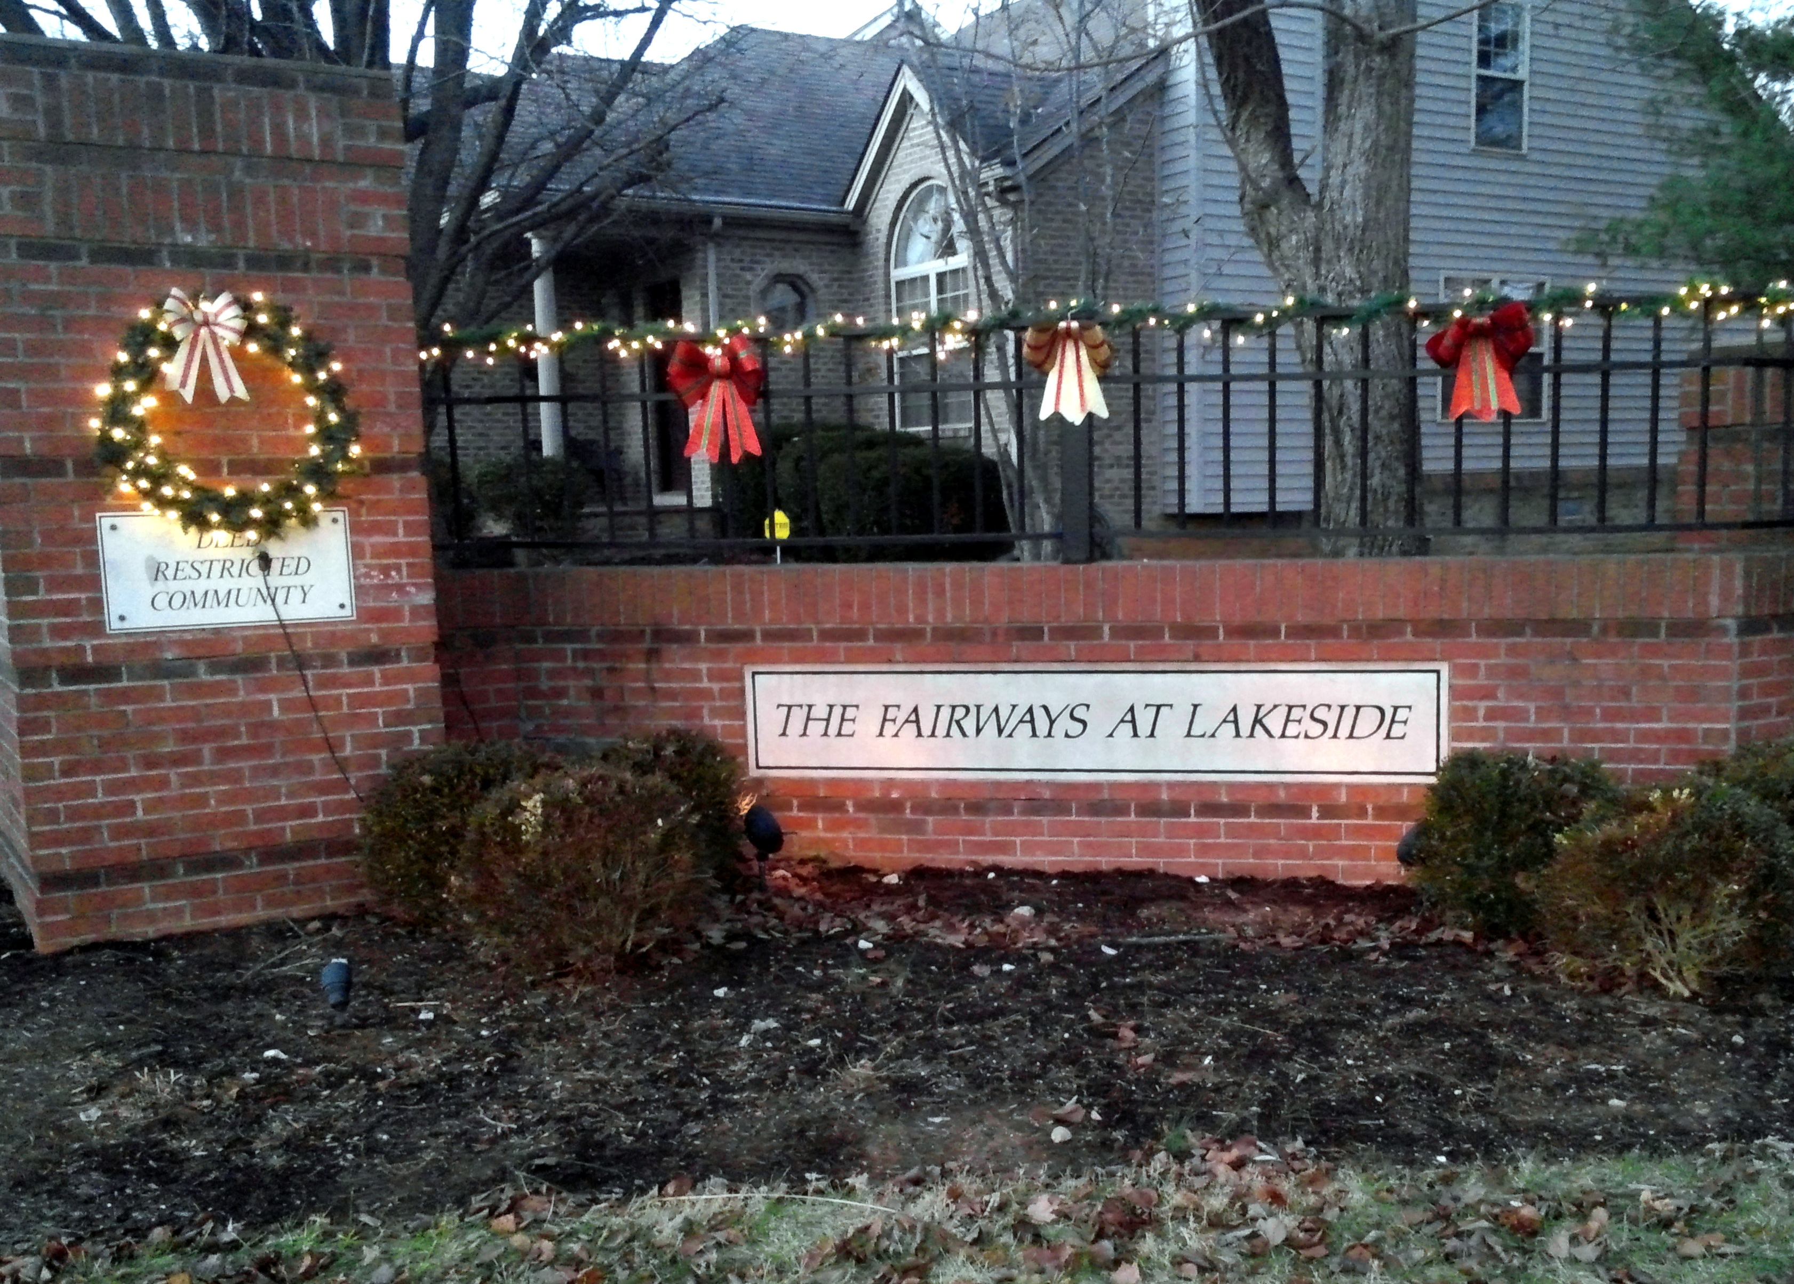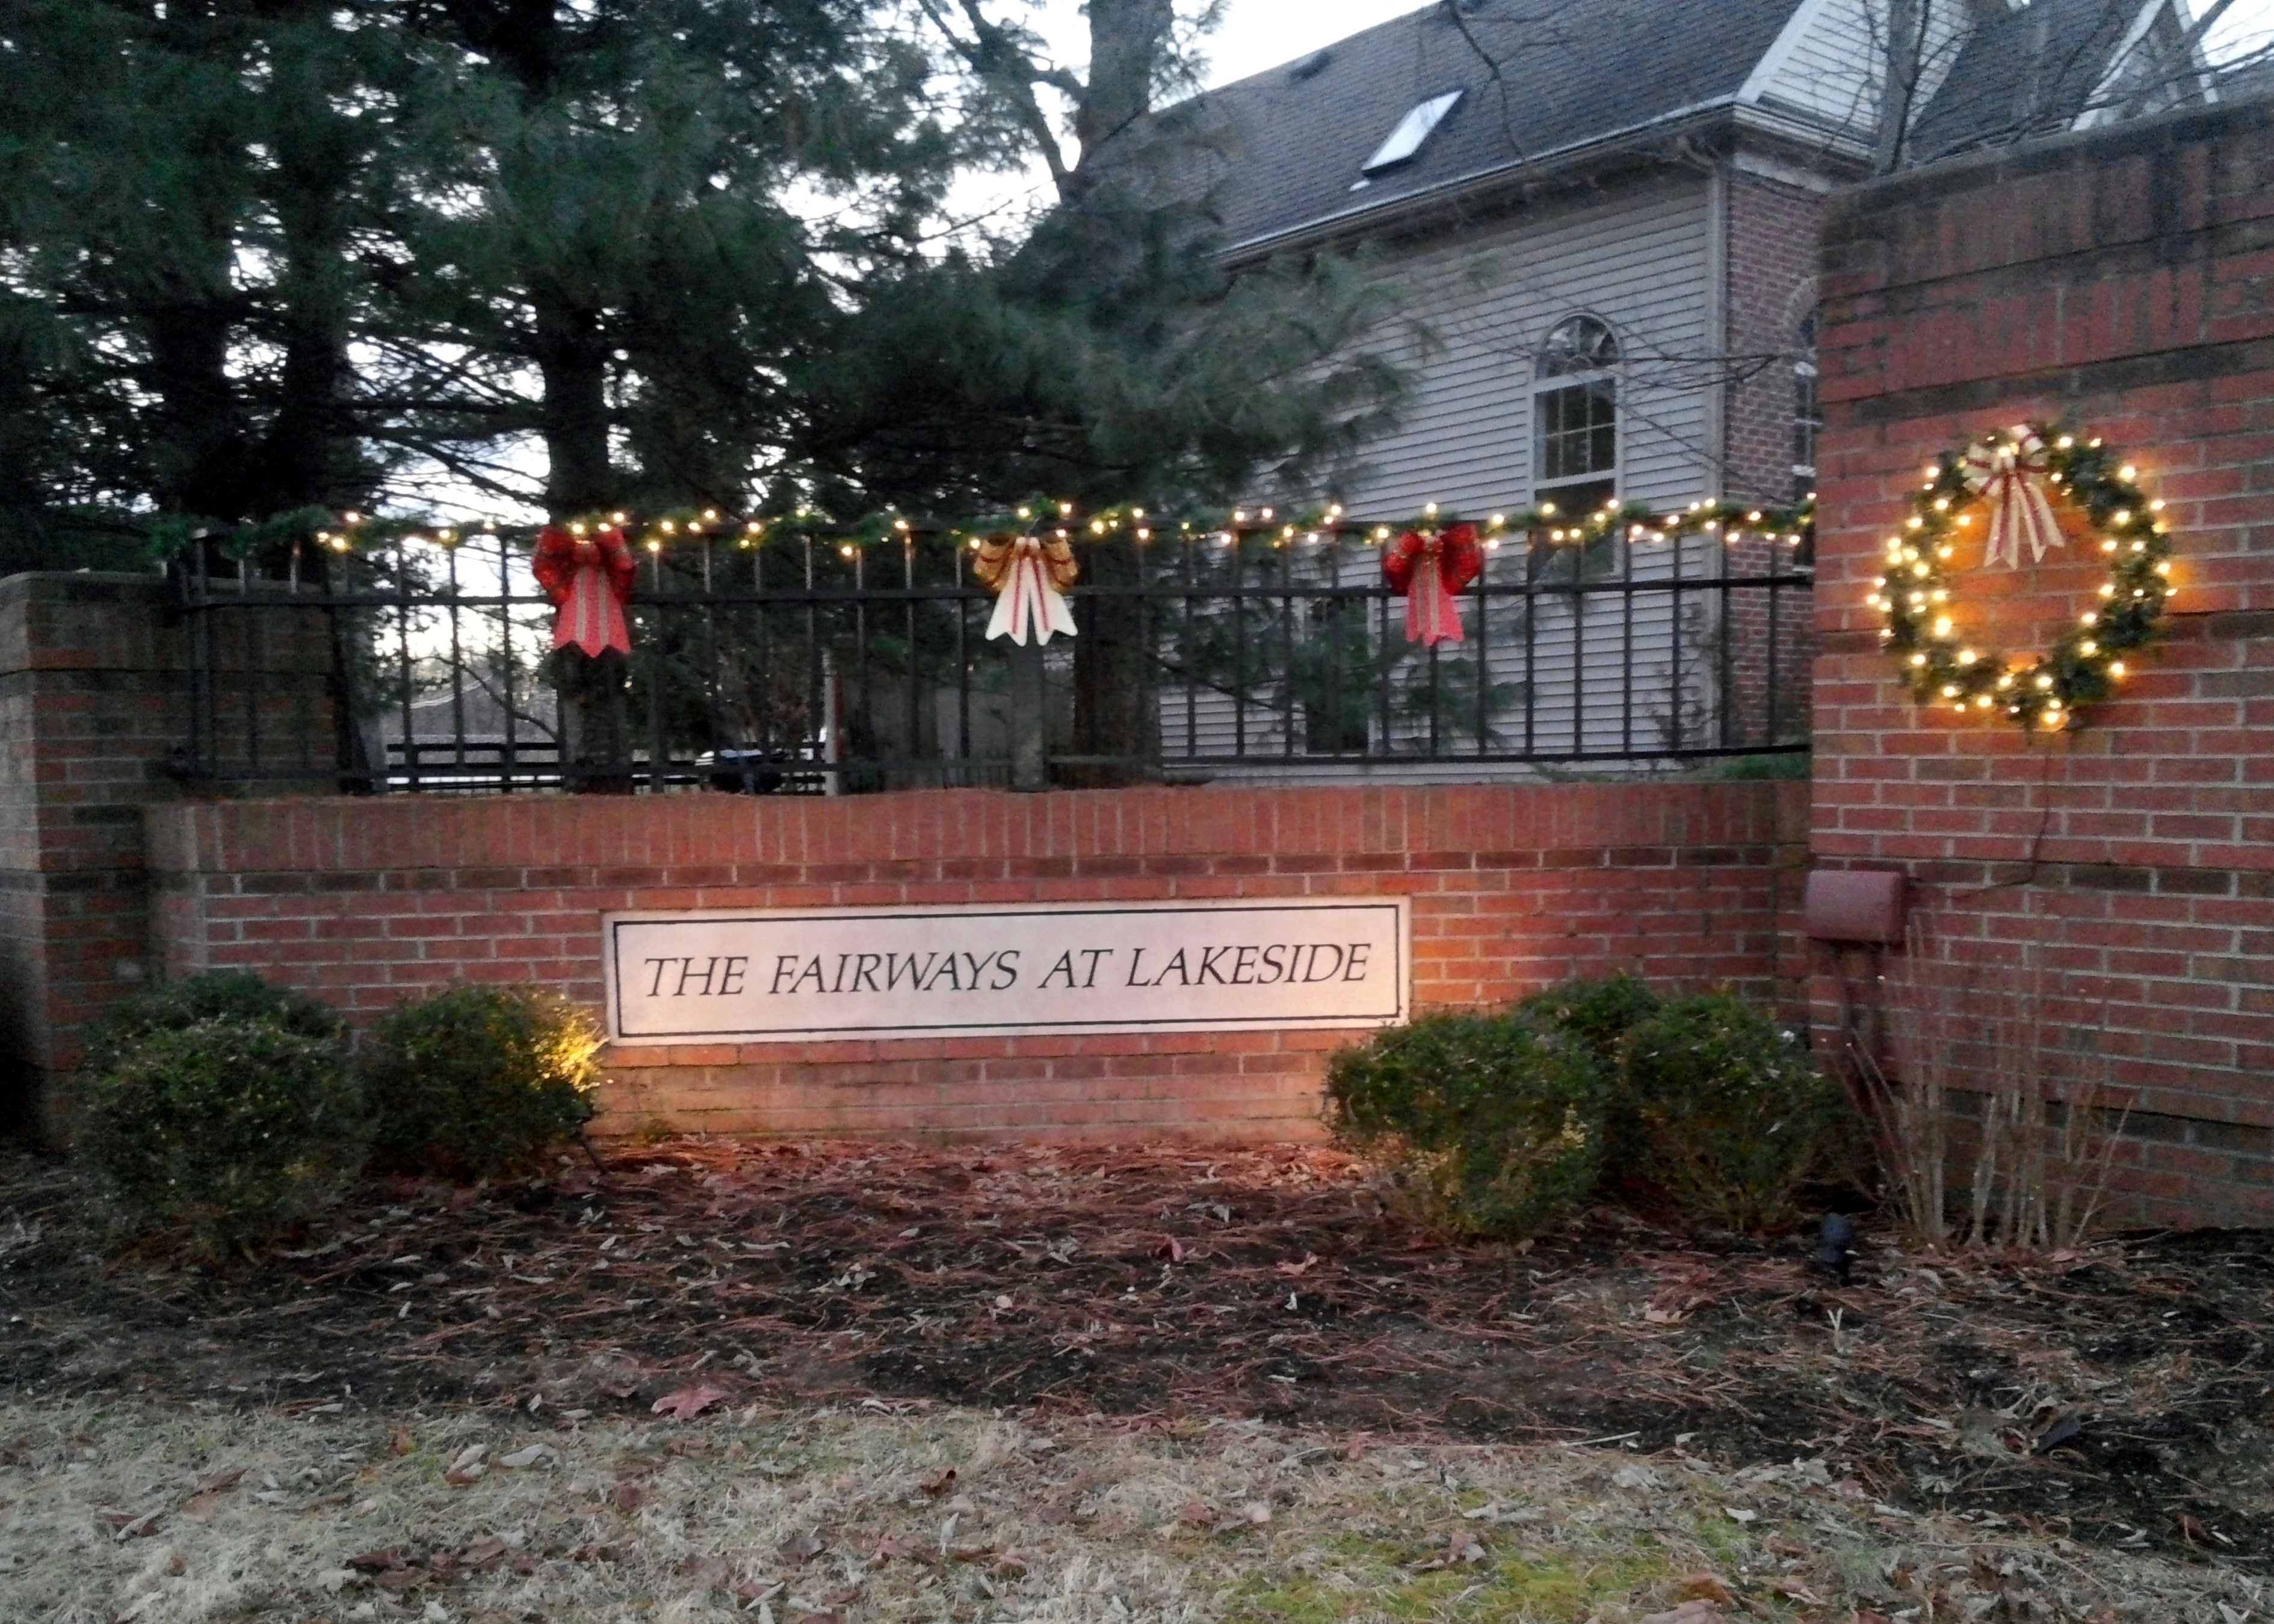
Fairways at Lakeside Community Association Newsletter
January 2018

A Word from Our President

I want to wish everyone a very Happy New Year 2018!! I hope that 2018 is filled with happiness and health.

Special thanks to the 2017 FALCA Board and Officers. I appreciate all the help and understanding through 2017 – it was a very unique year for me (spending a portion of it in mandatory bed rest and then a little over 3 months on a knee roller). I really appreciate all of the support, kindness and help.

A special THANK YOU to Retha Kreitzman for servicing on the Board for 3 years and acting as New Home Owner Welcoming Committee. Thank you Kim Buckner for serving as the Association Secretary for the last few years. Thank you also to Jay Jones for serving as a Board Member in 2017 – maybe when things calm down you can serve on the Board again.

I am excited to welcome our two new Board Members, Tiffany Compton and Jennie Hale, and our new Secretary, Jonathan Groth. We are excited to have your views and input in the management of the Association this year and the years to come.

Please be sure to take the time to thank your past and current Board and Officers when you see them for volunteering their time. Our neighborhood is small and special and the Board and Officers try to make decisions that will keep it special for all.

Robin C. Gall
President
Treasurer’s Report

As of November 30, 2017, John Kreitzman reports the following FALCA account balances:

Checking Account: $10,745.97
Certificate of Deposit #1: $ 6,076.81
Certificate of Deposit #2: $ 4,193.92
Certificate of Deposit #3 $ 5,000.52
Total FALCA Funds: $26,017.22

John reminds us that Annual Fees are due by January 31, 2018. Your fee invoice is enclosed with this newsletter.

2017 Association Annual Meeting Recap

The 2017 Association Annual Meeting was held on December 5, 2017 at Morning Pointe of Lexington East. We had 18 homes represented at the meeting. Thank you to everyone who attended and participated in the meeting.

Robin Gall reviewed the Board’s activities in 2017 and John Kreitzman presented the 2017 Treasurer’s Report and 2018 Proposed Budget. After discussion, the Association approved the 2018 Budget.

Tiffany Compton and Jennie Hale were elected to 3-year Director positions. The following officers were voted in for 2018:

Robin C. Gall President
Gary Renner Vice President
John Kreitzman Treasurer
Jonathan Groth Secretary

Steven Riddle also volunteered to join our Board Meetings as an interested Homeowner. We welcome any and all homeowners to join us for our monthly meetings. Please see the 2018 Board Meeting schedule on the last page of this newsletter.

Please welcome the following new homeowners:
- 3628 Fair Ridge Kai Jiang and Kangli Wong
- 3656 Green Park Jeremiah Hale and Jonathan Groth

Just a reminder, our Snow Removal Policy is to have our community automatically added to the snow removal contractor’s list if 4 or more inches of snow are projected at one time. If less than 4 inches is projected, the Board will still require 3 or more Directors to approval snow removal.

Please be sure to shovel your sidewalks in addition to your driveway. LFUCG ordinances requires homeowners to clear sidewalks.
Update on the Public Hearing on Zoning Appeal for 3515 Richmond Road, Whitehaven:
Robin Gall, Gary Renner and Steve Gall attended the Lexington-Fayette Urban County Council Board of Adjustment Public Hearing on December 15th to ask questions about the proposed zoning change for a portion of the White farm to be used as a wedding/events venue.

In the proposal to the City, the plans for the venue were to hold weddings and receptions twice a month from May to October on Fridays or Saturdays. They have stated they will observe the city noise ordinance with regard to music and dancing.

The LFUC Board of Adjustment Staff had reviewed the request and recommended approval with 6 conditions. Robin Gall was sworn in to testify and met with Don Cox and Nathan Billings, of Billings Law Firm. Mr. Billings explained that the venue can only be used for weddings and wedding receptions. They will not have events when the golf range is open. They will start closing events down around 10:00 pm trying to have all guests out by 11:00 pm and the staff out by midnight. Events will be outside or in tents, so they will be held from April – October. Portable toilets will be placed, when needed, near the parking area or the golf range. The property owners are committed to keeping the farm as a cattle farm and will not be requesting to open access through our subdivision.

Following are the 6 conditions placed on the venue by the Board of Adjustments Staff:

- The use of this property as a venue for weddings and receptions shall be operated in accordance with the submitted application and site plan.
- All events shall be limited to no more than 200 participants.
- Participants shall enter the site at the Yorkshire Boulevard entrance and shall not utilize the service access to Richmond Road, except in the event of an emergency.
- Any lightings for events shall be shielded and directed downward to avoid disturbing the surrounding properties.
- Temporary structures, such as tents, shall be permitted for this use up to 180 days, provided approval is obtained from the Division of Building Inspection.
- For events, approval for the septic system and/or any portable toilets as well as for any food services offered, shall be obtained from the Fayette County Health Department.

The Board of Adjustments approved the zoning appeal with the 6 conditions unanimously.
Thank you to Morning Pointe East for hosting our 2017 Annual Meeting. We really appreciate being able to use your common room.

Thank you to Gary Renner for putting up all of our decorations at the entrance to the community over the past year. The lights, wreaths and bows sure brighten up our entrance. Thank you for all your work in keeping our community festive.

2018 Board Meeting Schedule

The following is the proposed Monthly Board Meeting Schedule for 2018. Dates are subject to change. If you would like to come to meetings or be advised of changes please contact Robin Gall at rgall30539@aol.com.

January 16, 2018 7:00 pm
February 20, 2018 7:00pm
March 20, 2018 7:00 pm
April 17, 2018 7:00 pm
May 15, 2018 7:00 pm
June 19, 2018 7:00 pm
July 17, 2018 7:00 pm
August 21, 2018 7:00 pm
September 18, 2018 7:00 pm
October 16, 2018 7:00 pm
November 20, 2018 7:00 pm
December 18, 2018 7:00 pm

Meetings are held at Robin Gall’s home, 3693 Park Pointe.

Contact information for Officers and Board Members: Please always feel free to contact a Board Member or Officer when you have a question or concern. The Board and Officers will do their best to resolve any issues or answer questions that are brought directly to their attention. It is hard to know how to handle situations that we hear about indirectly. Please remember that your Board Members and Officers are volunteers who give freely of their time to help keep our neighborhood a wonderful place to live. We need your input and your support.

Director/President: Robin C. Gall 806-8843 rgall30539@aol.com
Vice President: Gary Renner 264-0069 garyrenner@windstream.net
Director/Treasurer: John Kreitzman 272-1524 johnbkreitzman@gmail.com
Director: Kevin Wilder 227-5323 kwilder701@gmail.com
Director: Tiffany Compton tcompton0427@gmail.com
Director: Jennie Hale 327-9621 jennie.hale02@gmail.com
Secretary Jonathan Groth 480-310-1108 jrgroth@gmail.com

