Jr ttrf-rn ,';
(R-2013-595) 2_:iof-;;;,

RESOLUTION NUMBER R-
308158

---'------

DATE OF FINAL PASSAGE - -'-M-A'Y--2--4-20-13----

A RESOLUTION OF THE COUNCIL OF THE CITY OF
SAN DIEGO AUTHORIZING THE SALE OF SURPLUS CITY­ OWNED REAL PROPERTY AT THE TERMINUS OF WEST QUINCE STREET, PURSUANT TO THE PURCHASE AND SALE AGREEMENT WITH JOHN D. BOLS, TRUSTEE OF THE JOHN D. BOLS SEPARATE PROPERTY TRUST.

WHEREAS, the City of San Diego (City) owns fee interest in that certain 16,858 square feet ofreal property, identified as Assessor Parcel Numbers 451-643-01 and 451-672-10, located southeast of the eastern tenninus of West Quince Street and west of Reynard Way in San Diego, California (Property). The Property consists of remnant parcels obtained from the County after a tax deed sale in 1954; and
WHEREAS, the Property has sat vacant and unused by the City, and is located on a steep slope. The Property is effectively landlocked, the only legal access being a dedicated street that has not been and likely will never be developed due to the steep topography of the overall site.
Also, the City and adjacent property owners have had to expend resources to perfonn brush management, weed and vagrancy abatement, and litter removal on the Property; and
WHEREAS, John D. Bols, a private individual and Trustee of the John D. Bols Separate Property Trust dated September 25, 2002 (Bols), owns the residential property immediately adjacent to the Property. Bois has approached the City to acquire the Property; and.
WHEREAS, Council Policy 700-10 provides that surplus City prope1iy may be sold, and that exclusively negotiated sales with contiguous land owners are justified and may be approved

(R-2013-595)

when a parcel is landlocked and where sale to a contiguous owner would correct a site deficiency; and
WHEREAS, the Property was appraised at a value of Ninety Thousand Dollars ($90,000) by an independent MAI appraiser; and
WHEREAS, the Property is not needed nor is it foreseeable to be needed by any City department for any public purpose or benefit; the sale of the Property would relieve on-going maintenance costs to City; and the Property is unused and deficient as effectively landlocked; and
WHEREAS, City staff negotiated a Purchase and Sale Agreement with Bols for the Property, a copy of which is on file in the Office of the City Clerk as Document
No. RR 308158 . After receiving cmmnunity input relating to the Property and the
potential transaction, staff included in the Purchase and Sale Agreement certain deed restrictions to limit use and development of the Property; NOW, THEREFORE,
BE IT RESOLVED, by the City Council of the City of San Diego, that the 16,858 square feet ofreal property, identified as Assessor Parcel Numbers 451-643-01 and 451-672-10, located southeast of the eastern tenninus of West Quince Street and west of Reynard Way in San Diego, California (Property), is deficient and surplus City property and may be sold; and
BE IT FURTHER RESOLVED, that the Mayor, or his designee, is authorized and directed to sell the Property to John D. Bols, a private individual and Trustee of the John D. Bols Separate Property Trust dated September 25, 2002, pursuant to the tenns and conditions of the
Purchase and Sale Agreement on file in the Office of the City Clerk as Document No. f£30 81.5 8, for the price of Ninety Thousand Dollars ($90,000); and

(R-2013-595)

BE IT FURTHER RESOLVED, that the Mayor, or his designee, is authorized and directed to execute and deliver all such agreements and all other instruments to effect and complete the transaction contemplated by this Resolution; and
BE IT FURTHERRESOLVED, that the Chief Financial Officer is authorized to accept and deposit the proceeds of the sale of the Property, net of costs related to the sale, into the Capital Outlay Fund 400002.

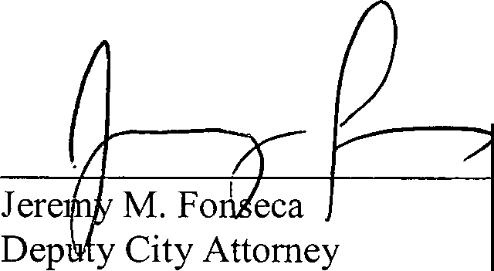
APPROVED: JAN I. GOLDSMITH, City Attorney

By

JMF:mcm April 30, 2013
Or.Dept: READ Doc. No. 534681

I hereby certify that the foregoing Resolution was passed by the Council of the City of San Diego, at this meeting of MAY 1 4-2013 .

Approved q1

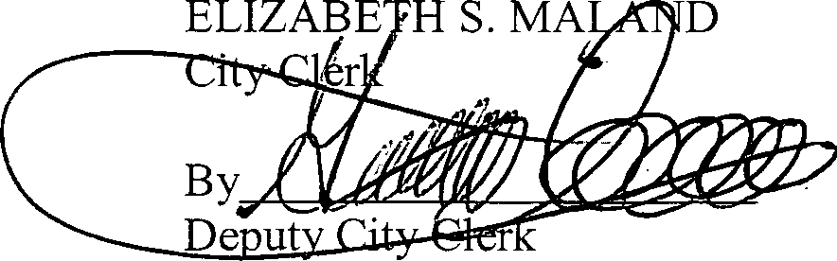(<lat
&r
BOB FILNER, Mayor

Vetoed:
(date) BOB FILNER, Mayor

Passed by the Council of The City of San Diego on MAY 14 2013 , by the follmving vote:
Councilmembers Yeas Nays Not Present Recused Sherri Lightner LJ □ LJ
Kevin Faulconer CZ □ □ LJ
Todd Gloria 0' □ □ □ District 4 (Vacant) □ □ □ □ Mark Kersey □ LJ □
Lorie Zapf 0' LJ LJ □
Scott Shennan [2 17 □ □
David Alvarez [21 □ n □
Marti Emerald n 11 □

Date of final passage

'
M_A Y2-----4,-2_0__13 _

BOB FILNER
AUTHENTICATED BY: Mayor of :ri:ie C1ty of San Diego, California.

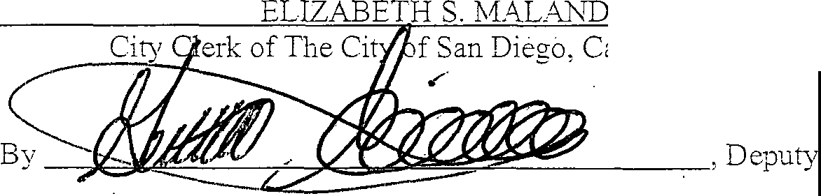(Seal)

f San Diego, California.

Office of the City Clerk, San Diego, California

Resolution Number R- 30815

