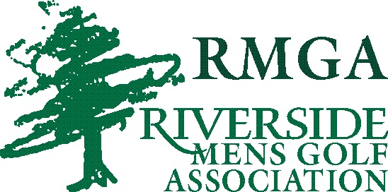

RMGA SCHOLARSHIP PROGRAMS
GOLF TEAM SCHOLARSHIPS (4) - $500 EACH
MEMBER SCHOLARSHIPS (5) - $300 EACH
RIVERSIDE MEN’S GOLF ASSOCIATION ANNUALLY AWARDS $3000 IN SCHOLARSHIPS TO AREA STUDENTS. APPLICATIONS FOR SCHOLARSHIPS ARE AVAILABLE AT THE FOLLOWING LOCATIONS:
- JANESVILLE HIGH SCHOOL GUIDANCE OFFICES
- RIVERSIDE GOLF COURSE-AT RMGA INFO BOARD
- RMGA WEB SITE; http://golfrmga.org/
APPLICATIONS ARE DUE BY: APRIL 15TH
RMGA HAS TWO TYPES OF SCHOLARSHIPS
- GEORGE CLATWORTHY RMGA GOLF TEAM SCHOLARSHIPS
- AVAILABLE TO GRADUATING GOLF TEAM MEMBERS
- JANESVILLE HIGH SCHOOL GOLF TEAMS (PARKER/CRAIG)
- 1 FOR EACH TEAM (BOY’S/GIRLS’S)

- GENE THORP, FRED PARKINSON, DON KAZDA RMGA MEMBERS SCHOLARSHIPS
- AVAILABLE TO GRADUATING SON’S OR DAUGHTER’S OF RMGA MEMBERS IN GOOD STANDING (2 YEAR MINIMUM)
- NOT LIMITED TO GOLF TEAM MEMBERS
- NOT LIMITED TO STUDENT OF JANESVILLE SCHOOL DISTRICT
SCHOLARSHIP PAYMENTS ARE CONTINGENT UPON SUCCESSFUL COMPLETION OF 1ST SEMESTER AND PROOF OF REGISTRATION FOR NEXT SEMESTER CLASSES. EACH RECIPIENT IS REQUIRED TO TAKE A MINIMUM OF 12 CREDITS AND ATTAIN A 2.0 GPA. RMGA SCHOLARSHIP COMMITTEE WILL REVIEW THIS DOCUMENTATION BEFORE ISSUING SCHOLARSHIP PAYMENTS.
IF YOU HAVE ANY QUESTIONS REGARDING THESE SCHOLARSHIPS PLEASE CONTACT: scholarships@golfRMGA.org
JIM CRAWFORD (RMGA SCHOLARSHIP CHAIRMAN)
TOM NOLL
JERRY RABBACH
CURT TERRY

