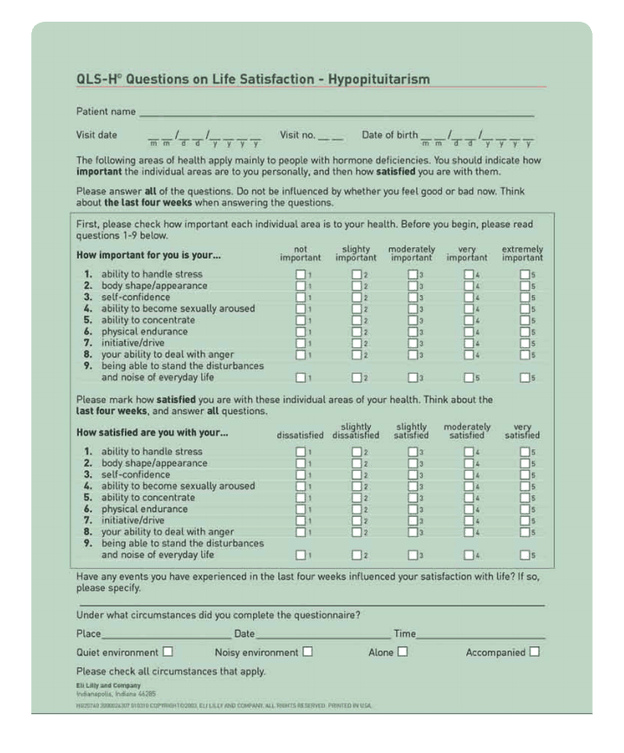

Adult Growth Hormone Deficiency Assessment

QoL-AGHDA
Instructions: Indicate whether each of the following statements below applies to you Yes No
I struggle to finish jobs............................................................................................................
I feel a strong need to sleep during the day ..........................................................................

I often feel lonely even when I am with other people..........................................................

I have to read things several times before they sink in ......................................................

It is difficult for me to make friends .....................................................................................
It takes a lot of effort for me to do simple tasks ..................................................................

I have difficulty controlling my emotions..............................................................................

I often lose track of what I want to say .................................................................................

I lack confidence ......................................................................................................................

I have to push myself to do things..........................................................................................

I often feel very tense...............................................................................................................

I feel as if I let people down....................................................................................................

I find it hard to mix with people.............................................................................................

I feel worn out even when I’m not doing anything ..............................................................

There are times I feel very low ...............................................................................................

I avoid responsibility if possible ............................................................................................

I avoid mixing with people I don’t know well .......................................................................

I feel as if I am a burden to people.........................................................................................

I often forget what people said to me ....................................................................................

I find it difficult to plan ahead ................................................................................................

I am easily irritated by other people ......................................................................................

I often feel too tired to do the things I ought to do................................................................

I have to force myself to do things that need doing ..............................................................

I often have to force myself to stay awake ..............................................................................

My memory lets me down .......................................................................................................

