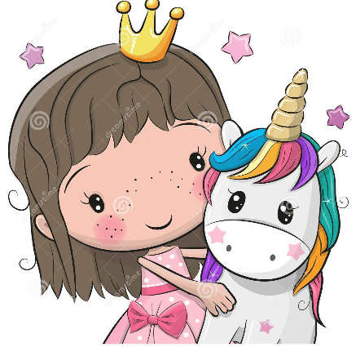
Magical Princess and Unicorn Dance and Luncheon
When: January 26th 2020
Where: Valley Middle Cafeteria
Time: 11:30-1:30pm
Cost: $10 per Girl Scout with patch included or $8 per Girl Scouts without patch
Come dressed in your best and enjoy a unicorn themed lunch, play magical games, make magical crafts, a visit from a special guest and dance to enchanted music!
Please RSVP by January 18th
Any questions contact Jen Kane 651-434-2976

Unicorn Dance and Luncheon Registration Form
Troop #:____________
Leader/Email: ______________________________________________
Total Number of Guest: _________
Lunch Choices (Please inquire number choices below):
Rainbow Buttered Noodles______
Unicorn Swirl Hot Dog_____
Unicorn Grilled Cheese____
Any special diet preferences?___________________________
Patch(Y/N)/How many?______
Please make checks payable to:
Troop 54833
992 Whitney Dr
Apple Valley MN 55124
Or paypal at jjank825@yahoo.com

