TWENTY FIFTH SUNDAY
IN ORDINARY TIME
SEPTEMBER 21 & 22, 2019

GOD IS ON THE SIDE OF THE POOR
Two of today’s readings make it quite clear that God is on the side of the poor. Amos describes in detail the exploitation of the poor and needy. The psalm repeats that God acts to benefit the poor and lowly. But Like turns things upside down, telling a tale of a conflicted steward, about to be fired, who demonstrates his cleverness and is rewarded. Like the community to whom Paul writes in Timothy, these readings are personal, directed to believers, members of the Jewish and Christian communities, who struggle to deal with personal choices about how to conduct their lives. They offer an outline for how God wishes us to live in a world as complicated and as confusing as our own.

SUBMISSION TO GOD
By Dennis Tavares
There are as many stories of suffering as there are individual humans. And because suffering is the key to our place in heaven, everyone has a different place in heaven. There is a hierarchy in heaven with those who suffered most for God’s sake closest to Him, who suffered most for us. Jesus underwent torture and death for love of all, who ever live. We should remember that life consists of only two things, circumstances we encounter and our activities in response to those circumstances. We must accept the circumstances of our life, mostly outside our control as the will of God for us. By this abandonment, we show our trust in God, who creates and cares for us, and which allows His love in us to channel our choices, our activities, to things that matter in our journey to heaven.

PRAY FOR OUR FAMILY AND FRIENDS THAT ARE
IN THE MILITARY SERVICE
Rebecca Sánchez, José Araiza Jr., Edgar Toscano, Marina González, Alondra Jara, Sonia Jara, Jason Lorenz, Matt Mill & Jared Schroeder.

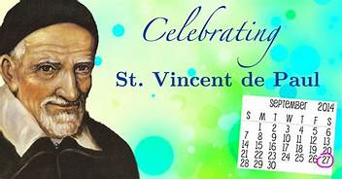
THE PATRON OF ALL CHARITABLE SOCIETIES

St. Vincent de Paul was born to a poor peasant family in the French village of Pouy on April 24, 1581. His first formal education was provided by the Franciscans. He did so well, he was hired to tutor the children of a nearby wealthy family. He used the monies he earned teaching to continue his formal studies at the University of Toulose, where he studied theology.
He was ordained in 1600 and remained in Toulose for a time. In 1605, while on a ship traveling from Marseilles to Narbone, he was captured, brought to Tunis and sold as a slave. Two years later he and his master managed to escape and both returned to France.
St. Vincent went to Avignon and later to Rome to continue his studies. While there he became a chaplain to the Count of Goigny and was placed in charge of distributing money to the deserving poor. He became pastor of a small parish in Clichy for a short period of time, while also serving as a tutor and spiritual director.
From that point forward, he spent his life preaching missions to and providing relief to the poor. He even established hospitals for them. This work became his passion. He later extended his concern and ministry to convicts. The need to evangelize and assist these souls was so great and the demands beyond his own ability to meet that he founded the Ladies of Charity, a lay institute of woman, to help, as well as a religious institute of priests - the Congregation of Priests of the Mission, commonly referred to now as the Vincentians.
This was at a time when there were not many priests in France and what priests there were, were neither well-formed nor faithful to their way of life. Vincent helped reform the clergy in a manner in which they were instructed and prepared for the priesthood. He did this first through the presentation of retreats and later by helping develop a precursor to our modern day seminaries. At one point, his community was directing 53 upper level seminaries. His retreats, open to priests and laymen, were so well attended that it is said he infused a "Christian spirit among more than 20,000 persons in his last 23 years."
He was eighty years old when he died in Paris on September 27, 1660. He had "become the symbol of the successful reform of the French Church". St. Vincent is sometimes referred to as "The Apostle of Charity" and "The Father of the Poor".
His incorrupt heart can be found in the Convent of the Sisters of Charity and his bones have been embedded in a wax effigy of the Saint located at the Church of the Lazarist Mission. Both sites are located in Paris, France.
The feast day for St. Vincent, the Patron of all Charitable Societies, is September 27.

ATTENTION
MASS WILL BE CELEBRATED ON MONDAY, SEPTEMBER 23RD AT NOON.
ALSO, THERE WILL BE
NO MASS ON TUESDAY, SEPTEMBER 24TH AND THE OFFICE WILL BE CLOSED.

KNIGHTS OF COLUMBUS
ARE HAVING A
TRI-TIP ROAST SALE
WHEN:
SATURDAY, OCTOBER 5TH, 2019
PRICE:
$25.00 EACH
MARINATED BBQ’D AND READY TO EAT.
YOU CAN PLACE YOUR ORDER TODAY
AFTER MASS OR CALL 480-4614.

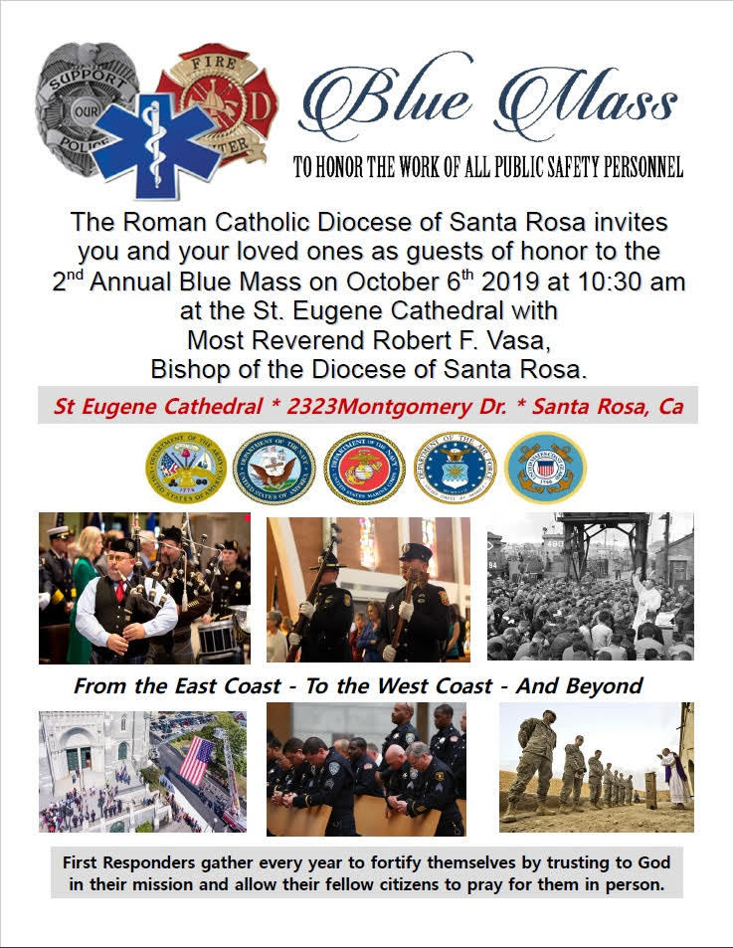

Santa Rosa Religious Education Congress 2019
The Diocese of Santa Rosa invites everyone to attend the annual Santa Rosa Religious Education Congress on Saturday, September 28, 2019. This year's theme is "Encountering Jesus in the Liturgy”. Workshops are in English and Spanish. Come hear great speakers. For more information check out the diocesan website @ www.santarosacatholic.com

OLGC’S MEMORIAL TREE
In the vestibule of the Church, on the southern wall,
is a beautiful Memorial Tree.
Its bright leaves represent permanent memorials to the
departed of our Parish.
For the sum of $200.00, you can give to the Parish Secretary, the correct spelling and dates of the departed and in due time the leaf is printed and attached to the tree: a permanent reminder of a loved
one who is gone.
For more information, call the Parish Office at 964-0229.

MASS INTENTIONS
SEPTEMBER 23 - 29, 2019
Monday (23)  Tuesday (24)  Wednesday (25)  Thursday (26)  Friday (27)  Saturday (28)  Sunday (29) | 12:05pm  12:05pm  12:05pm  12:05pm  12:05pm  5:00pm  6:30pm  8:00am  10:00am | Candelaria Tascanio †  John Dompeling †  NO MASS  Conley Family †  Rosaura Sánchez †  Ricardo Trujillo †  Fred & Clara White †  Wooden Family †  James, Pat & Margaret Conley †  Edelmira Mora Toscano †  Ambrose & Carla Torretta †  Muñoz Mendoza Family †

PLEASE PRAY FOR OUR SICK PARISHIONERS
Antonia Rentería, Pauline Ortiz, Ana María López, María Cristina Reyes, Karma Mendez, Juan Hernández, Frank Richards, Lisa Wright, Ricardo Contreras, Florencia Chávez, Refugio Yáñez, Tarcicio García, Sofía García, María de Jesús Mendoza, Antonio Cazares, Ana García, Ryan Moore, Marianne Brannan, Lilia Parrish, Nancy Smith, Julián Palomar, Jennifer Vera, John Braet, Kim Koskinen, Margaret Valencia, Matthew Marcoulier, Dennis Tavares, Jose Freitas, Alfredo Sousa, Juana Arreguín, Aron Yasskin, Victoria Walzer, Fidela Yáñez Jara, Erika Ramos, Bill Gibson, Carla Tomas, Erasmo Yáñez, Memo Soria, Patricia Vargas, Fidela Yáñez, Elvia Flores, Yonel Ruíz, Angie Freitas, Russel Bryant, Derrick Heater, Luis Angel, Juan Barrera-Terán, Gabriel Hurtado, Gerald Butler, Helen Reynolds, Toni Clark, Ann Gallagher, Brianna Lopez, Margaret Milliken, Gina Pivirotto, Nick Quin, Mary Servis, Denis Sousa, Victor Venegas, Matty Walker, Charles Lorenz, Rebecca Lorenz, Ofelia Ibarra, Leonardo Naal, Gina Leal.

WEEKLY COLLECTION

SEPTEMBER 14 & 15, 2019……..$2,630.00
MAINTENANCE FUND…..$512.00

THIS WEEKEND’S SECOND COLLECTION:
DIOCESAN SEMINARIANS
NEXT WEEKEND’S SECOND COLLECTION:
YOUTH MINISTRY

THANK YOU
FOR YOUR SUPPORT & CHRISTIAN GENEROSITY

REMEMBER
IT IS NEVER THE WRONG TIME,
TO DO THE RIGHT THING.

