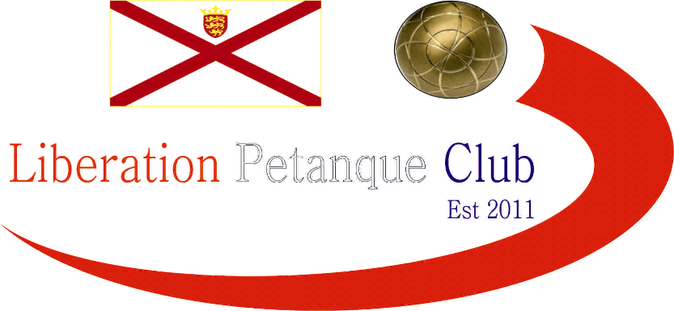

2016

Liberation Petanque Club

Doubles Open

With only 14 teams taking part in this years competition there was no hiding places as a defeat could easily mean the end of the line.

Round 1 saw the biggest win for Jake Romeril & Keith Boleat over Dawn Buckley & Brigitte Ibitson. Andrew Bellamy-Burt and Callum Stewart just beat Ellis Turmel & James Rondel 13 – 11.

Round two saw Chris Romeril & Lee Holberry beat Toby Northern & Matt Pinel 13 – 12. Andrew & Callum beat Ross Payne & Antony Di Santo and Geoffroy Buffetrille & James Gennoe made it two wins out of two beating Jake & Keith.

Round 3 saw Brian Harris & Paul Le Moine lose their first match to Andrew & Callum. Toby & Matt beat Guernsey couple Delpine & Seb and Ross & Antony got back to winning ways.

Round 4 saw the pressure hot up, with Jake Romeril (& keith Boleat) beating his dad Chris Romeril (& Lee Holberry) 13 – 11. Alan Lahiffe & Matthew Scholefield beat Seb & Delphine 13 – 12. Ian Black & Luke Nightingale beat Ellis & James 13 – 1.

Round 5 saw the top 8 places confirmed with Andrew & Callum taking top spot with 5 wins out of 5 by beating Jake Romeril & Keith Boleat.

Toby & Matt beat James & Geoffroy 13 – 10 to confirm their top 8 finish with 3rd place. Ross & Antony took 2nd place by beating Chris Romeril & Lee Holberry.

Final Rankings below.

Quarter Finals

Andrew Bellamy –Burt & Callum Stewart v Chris Romeril & Lee Holberry

Ross Payne & Antony Di Santo v Ian Black & Luke Nightingale

Toby Northern & Matt Pinel v Alan Lahiffe & Matt Scholefield

Geoffroy Buffetrille & James Gennoe v Jake Romeril & Keith Boleat

Andrew & Callum made it though to the semi finals with a good win over Chris & Lee. Jake and Keith beat Geoffroy & James who had chances to win the match.

Toby’s placing out did Alan & Matt as did Antony’s and he and Ross made the Semi-Finals at the expense of Ian & Luke.

A Close first Semi Final between Ross & Antony v Toby Northern & Matt Pinel, but Antony’s placing on a difficult terrain made the difference as they they made the final.

Callum & Andrew continued their winning run with another good performance against Jake & Keith.

Toby regained his excellent placing as both he and Matt made light work of Jake & Keith to take 3rd place.

There was a close start to the final before Ross & Antony stepped up a gear and got revenge for their round 2 defeat to take the title, 13 – 6.

Congratulations to everyone who took part in another successful competition.

Thank you to everyone who helped prepare for this competition and the running of it on the day which takes a great deal of time and effort. If you like to help out at future competitions please let me know.

Kind Regards,

Chairman

Liberation Petanque Club

