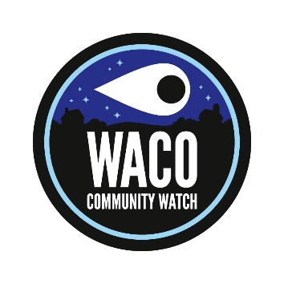 Waco Community Watch Meeting

May 2, 2024

Meeting with Macedonia Missionary Baptist Church Outreach 6:00 pm

Members met with the MMBC Outreach Committee and discussed plans for the “Back to School Block Party” scheduled for August 24th. Topics discussed:

* Rental of a large Bounce house with water feature
* Fire department involvement with possible water feature-smoke house
* Cleveland County Sheriff’s dept. display and activities
* Cleveland County EMS
* Crime Stoppers
* Indoor activities for older citizens like Bingo
* Hotdog plates with chips, cakes,
* Homemade ice cream
* Music
* Popcorn and Snow cones

Groups will continue to meet to finalize plans in July and assign duties.

Discussion on re-starting the Waco Christmas Parade this year. Tentatively chose Saturday December 7th at 6:30 pm. Issues to be addressed prior to the next meeting are – closing Main St and crossing Cherryville Rd. Who to involve and invite to participate? Getting the other churches in the community involved. Ideas will be addressed at the July meeting and will start assigning roles and tasks.

Waco Community Watch Meeting 6:30pm

* J. Barrett presented the 2021-2022-2023 crime stats that were presented at the “State of our Small Towns” meeting with the Cleveland County Sheriff’s Department.
* Discussion on Bingham Rd. concerns / updates.
* Chester reported that a church member had found a box of gun shells under a coat behind Waco Baptist and they had been turned over to the police.
* Group reviewed and discussed new rental agreement that was developed for the Popcorn Maker, Snow Cone Machine and Mist fans.
* Group discussed the cost breakdown on items listed on the rental agreement including new individual popcorn packets and snow cone syrup pricing.
* J. Barrett presented the monthly financial statement for review.
* J. Barrett presented the new summer Community Watch white tee shirts and discussed pricing. Shirts will sell for $15.00 which will provide a $5.01 profit per shirt. We still have various sizes of the Colbalt blue tee shirts available. Discussion on how to market these.
* Discussion on our offer to host a spaghetti dinner for the members of the Waco Community Vol. Fire Department. Barrett reported that his offer had been positively received and that the fire dept. had requested the dinner be presented at their business meeting held on the first Thursday of the month. Tentative dates discussed with the first being June 6th . Barrett states that he is unavailable that date due to a CAGO meeting. Once big concern is having enough Watch members to host the dinner and cook and serve. The group needs to see a larger group attendance for this activity as well as the upcoming Block Party. The discussion was that we probably needed to push this off until July to make sure we can meet again and recruit people to help. Barrett will follow up with the fire department.
* Discussion on the tentative December 7th Waco Christmas Parade and we need to make contact with other municipalities to get some ideas and pointers on how to best manage and plan the parade. This will be discussed further in June.
* Park project discussions are on-going between the town and MMBC.
* Discussion on the offer from Andre Terrel and Israel Hamilton on pressure washing the Community Center and the bridge. The Community Center is booked on Saturdays up to July. Need to discuss alternative days or times to get this done with Andre and Israel.
* The letters on the right side of the sign had all blown off due to several windy days and the letters had been picked up. We need to follow up with Andre on the retro-fit of a Plexiglas cover for each side.
* The Spring Litter Sweep was a success and all streets looked great. We will stay on-top of this.
* Planning of the “Back to School Block Party planning needs to begin no later than the June meeting.
* We really need to recruit more active members to help with all the upcoming planned activities. Discussion on how to get more people involved was held and all agree this is a priority.
* Minutes of the meeting will be completed and shared via Facebook and email to members.
* The next meeting is Thursday June 6th at 6:30 pm. Please attend and bring a friend.
* Meeting adjourned at 7:30 pm.