**Effect of Temperature on Lactase Enzyme Activity**

Lactose intolerance is caused by the insufficient production of the enzyme lactase, which hydrolyzes lactose, a disaccharide, into its component monomers glucose and galactose. Commercially available tablets of lactase can be used as a supplement to relieve symptoms of this disorder. The tablets, like “Lactaid”, hydrolyze the lactose you ingest by consuming a milk product before it enters your intestines.  
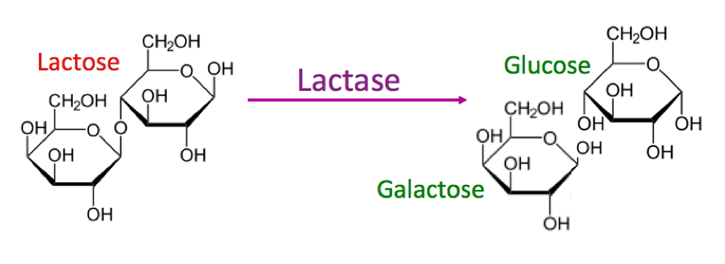  
  
 In today’s lab, we will investigate the effects of temperature on lactase activity.   
  
Milk and other dairy products contain this disaccharide lactose. After consuming lactose, an enzyme in your body called lactase will hydrolyze (break) the glyosidic bond and form galactose and glucose. These monosaccharides can then be used by cells for cellular respiration.   
Milk has a pH of ~6.5 and this slightly acidic pH is optimal for the lactase enzyme.   
For this experiment we will explore how lactase breaks apart lactose by testing a disaccharide called ONPG which stands for O-Nitrophenyl-β-D-galactopyranoside When ONPG is hydrolyzed, it releases galactose and nitrophenol and the solution turns yellow. IF ONPG is not hydrolyzed, the solution stays clear. The yellow color that can be quantified by a spectrophotometer. So the ability of the enzyme to perform this reaction can be measured by how much nitrophenyl = yellow color is produced.  
  
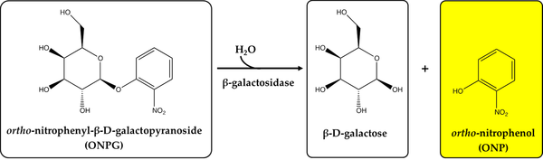  
  
**Procedure:**Obtain the following materials from the supply bench:   
Five glass test tubes   
1 15 mL tube of 91% isopropanol  
Micropipettes (p200, p1000)  
1 15 mL tube of 25mM Tris buffer  
1 Lactaid (lactase) tablet  
1 microcentrifuge   
2.5 mM ONPG   
1 mortar and pestle  
  
**Safety:** ONPG is *mildly* toxic if it contacts the skin. Please wear gloves and exercise due care when working with ONPG. Alert me immediately of any spills and do not try to clean them yourself. Any liquids containing ONPG at any concentration should be collected in a labeled waste container.   
  
**Exercise 1**: Propose a hypothesis.  
How do you think the activity of lactase will vary with temperature?   
  
  
  
  
  
  
  
  
Without using specific numbers, sketch a graph showing the relationship between temperature and activity for this enzyme.  
  
 **Exercise 2:** Effect of temperature on lactase enzyme activity   
We’ll first isolate lactase from the Lactaid tablets:  
1. Using a mortar and pestle, crush one Lactaid tablet into a fine powder.  
2. Carefully transfer the Lactaid powder into a 1.5 mL Eppendorf tube using a folded piece of notebook or filter paper.  
3. Use a micropipette to add 1 mL of Tris to the Eppendorf tube and vortex it thoroughly.  
4. Centrifuge your lactase slurry for 3 minutes.  
 NOTE: Be sure to centrifuge your sample with other groups (or use a tube with water) to keep   
 the centrifuge balanced.  
Then we’ll use the enzyme we’ve prepared in this experiment:  
5. Label each of your five glass test tubes with your group number. Then, label one test tube for each scenario:   
 4 degrees C  
 25 degrees C  
 37 degrees C  
 60 degrees C  
 Blank.   
 Each number indicates a temperature for incubation and the “blank” is the negative control.  
  
6. Add 1 mL (remember how many µL are in one mL?) of Tris to each tube.  
7. Then, add 200 µL of your ONPG stock to each tube.  
8. Place each of your samples at the appropriate temperature:  
 The 4C sample goes in the refrigerator  
 The 25C sample will sit on your bench at room temperature  
 The 37C sample goes in the 37C incubator  
 The 60C sample goes in the water bath labeled “60C”  
 Leave the “blank” tube at room temperature  
  
9. Wait 5 minutes to give the tubes time to heat up/cool down.  
10. Then add 20 µL of lactase to your 25C sample, mix it by swirling carefully, and then leave your reaction on the benchtop for two minutes. After 2 minutes of incubation, stop your reaction by immediately adding 1 mL 91% isopropanol.  
  
Repeat step 10 for the 60C, 37C, and 4C samples in that order one at a time. For each of these samples, return them to the fridge, incubator, or water bath they came from for the two minute incubation. After their two minute incubation, add 1 mL of 91% isopropanol.  
  
To make your negative control, add ONLY 1mL of 91%isopropanol to the “blank” tube. Do not add that lactase to the blank tube. (hmmm, why not?)  
  
 **Exercise 3**: Quantifying ONPG hydrolysis with spectrophotometry  
1. Use a spectrophotometer to measure the absorbance of each sample your team produced at a wavelength of 420 nm. Be sure to “blank” the spectrophotometer before use.   
  
Record the absorbance (A) at 420 nm for:  
4C  
25C   
37C   
60C  
blank  
  
Questions:  
1. In this lab, you investigated the activity of lactase at several temperatures. Complete the following sentences.   
Lactase is an enzyme which normally catalyzes the ________________________ of lactose.  
The products of this reaction are ________________________ and__________________.  
In this investigation, we used ONPG as our _________________________ to investigate the effect of temperature on the activity of lactase.   
  
2. How did we measure the how much product was formed by our enzyme?  
  
  
  
  
3. What were the independent and dependent variables for this experiment?  
  
  
  
How many controls can you name for this experiment? (remember, controls are kept constant across all experimental groups).   
  
  
Why did we set up the “blank” tube?  
  
  
4. Can you identify the ideal temperature for lactase from our data?   
Why or why not?  
  
If not, propose further experiments or experimental groups to determine the ideal reaction temperature for lactase. You may use a diagram or drawing in your answer.