- HLAA Westchester  chapter meeting  The Connection Between Hearing Loss & Balance  According to a study conducted at Johns Hopkins University, people between the ages of 40 and 69 who have even mild hearing loss are three times more likely to become dizzy, lose their balance and fall, creating the risk for injury or death. The greater the hearing loss, the greater the risk of falling. Hear from two medical professionals at Westchester Medical Center’s Balance and Cochlear Implant Center about the risks and what you can do about them. Speakers: Sheetal Thayil, PT, MSPT and Alison Rothman, PT, DPT  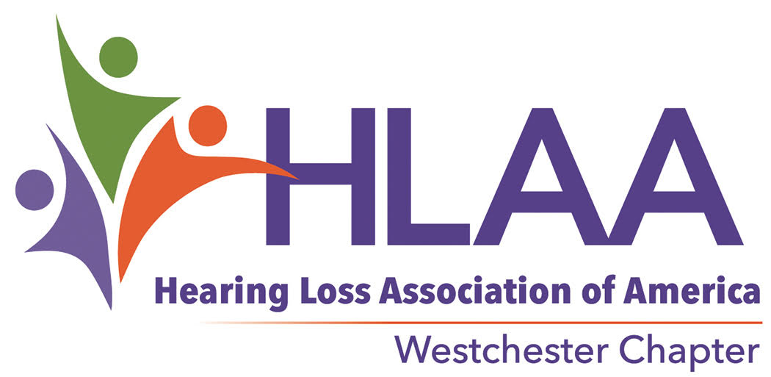  The mission of HLAA is to open the world of communication to people with hearing loss through information, education, support and advocacy | Saturday, April 20 12:30 – 2:30 p.m.  ____  Irvington Public Library, 12 South Astor Street, Irvington, NY  ____  Free for all HLAA chapter members and guests  ____  Stay for refreshments and socializing  ____  Meeting room is looped with captioning provided  information:  stevewolfert98@gmail.com or call 914-960-4692  HLAA Westchester www.hlaawestchester.org

