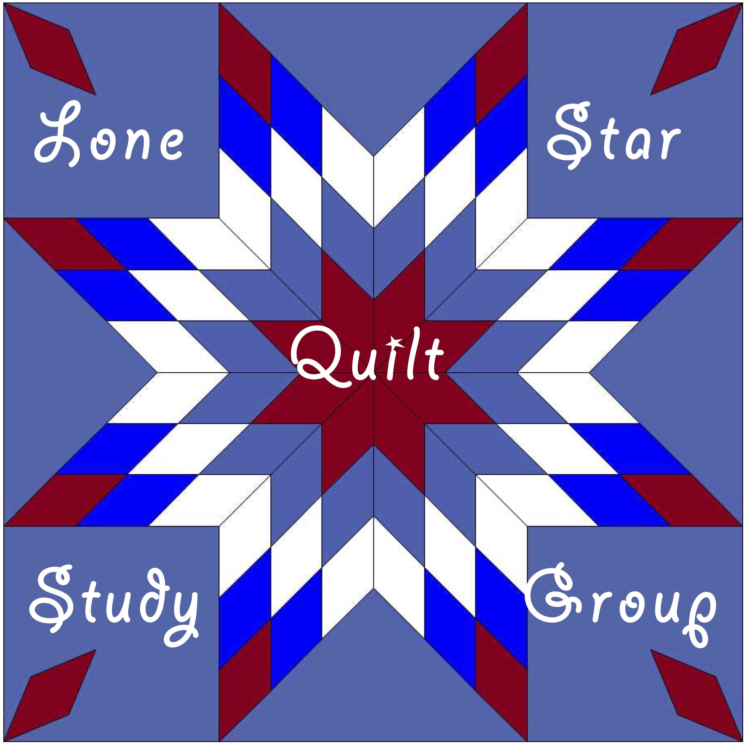
Lone Star Quilt Study Group
The Influence of the Business of Quilting
…the story of commercial quilt batting and quilt pattern development in the United States: who, why, how, when and where
Date: February 17, 2018
Time: 10:00 a.m. to 4:00 a.m.
Cost: $40.00 per person
Location: Georgetown Public Library, 402 W. Eighth Street, Georgetown, TX 78626
Topics: Mountain Mist: The Story and The Quilts
The Inside Story: History of Batting and Batting Manufacturers, Mid-1800s to Today”

Our first presenter, Marcia Kaylakie, is a certified quilt appraiser, collector, and author of Texas Quilts and Quilters: A Lone Star Legacy. She has done, and continues to do, extensive research on the Mountain Mist Corporation and the quilts inspired by its promotional efforts. She will describe how Mountain Mist® quilts and batting have played an integral part in the history of quilting in the United States since 1856, when the first commercial batting was created by Stearns & Foster (which later became the Mountain Mist company). Their influence on quilting history and the quilting industry played a prominent role in the practice of offering a full-size free pattern with the purchase of each batt and the development of a nation-wide quilt contest – the 1933 World’s Fair in Chicago, Illinois – practices which continue to drive the industry. Our February 2018 program will fill in the details on the development and growth of this company and their influence on the quilting industry. During her presentation, Marcia will display a representative sample of quilts from her personal collection.

Our second presenter, Linda Pumphrey, is an award-winning quilter, scholar and author who has spent her 25-plus year career in the quilting industry. Quiltmaking is a practice which goes back at least five consecutive generations in her family and includes her mother and grandmother. She is currently Senior Account Executive for Fibrix, LLC, makers of Mountain Mist batting, and is also an active member on several non-profit boards including the Quilts, Inc. Advisory Board and the International Quilt Association. She also works closely with the International Quilt Study Center & Museum, University of Nebraska-Lincoln as their Collections Coordinator.
Linda’s presentation will cover the beginning of the production of commercial batting in the United States and will include information on the Stearns & Foster Company and their competitors. She will also share details on market influences that affected the survivability of these companies and their influences on our quilting history.
⌘⌘⌘
Attendees are invited to bring examples of relevant quilts and ephemera from their own collections to exhibit and discuss during show-and-tell at the end of our meeting.

___ ___ ___ ______ ___ ___ ___ ___ ___ ___ ___ ___ ___ ___ ___ ___ ___ ___ ___ ___ ___ ___ ___ ___ ___ ___ ___ ___ ___ ___ ___ ___ ___
Complete the form below and mail it with your check for $40 to LSQSG c/o Lisa Erlandson, 1920 County Road 150, Gainesville, TX 76240. Capacity is limited and registration is not guaranteed until confirmed. Cancellation with refund will be allowed until February 1, 2018, less $5 administrative fee. No refunds can be made after February 1, 2018. Registrations are not transferable.

Name E-Mail

Address City/State

Zip Code Home phone Cell phone

Lunch will consist of 2 sandwich choices, salad, and brownies served buffet style. Please circle any special need(s): Gluten Free Vegetarian

This event is not affiliated with or sponsored by the Georgetown Public Library or the City of Georgetown

www.lonestarquiltstudygroup.org lonestarquiltstudygroup@gmail.com
LSQSG c/o Lisa Erlandson, 1920 County Road 150, Gainesville, TX 76240

