Grand Court of Wisconsin
Order of Amaranth Newsletter
Volume 14, Issue 1 November, December 2019/January 2020

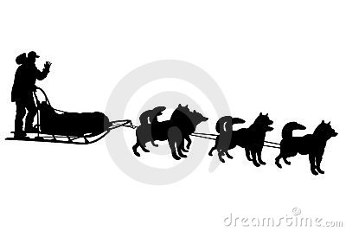

Message from

Grand Royal Matron

Betty Miller

I look forward to working with each you this year. Involve all membership.

In the activities of the Court. YOU may not be able to attend, but YOU can let others know what we are doing….MUSHING FOR FUNDS TO SUPPORT DIABETIES. Many of you can help pass the work regarding our ADF charitable work. We look forward to our Diabetes Coordinators Mary & Diana to some creative ways for us to earn funds.

Everyone needs to talk up our organization encouraging others to join us. S.K. LeRoy and I hope to help everyone make our meetings more meaningful.

One of the ways all members, not just the officers, can learn more about our order is to attend School of instruction Sunday February 23rd at noon, 2020. It is not too early to start putting dates on your calendar. Remember the Grand Lecturer’s visit is not a school of instruction. We would love to have everyone come. You get out of an organization what you put into it.

The holidays are coming soon. Be thankful for all you have. We have many members who can use our prayers for themselves or family members. Pause for a few moments to think of them. December is just around the second corner. Enjoy the holiday. Take time to be with family and tell them how much they mean to you via face to face, facetime, social media, phone, or slow mail. My best to everyone. STAY ON TRACK BY MOVING FORWARD.

Amaranth Love,
HL Betty Miller, GRM

Message from
Grand Royal Patron
LeRoy Kifer

Thank you for the privilege to serve this Grand Court once again as the Grand Royal Patron. I will do my best to serve.

Honored Lady Betty Miller and I will have more information coming soon for events that I hope you can attend and have some Amaranth fun.

Installations are on the horizon and I hope to see a lot of you traveling to these Installation and showing support to the other members of Wisconsin.

Make some calls and find out who might be going and carpool. Make memories and have some fun. Support one another. Let’s get back to what I remember when I first joined over 20 years ago.

Try and attend special events this year when you can. Try something different, you might have fun. I would not want to sit on the sidelines when I could participate.

I do know that Friendship Court will have an Initiation soon. I am not sure of the date but when that is decided, try and attend.

Wisconsin Grand Court is a smaller jurisdiction but we are mighty. We have what it takes to get the job done and have some fun doing it. Take part. Do not miss out.

I hope to see you on the Amaranth trial.

Respectfully yours,

SK LeRoy Kifer
Grand Royal Patron

Message from
Grand Associate Matron
Lila Kimball

H.L. Cheri Brus and S.K. Robert Miksch had a most exciting and fun session for Grand Court.

It is going to be another wonderful year with H.L. Betty Miller and S.K. LeRoy Kifer

I would like to thank the Grand Court for electing me, Grand Associate Matron and electing S.K. Dale Holman to serve along with me.

Please try to attend the other Courts to see how much fun we all have when we get together.

H.L. Lila Kimball, Grand Associate Matron.

Message from
Grand Associate Patron
Dale Holmen
What a fast week it has been and I have been caught off guard. One week into a new position and I have to write an article for the newsletter. My first day as the Associate Grand Patron started with two trips back and forth between the Madison airport and the Wintergreen in the Dells all before noon.
Then mid-week it was off to Illinois for their Grand Court. It is always interesting to see how Grand Court is handled away from home. Wisconsin was represented by five members and everyone seemed to be having a good time.
Now it will be time for our Court installations which I am planning on attending as of this writing. I do hope to see you all on one of these days.
As the Grand Associate Patron, it will be my job to head up our Ways and Means activities for the year and do we have some new and exciting plans for you. Keep an eye out for more details in our next issue.
I will start looking for bad jokes so I can keep up with the tradition. Until the next newsletter, have a great fall season and stay out from under all the leaves.
Dale Holmen, Grand Associate Patron
Message from
Grand Conductress
Amanda Grunewald

Welcome to another wonderful year in our Grand Court history. I can’t wait to see where this year will take us.

As part of the Ways and Means committee, it is our job to come up with some ways to raise funds to help with our operating costs. We’ve come up with a new fundraising idea for this year. Please keep an eye out for Sir Dale or I as we travel around the state.

We will see you all soon!!

Message from
Cheri Brus, PGRM

Hi everyone. I want to thank everyone once again for all the help, support and love I felt during my year as GRM. I enjoyed myself immensely.

I also want to take this time to tell you that I will be looking for items created by all the talented people for the ways and means table next October. I figure if I start letting you know now, you might find some things to make during the long cold winter months. Also it would be very helpful if you could price the items. That way if I don't see them until Grand Court I won't have to price them. Thank you very much and hope to see you.



Message from
Robert Miksch, PGRP

That was a quick year! I am sure it was that way because of H.L. Cheri. She needs to be commended on a great session. Thank to everyone who was supported her during her year.

I had numerous people ask me why I took “SKULLS” as my symbol. Mackey's Masonic Encyclopedia has three entries relating to the skull:

The first being "The Skeleton", which is simply a symbol for death used by the ancient Egyptians, which reminded them of mortality.

The second being the "skull", which it says "The skull as a symbol is not used in Freemasonry except in Masonic Templarism, where it is a symbol of mortality."

And, the third mention is that of the "skull and crossbones" which it defines as the following:

They are a symbol of mortality and death and are so used by heralds in funeral achievements. As the means of inciting the mind to the contemplation of the most solemn subjects, the skull and cross-bones are used in the Chamber of Reflection in the French and Scottish Rites, and in all those Degrees where that Chamber constitutes a part of the preliminary ceremonies of initiation.

I want to thank everyone again for a great year.
SK. Robert Miksch

Message from
Milwaukee Court No. 2
Lila Kimball, RM
Gene Hass, RP

Milwaukee Court will have their installation on Monday, November 4th there will be a meeting at 5:30 with Installation at 7:00. S.K. A. Gene Hass was elected to be Royal Patron this coming year.

December meeting is on Monday, December 2.

We wish H.L. Cheri Brus all the best.

Message from
Racine Laurel Court #6
LuAnn Hansen, RM
Gene Hass, RP

Racine Laurel Court #6: Installation on Sunday, November 24. 1:00 pm meeting, 3:00 pm installation.

Sunday, December 8: Breakfast with Santa at the Racine Masonic Center – 9:00 am to 12:00 noon.

Friday, December 13: Stated Meeting at 7:00 pm - Christmas meeting - wear Christmas colors. We are Dark in January and February.

March meeting will be Saturday, March 21 at 10:00 am with lunch to follow. This is our Grand Lecturer’s official visit.

Message from
Madison Court No. 7
Gail Piper, RM
Dale Holmen, RP

Is our Amaranth glass half empty or half full?

The elephant in the room right now that is mentioned at times but being ignored for the most part is the impact our decreasing and aging membership is having on our four subordinate courts as well as Grand Court. While that problem exists, in addition to taking action to build our numbers we need to celebrate the members we have and be glad when we have the required numbers to hold our meetings and to continue our important philanthropic work. Unfortunately, we are required to function according to Supreme regulations and ritualistic “guildlines” that set up big hurdles for us, such as requiring certain positions be filled by non-elected members, how certain ritualistic work is done, or requiring positions be filled by members of Grand Court, etc. etc. Sometimes we feel our resources are so very drained. But, as our Grand Royal Matron Betty Miller’s motto says, we must “Keep Moving Forward” and do the very best we can with what we have. One thing I’ve noticed with the declining number of members is an increase in the strength of bonding between those who are still with us and active. I know I speak for everyone when I say we are all appreciative of those who step up and assist, those who are so willing to say, “Sure! I can help you with that.” It makes our glass half full, for sure. The decision makers at Supreme Council know we are struggling and have taken some important steps to help (e.g. relaxing some requirements for membership to help us grow). We must have confidence in their willingness to address some of the other constraints put on us at the lower levels of the order.

Madison Court #7 will have a closed installation of officers at the regularly scheduled Saturday, November 2nd meeting. Light breakfast is at 9am; meeting at 10am. We hope to see members of other courts there that day, and we can really use some help covering the stations.

We have a regular meeting on Saturday, December 7th, are dark in January/February, and will be returning on Saturday, March 7th. This is our Grand Lecturer official visit.

In December Madison Court provides refreshments for the gatherings held after the Sunday morning church services at the William S. Middleton Memorial Veterans Hospital. We will be lining up volunteers to cover that at our November (and possibly December) meeting. Please consider volunteering to take refreshments on a December Sunday.
If you have any questions, please contact H.L. Gail Piper at 608-516-2098.

Message from
Friendship Court No. 14
Nancy Saggio, RM
Jamison Kifer, RP

Friendship Court installation was held on Sunday, November 3.

Saturday, December 14, 2019 – Our afternoon begins with lunch at 12:00 noon and our meeting at 1:00 pm. We will be performing the Initiation Ceremony for Christin Kifer. Please let Nancy Saggio, RM, know if you could assist in holding a station for this very important meeting. (From the Editor: I know square ladies are a high priority).

Friendship Court is dark in January and February.

DEADLINE FOR NEXT GRAND COURT NEWSLETTER IS JANUARY 20 FOR ALL EVENTS FOR THE MONTHS OF FEBRUARY, MARCH AND APRIL 2020.

Mush for Diabetes

On a separate attachment to this newsletter is a dog house.
Our Dogs are in the need of food.
During racing season It takes 1500 calories per day for each dog
Our team is 18 dogs. That is a lot.
Cut your dog house out of cardboard
Assemble, color it if you want.
Daily as you eat your meals give the dog
some coins to help buy his food.
We ask you bring your dog house of food to the August meeting or otherwise mail a check.

WE WANT EVERYONE TO MUSH FOR DIABETES

Message from
The Diabetes Committee
H.L. Mary Schultz and
H.L. Diana Kifer

Another new year in our Wisconsin Grand Court has begun and we have a few new ideas up our sleeves to raise monies for diabetes. Our GRM would like you to make a dog house and fill it with coins or dollars for diabetes. Monies need to be turned in to the Diabetes Committee by September 1.

We are raising monies for our GRP to model his new moose boxers that were presented to him at Grand Court. We have $80.00 raised so far. Maybe we could have a goal that for every $100.00 raised for the GRP boxers, the GRP needs to wear them visibly for the next Grand Court event that is planned. So the first event would be the School of Instruction/Leadership Training, the next event would be the GRM/GRP reception, etc.

Tentatively planned is Paint a Board project for diabetes on Saturday, March 14, 2020 at 2:00 pm in the afternoon before the Grand Lecturer’s visit at Friendship Court. Cost is $10.00 per board. RSVPs are a must as I have a limited about of boards. More details to follow in the next newsletter.

Message from
Sunshine Committee
Mary Schultz, Chairman

Honored Ladies and Sir Knights: Please contact me when you know of someone in our Wisconsin Grand Court family or other jurisdictions that may be in need of sunshine. I can be contacted at 414-526-2715 or greeneyesgerman@wi.rr.com.

Thank you to everyone for your sympathies on the loss of my mother, Marion Doerr. She worked very hard on Diabetes fundraising and her efforts will truly be missed.

Newsletter

Do you have an email address? Does the Grand Court know that you have an email address? If not, please let your court know. A suggestion at our last Grand Court session is to ask those members who receive the newsletter via the United States Postal Service to give a donation of $10.00 to help defray the costs of this newsletter. Please let me know if you have any questions.

The Humor Column
Submission from Robert Miksch
TAXI
I would like to share a personal experience with my friends and family about drinking and driving. This might save you the cost and embarrassment of being arrested for a DUI. As you know, people have been known to have unexpected brushes with the authorities from time to time, often on the way home after a "social session" with family or friends.

Well, this year, it happened to a me. I was out for the evening to a party and had more than several martinis coupled with a bottle of rather nice red wine. It was held at a great Italian restaurant. Although relaxed, I still had the common sense to know I was slightly over the limit.

That's when I did something I've never done before. I took a taxi home. On the way home there was a police DUI Check Point, but since I was in a taxi they waved it past and I arrived home safely without incident.

These roadblocks can be anywhere and I realized how lucky I was to have chosen to take a taxi.

The real surprise to me was I had never driven a taxi before. I don't know where I got it and, now that it's in my garage, I don't know what to do with it. If you want to borrow it, give me a call.

Submission from Gail Piper

The Turkey Shot Out of the Oven
(Sung to the tune of My Bonnie Lies Over the Ocean)

The turkey shot out of the oven
And rocketed into the air,
It knocked every plate off the table
And partly demolished a chair.

It ricocheted into a corner
And burst with a deafening boom,
Then splattered all over the kitchen,
Completely obscuring the room.

It stuck to the walls and the windows,
It totally coated the floor,
There was turkey attached to the ceiling,
Where there’d never been turkey before.

It blanked every appliance,
It smeared every saucer and bowl,
There wasn’t a way I could stop it,
That turkey was out of control.

I scraped and I scrubbed with displeasure,
And thought with chagrin as I mopped,
That I’d never again stuff a turkey
With popcorn that hadn’t been popped!

Amaranth Shirts

Orders may be placed by sending or giving me the Order form. You do not need to pay UNTIL your order is received. Proceeds will be shared between our Diabetes Foundation and Ways and Means. Logo will be on all shirts. Order forms are included with this newsletter. Available shirt colors: black, yellow, green and white. Prices are: Polo $35.00, long sleeve $25.00 and t-shirt $25.00.

Nancy Saggio
N5109 Oak Hill Road
Fond du Lac, WI 54937

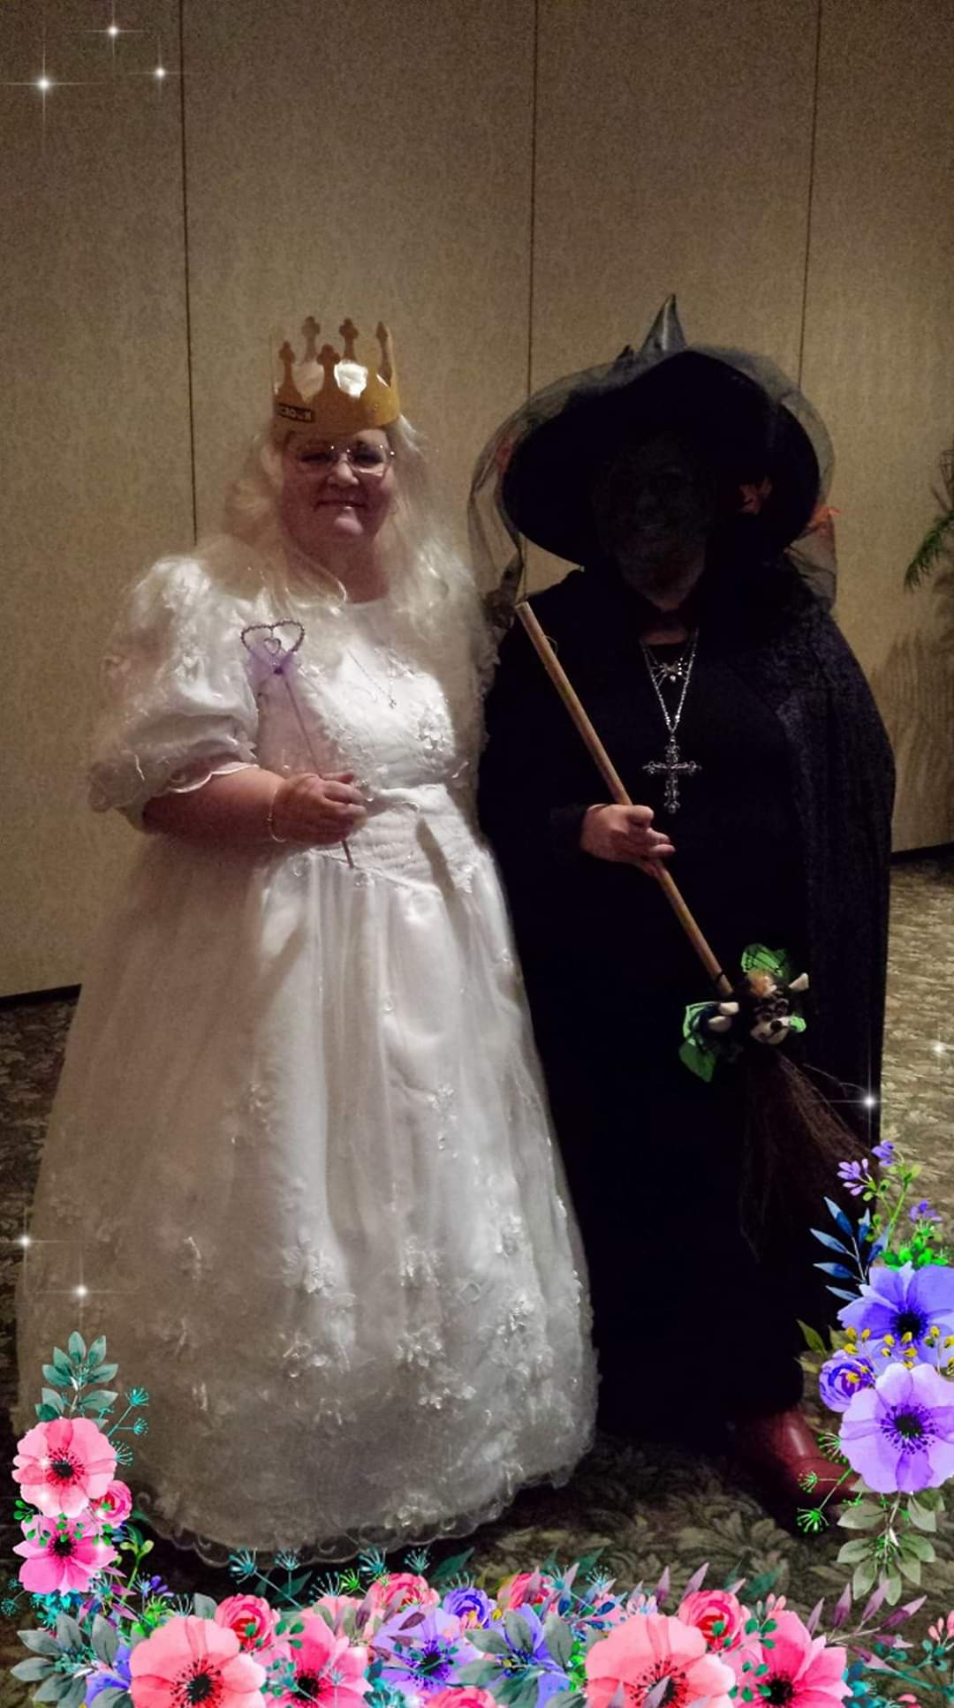

Message from Parker Dow, PGRP

Greetings Sir Knights and Honored Ladies

Please accept my absence at this last Grand Court as I was out of state with my bride at a different State's Grand Conclave. I wish the new Grand Royal Matron and Grand Royal Patron have an extremely successful year ahead - one for the record books. If there is something that the Grand Commandery Knights Templar of Wisconsin can do to help then please do let me know.

The Grand Commandery KT has its inspection season rapidly approaching

For your information here is the schedule
Inspections
11 Jan Div 2 Madison
25 Jan Div 4 Marinette
1 Feb Com 24 Milwaukee
8 Feb Div 1 Eau Claire
15 Feb Com 11 Oshkosh
22 Feb Div 3 Burlington

Thank you for your time and consideration

Parker Dow
Grand Commander

Dates to Remember

School of Instruction/Leadership Training
Sunday, February 23, 2020
Fond du Lac Masonic Center
Join us for lunch at noon
School of Instruction at 1:00 pm
Leadership Training at 2:00 pm

Grand Lecturer Visits
Milwaukee Court March 2, 2020
Racine Laurel Court March 21, 2020
Madison Court March 7, 2020
Friendship Court March 14, 2020

Grand Royal Matron and
Grand Royal Patron
Reception
Saturday, April 4, 2020

Grand Royal Matron’s Official Visit
Accompanied by the Grand Royal Patron
Milwaukee Court June 1, 2020
Racine Laurel Court May 8, 2020
Madison Court May 2, 2020
Friendship Court May 9, 2020

(Remember dates and times are subject to change)

Supreme Council Order of the Amaranth
Red Lion on the River Hotel
Portland, Oregon
July 5-9th, 2020

Grand Court of Wisconsin
Order of the Amaranth
Clarion Hotel & Suites and
Wintergreen Conference Center
Wisconsin Dells, Wisconsin
October 8-10, 2020

