HARBOUR ISLE EAST
Condominium Association, Inc.
c/o FirstService Residential Inc.
6A Harbour Isle Drive East
Fort Pierce, Fl. 34949
(772)595-3660 (772)595-8809 FAX
www.harbourisleeast.com
Julie.lynch@fsresidential.com

RENTAL APPLICATION INSTRUCTIONS:

1. Fill out application & background check forms completely (each applicant must complete a separate background check form). Submit all documents to Harbour Isle East Condo. Association, 6A Harbour Isle Drive East, Fort Pierce, Florida 34949, fax to (772) 595-8809 or email to Julie.lynch@fsresidential.com

Please allow 10 days for review and action to be taken by the Harbour Isle Condominium Association, Inc. There is a $100.00 Non-Refundable application fee payable to Harbour Isle East. Barcodes for Vehicles are $15.00 each.

2. This signed acknowledgement of the Rules and Regulations must be submitted along with the application, as well as, a copy of the lease agreement.

Every effort will be made to expedite the notification process.

3. All renters are required to attend a brief orientation prior to moving in to the unit.

ACKNOWLEDGEMENT

I agree to abide by the rules and regulations of the HARBOUR ISLE EAST CONDOMINIUM ASSOCIATION, INC. and am subject to the Declaration of Covenants of HARBOUR ISLE EAST CONDOMINIUM ASSOCIATION, INC. Failure to comply with terms and conditions thereof shall be a material default and breech of the lease agreement Owners are responsible for ensuring that all permits, approvals, and other rental requirements of the City are satisfied.

______________________________ _________________________________________
Lessee Lessee

Date:__________________________
HARBOUR ISLE EAST
Condominium Association, Inc.
c/o FirstService Residential Inc.
6A Harbour Isle Drive East
Fort Pierce, Fl. 34949
(772)595-3660– (772)595-8809 FAX
www.harbourisleeast.com
Julie.lynch@fsresidential.com

Rental Application

Name: _____________________________________________Phone: ______________________________

Name: _____________________________________________Phone: ______________________________

Bldg/Unit #: ________________________________________ Move-In Date: ________________________

Mailing Address: __________________________________________________________________________

Email Address/es: _________________________________________________________________________
________________________________________________________________________________________

Name of Owner: _________________________________________________________________

Name of Agent: ______________________________________Phone: _____________________________

In Case of Emergency:

Name: _____________________________________________Phone: ______________________________

Relationship: ________________________________________

Names and Ages of Children Living on Property:

______________________________________ ___________________________________________

______________________________________ ___________________________________________

Will anyone other than spouse or children listed above reside with you (if so, please provide names & ages):

______________________________________ ____________________________________________

Driver’s License #: _____________________________ ________________________________________

Do you have any commercial or recreational vehicles (boats, campers, trucks, trailers, or paneled vans)? ___

THESE VEHICLES ARE NOT ALLOWED TO BE PARKED OVERNIGT ON ANY COMMON ELEMENTS!

TENANTS ARE NOT ALLOWED TO HAVE PETS

HARBOUR ISLE EAST
CONDOMINIUM ASSOCIATION, INC.

Approved Guest List
Guests that visit you regularly that you want to allow to enter without having to contact the guard.

________________________________ ____________________________________

________________________________ ____________________________________

________________________________ ____________________________________

________________________________ ____________________________________

________________________________ ____________________________________


SECURITY DATABASE FORM

New Renter Barcodes cost $15 each

Please bring cash, check, or money order
BUILDING NUMBER_____UNIT NUMBER_____

RENTER NAME (LAST) __________________________ (FIRST) ________________
PHONE NUMBER_______________

RENTER NAME (LAST) __________________________ (FIRST) ________________
PHONE NUMBER_________________

LEASE DATES______________

VEHICLE 1 VEHICLE 2________
MAKE____________ MAKE___________
MODEL__________ MODEL__________
COLOR__________ COLOR__________
TAG #____________ TAG#____________
STATE____________ STATE___________
BARCODE #__________ BARCODE #_________

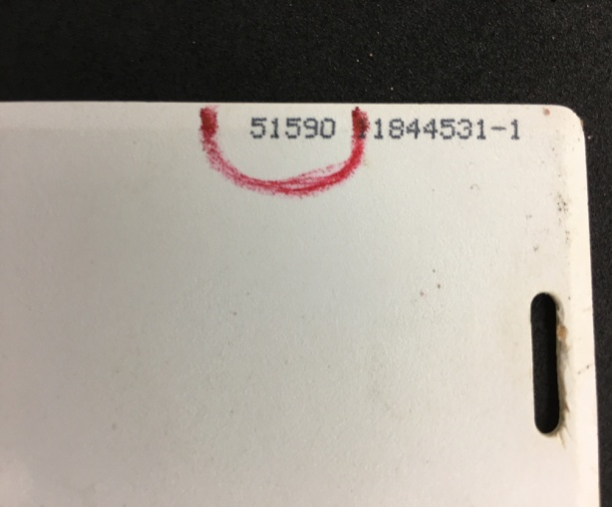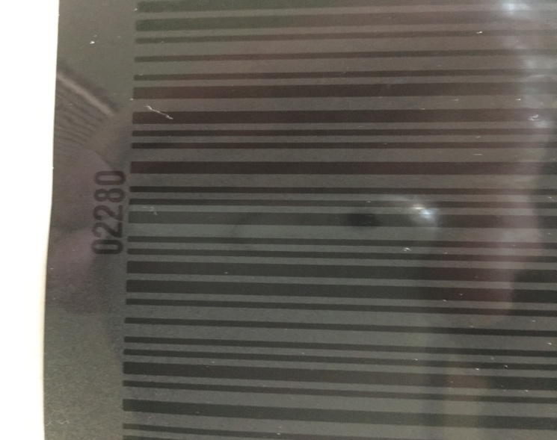
5 DIGIT SWIPE CARD#____________
5 DIGIT SWIPE CARD #___________


