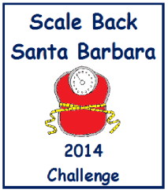
How to Register
Official Registration Information
Send the following information to
ScaleBackSB@gmail.com
Register: E-Mail the following information to ScaleBackSB@gmail.com anytime during the challenge.
1. Name of your team Example: Buff Bodies 2. Number of participants Example: 3 Participants
Finish: E-Mail the following information to ScaleBackSB@gmail.com at the end of the 10 week challenge between March 30 and April 13, 2014.
1. Name of your team Example: Buff Bodies
2. Total Number of pounds lost Example: 18 Pounds
Name of Weigher (Optional) _______________________________________________________
E-Mail (Optional) ________________________________________________________________
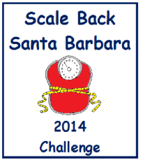
Unofficial
Participant Weigh-In/Weight-Out Registration Form
(Keep this form for your PRIVATE records.)
Weigh-in challengers between January 20 – February 2, 2014 or anytime during the challenge.
Weigh-out challengers between March 31 – April 13, 2014.
 | Date In | Date Out | Name | Starting  Weight | Ending  Weight | Weight Lost
1
2
3
4
5
6
7
8
9
10
 | Date In | Date Out | Name | Starting  Weight | Ending  Weight | Weight Lost
11
12
13
14
15
16
17
18
19
20
21
22
23
24
25
26
27
28
29
30

