**Naunton AGM Local Police Report**

**Spring 2017**

Number of incidents reported to police over a twelve month period

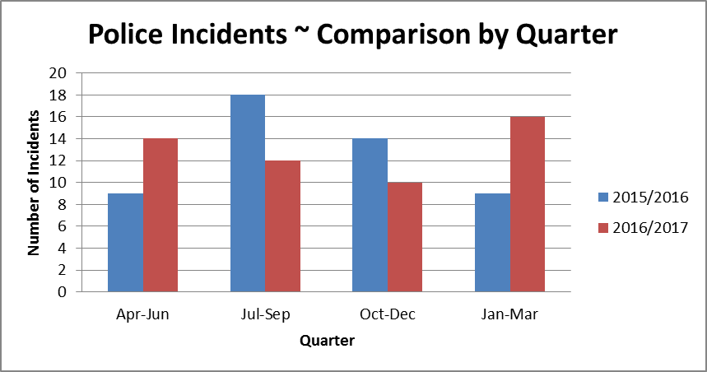

Breakdown of incidents by type reported to police over a twelve month period

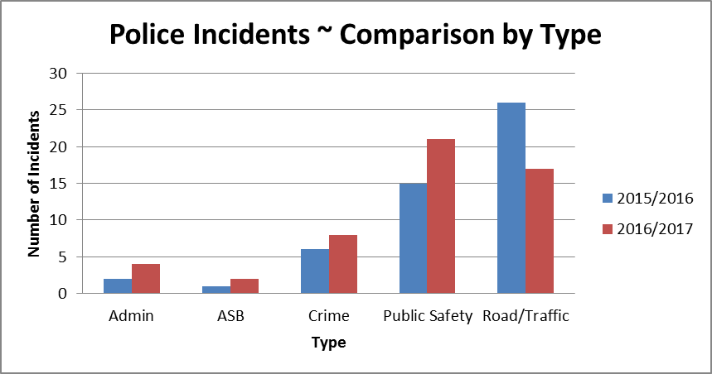

Breakdown of incidents related to crimes dealt with by police over a twelve month period

|  |  |  |
| --- | --- | --- |
| **Type of Crime** | **Apr 15 / Mar 16** | **Apr 16 / Mar 17** |
| Burglary dwelling | 1 | 1 |
| Burglary non dwelling | 1 | 2 |
| Crime - other | 0 | 1 |
| Theft - other | 3 | 2 |
| Theft from motor vehicle | 1 | 1 |
| Theft of motor vehicle | 0 | 1 |
| **Total** | **6** | **8** |

**PTO**

|  |  |  |
| --- | --- | --- |
| **Admin**   * Complaint against police * Lost or found Property or animals * Messages inc. press release * Police generated resource activity * Pre-planned event | **Public Safety**   * Alarms ~ Personal, etc. * Animals/Wildlife * Awol/abscond from hmp * Civil dispute-not btw neighbours * Concern for safety * Domestic incident - non crime * Missing Person * Susp. Circs./Insecure veh./prems. | **Road/Traffic**   * Highway disruption * Road related offence * RTC Death / Injury * Rtc_damage only(inc animal rtcs) |

***We will not be able to attend every meeting we are invited to and on some occasions may have to cancel meetings providing little or no notice due to the nature of Emergency service demands. We will however always provide a Police Report which is designed to provide clear and simple information which can be shared with all those present at the meeting.***

***If questions are raised by those present please note the email addresses of both Beat Managers and PCSOs covering your area. We will be happy to address any concerns you have or that are raised during the meeting.***

***We will endeavour to attend as many meetings as we can but the new format of police Report combined with an up to date list of contact details will be provided for occasions we are not present.***

PCSO 9050 Adrian Palmer

[Adrian.Palmer@gloucestershire.pnn.police.uk](mailto:Adrian.Palmer@gloucestershire.pnn.police.uk)

PC 2285 Richy Webb

[Richard.Webb@gloucestershire.pnn.police.uk](mailto:Richard.Webb@gloucestershire.pnn.police.uk)