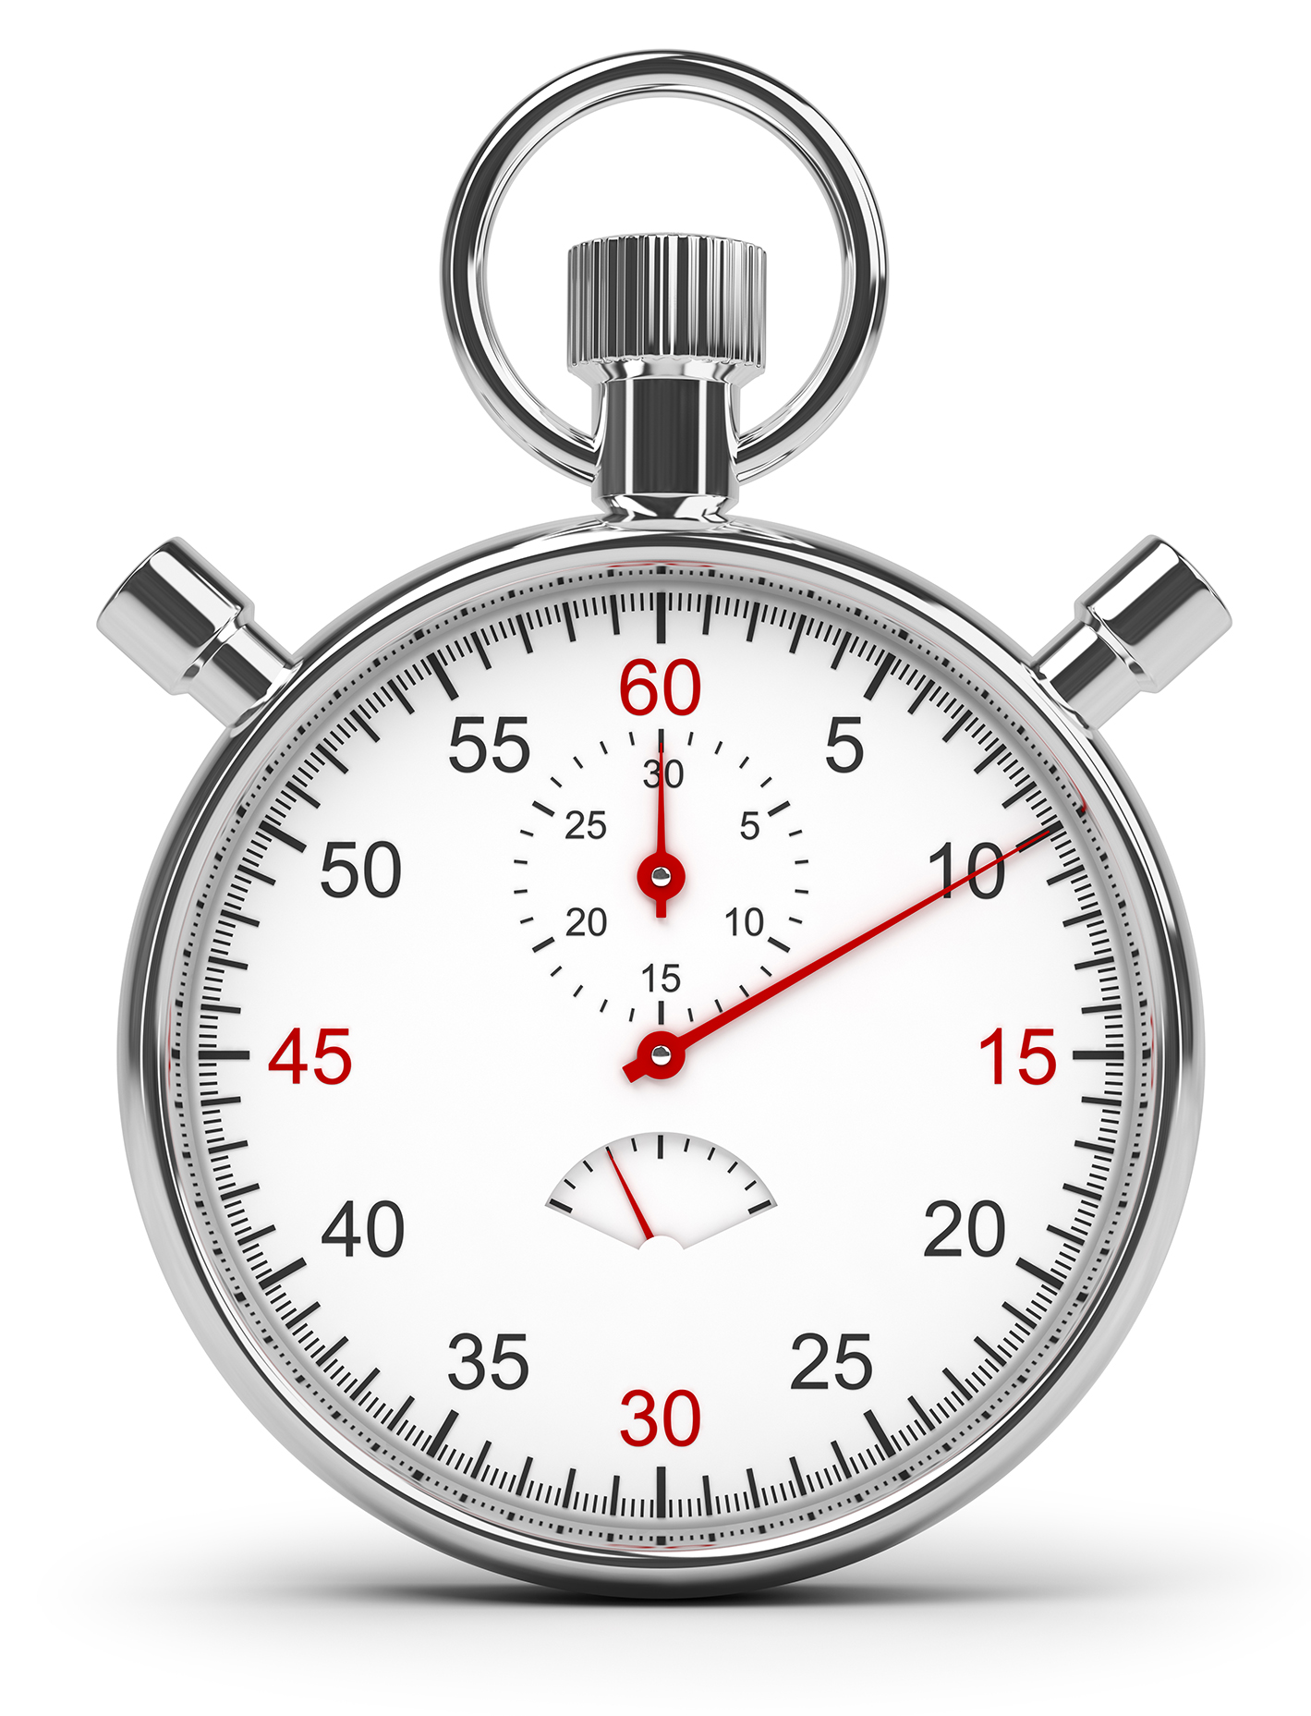

Just part of your comprehensive wellness program. Find out more at www.empowerlinc.com or call a health coach today at 888.882.LINC (5462).



Ubeat

a proven approach to better heart health

WILL U

FIND OUT WHAT

MAKES YOU TICK?