2024 BCMW SCHOLARSHIP PROGRAM
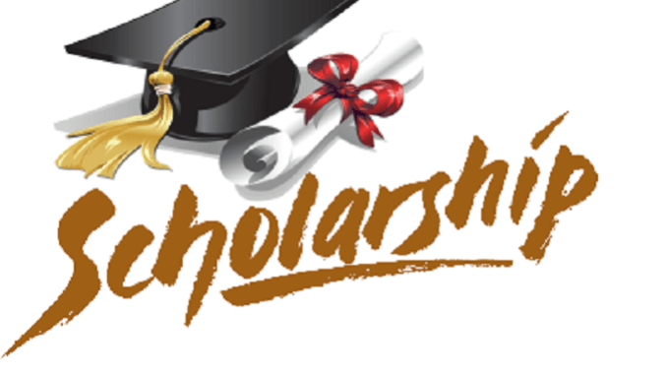


BCMW Community Services Block Grant will be awarding 5 - $1,000 Scholarships to residents who meet our criteria in our servicing counties of Bond, Clinton, Marion and Washington

Award recipients may use the scholarship award for education expenses and payments will be sent directly to the college/university.

Eligibility Criteria will be based on:

- Income
- Grade Point Average
- A 100-200 Career Goals Statement
- Three letters of recommendation
- Interview with the Scholarship Committee

APPLICATIONS MAY BE PICKED UP AT:

BCMW COMMUNITY SERVICES
909 E REXFORD
CENTRALIA, IL 62801

www.bcmwcommunityservices.org
or
BCMW Outreach Office in the county you reside.

Applications available March 1, 2024 thru March 29, 2024

For further information, contact Liz Garner at 532-7388, ext.146 or liz.garner@bcmw-il.org

