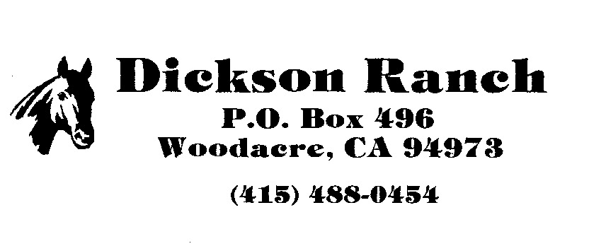
INSTRUCTION RELEASE

Dawn Ellen Ramsier D.B.A. Dawn Ellen Enterprises
Steven Pleasant D.B.A Pleasant Riding
______________________________________________________________________________

I have contracted for riding lessons from Dawn Ellen or Steven Pleasant or any assistant that may be working with Dawn Ellen or Steven Pleasant for me or my child or ward. I am fully aware of the DANGER involved in the riding and handling of horses. I realize that horses are sometimes unpredictable and strong and could cause injury to me or my child or ward. I realize that unknown accidents could occur to myself or my child or ward falling off while riding or a horse falling during a lesson.

FULLY RECOGNIZING THESE DANGERS AND OTHERS, I ASSUME ABSOLUTE RESPONSIBILITY FOR ANY AND ALL ACCIDENTS OR INJURIES THAT MAY OCCUR WHILE I OR MY CHILD OR WARD ARE UNDER THE INSTURCTION OF DAWN ELLEN OR HER ASISTANT OR WHILE ON DICKSON RANCH PROPERTY IN WOODACRE, CALIFORNIA.

I hereby release the Dickson Ranch, Chalmer Tolson and or Grace Tolson and all other owners, Dawn Ellen or Steven Pleasant, all other instructors, employees, or volunteers or and from all claims which may hereafter develop or accrue to me on account of, or by reason of, any injury, loss or damage, which may be suffered by me or to any property, because of any matter, thing or condition, negligence or default whatsoever, and I hereby assume and accept the full risk and danger of any hurt, injury or damage which may occur through or by reason of any matter, thing or condition, negligence or default of any person or persons whatsoever.

* Please note: the above paragraph is a copy of a release which held in court in December of 1991

Signature: _______________________________________________ Date: _________________________

Name (printed): _________________________________________________________________________

Address: _______________________________________________________________________________

_______________________________________________________________________________________

Home Phone: ______________________________________ Work: _______________________________

Cell Phone: ________________________________________ Other: _______________________________

Email Address: __________________________________________________________________________

Name of Child (If applicable): __________________________________________________________

Emergency Contacts:

1. Name: _________________________________ Phone: ____________________________________

2. Name: _________________________________ Phone: ____________________________________

