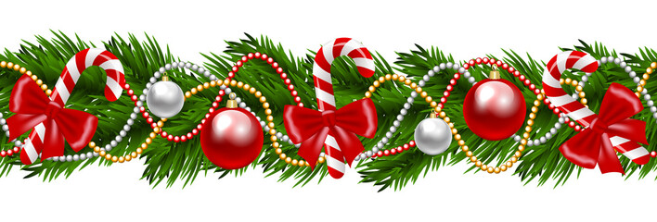
Christmas is Coming!!!

Come join us for the 2022 NCMOM Convention!!
November 4-5, 2022
Clemmons, NC
Hosted by TCMOMs

