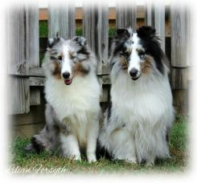 | The Sheltie Seanachie  May - June 2021  www.potomacvalleyshetlandsheepdogclub.org  The Potomac Valley Shetland Sheepdog Club, Inc.  Serving the Greater Washington Metropolitan Region (DC-MD-VA) since 1972

PVSSC 2020 OFFICERS
Cathie Skoog, President
Jack Gurney, Vice President
Fran Beacham, Recording Secretary
Nancy Penn, Corresponding Secretary
Donna Richards, Treasurer
Members of the Board
Patrick Keough Sandra Green
NEXT MEETING
May 17, 2021
ON LINE
TOPICS IN THIS ISSUE
Page 2-3: Brags! & Links
Page 4: Product Recall
ASSA National Winners
Page 5: Making Your Dog Throw Up!
Page 6: Yard Design
(with dog-friendly features)
Page 7: Grooming your Sheltie Page 8: In Memory of Carol Howell Page 9: Trick Evaluations

PVSSC EVENTS:
Specialty Show
PVSSC
Going Virtual for
Meetings
and Socials
The PVSSC Specialty Show will take place as part of the Mattaponi Kennel Club Cluster at Meadow Event Park in Doswell, VA on Friday July 2.
Join us online for our Zoom Meeting on Monday, May 17 at 7:30pm, when we will begin our business meeting, followed by Guest Speaker, a representative from AKC Pet Insurance.
This event will be held indoors.
Due to COVID, spectators might not be able to attend, unless there are changes.
13191 Dawn Blvd, Doswell, VA 23047
We hope you will be able to join us. Below is information to access the meeting via Zoom. If you have any questions regarding accessing Zoom, contact Jack Gurney or Cathie Skoog - or email us at PVSSC.Shelties@gmail.com
Topic: PVSSC General Membership Meeting Time: May 17, 2021 07:30 PM Eastern Time
Join Zoom Meeting
https://us02web.zoom.us/j/83400395115?pwd=TlhMRU xFaHVwck0rcVRnOXNa WTZqZz09
Herding Trials and Tests
PVSSC will be hosting 2 Herding Trials and
Tests at: Keepstone Farm on Saturday,
November 6
PVSSC Walks
PVSSC plans to offer group walks with our Shelties on the last Saturday of the month when possible. Our first walk was on March 27 led by Donna Richards in Reston, VA. The April Walk was cancelled due to weather. Stay tuned for more information on future walks!

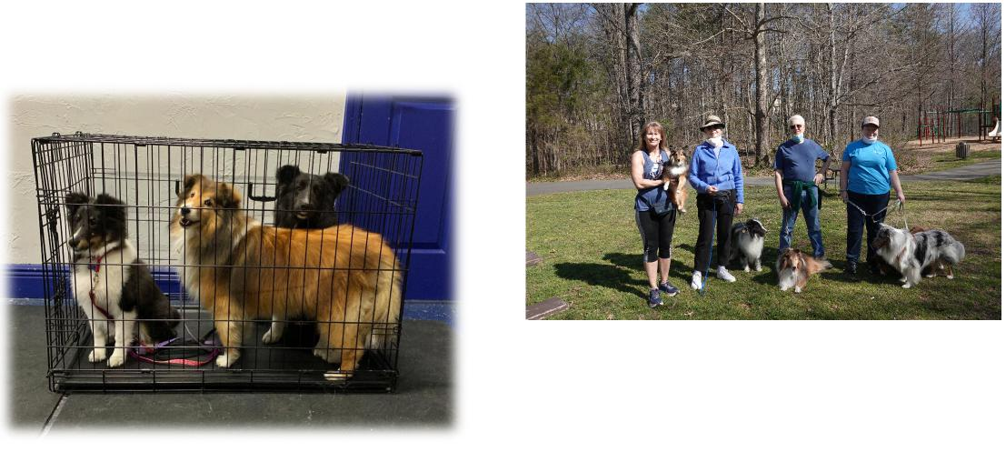
BRAGS!
PVSSC members Nancy Penn with Dusty, Donna Richards with Prince, Jack Gurney with Rosebud and guest Dayna Draeger with Johnny (blue) and Bennett (sable) enjoyed a morning walk on wooded paths in Reston VA on Saturday March 27.
Monday, May 3 was the FIRST day of class for Ashley, where she is attending AKC S.T.A.R. Puppy Training at Bratty Paws in Punta Gorda, FL. It was also a first day of Scent Work for Annie. Savannah returned for her more extensive Scent Work Training.
(Shelties owned by Cathie and Mike Skoog)
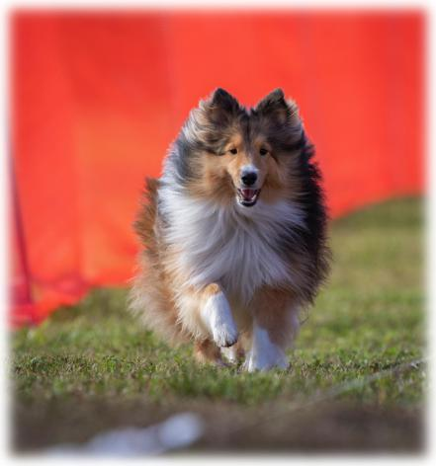
Marilyn Manser and Rich Gurney’s boy Callum participated in his first Fast CAT event, held in Fort Myers, FL, by the Greater Fort Myers Dog Club on March 19. They want to thank Cathie Skoog for alerting them to this activity and to Mike for releasing him. Callum first wasn’t sure what he was supposed to do, but after that false start completed the course with glee. He ended up achieving a speed of about 20 miles/hour, which is middling for a sheltie and good for his first effort.
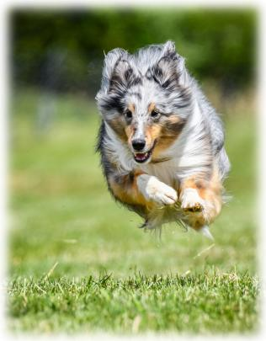
Nancy Hansbrough’s Archer received her BCAT title on April 23 during the Warrenton Kennel Club FCAT trials. Here is a picture of her in action and one with her ribbon.
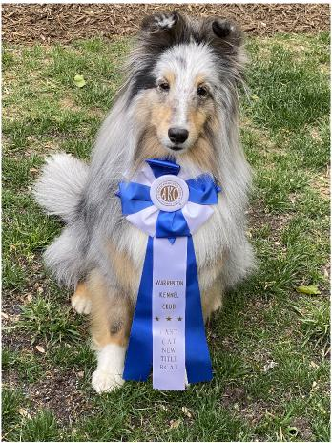

Patches and Nancy H. passed the Pet Partner team evaluation on April 25 so Patches can be a Therapy Dog. Just a few more steps and Patches will be ready for the library to open so children may read to her as part of the Woof and Paws Program.
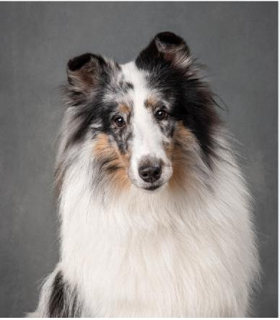 | More Fast CAT Brags!
 | 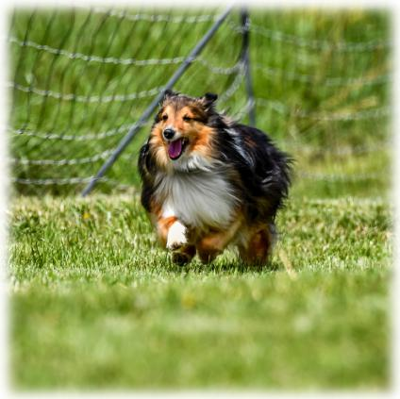
Dusty’s 2nd competition for Fast CAT at Warrenton Kennel Club. Nancy Penn ran the 100yds first to get Dusty to see where she went and would be.

Patches' birthday is May 21 and Archer's birthday is May 30.
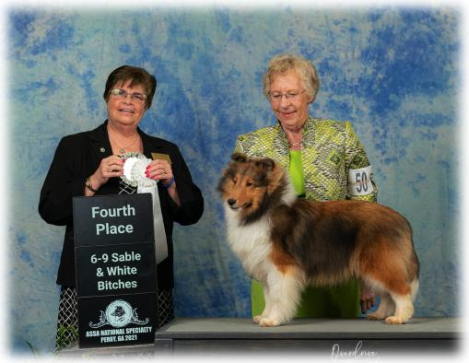

Eevee (Fairbrook Belmar Esperanza) placed 4th in the 69 month Sable & White Puppy Class at the 2021 ASSA National Specialty Show. There were a total of 7 puppies in the ring and handler Zana Friend showed her for co-owners Lilian Yeh Forsyth (club member) and Linda G. (Belmar Shelties). Eevee was a little naughty trying to bite the leash and take Zana for a walk in the ring!
Eevee is sired by GCH Kell Right Now x Blue Heavens Call Me A Dreamer and just turned 8 months. She is Lilian’s first home-bred to be entered at a National.
We were informed that Nancy P. ran faster than the Basset Hound. Job well done, Nancy!
LINKS
Coursing Sports: https://www.akc.org/sports/coursing/ Fast CAT: https://www.akc.org/sports/coursing/fast-cat/
ASSA:
https://www.americanshetlandsheepdogassociation.org/

PVSSC BREEDER REFERRAL
PRODUCT RECALL

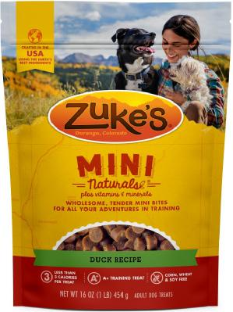
Looking for a Sheltie?
For information on obtaining a Sheltie, contact PVSSC members Jan Stanley or Doey Blount. They will work to find you the Sheltie that is right for you and your family!

Contact:

April 30, 2021 — Zuke’s has voluntarily removed its popular Zuke’s Mini Naturals Dog Treats from retail stores due to “a potential quality issue”.
Zuke’s reported “At this time, we are proactively and voluntarily removing our Zuke’s Mini Naturals products from sale due to a quality issue.
Zuke’s is a natural product, which uses a natural preservation system. We have identified a product quality issue during recent production with instances where the natural preservation system may not be working as effective as it should. While not a food safety issue, we are proactively and voluntarily removing Zuke’s Mini Naturals from sale because we want pet parents to continue to have the best experience with our products.
“Since this step is being taken due to a quality issue, we are not asking pet parents to return the product. If you are not completely satisfied with your Zuke’s purchase, we are always happy to issue a refund. Please reach out to our Pet Parent Relations team.”
ASSA National Specialty Show
This year’s winners:
Best of Breed - GCHS Rosmoor Afterglow
Best of Winners and Winners Bitch - Laureate Diamond
Is Forever
Best of Opposite Sex - CGH Mystic Suntime Everclear
Select Dog - GCHS Solange Valedictorian
Select Bitch - GCHS Solange Viva La Vida
Winners Dog – Sandy Isle Californication
Here are the photos from the show photographer:
https://imagestore.ovrdrvmedia.com/
Jan Stanley: 703-281-2828
SheltiesReign@gmail.com
or
Page 4
Doey Blount: 301-567-3933
jimjandoey@aol.com
THE SHELTIE SEANACHIE
The Sheltie Seanachie will be published bimonthly. Email brags and other items for the newsletter to Lilian at theleafstudio@gmail.com
The Newsletter is sent to members and friends preceding the meeting. Back issues of The Seanachie are available on the PVSSC website:
www.potomacvalleyshetlandsheepdogclub.org
New CONTACT Information???
Let PVSSC know if you have a new email address, or any other changes. We want to make sure you don’t miss a single issue of The Sheltie Seanachie.

Make sure your contact is current.
Send any changes to the Corresponding Secretary at PVSSC.Shelties@gmail.com

Making Your Dog Throw Up!
Page 5
(Submitted by Cathie Skoog: A Life Lesson from A Friend’s Experience)
You may ask, why would I want to make my dog throw up? What if you just saw your dog eat a sock? Or, what if your dog eats an entire box of raisins? And everything a puppy sees goes into its mouth.
Thank goodness I’ve never had to induce vomiting in any of my dogs and I hope I never do. However, a couple of months ago, one of our members related a horrible situation when one of her Shelties ate a sock and she induced vomiting. She told us about administering hydrogen peroxide to induce vomiting.
I thought this was something good to know in the event of an emergency - I keep hydrogen peroxide on hand ever since Savannah chased a skunk!
Several months ago, Carole, a friend of mine from Virginia, posted on Facebook about her Libby. Libby was seriously ill and in the ICU. BACKGROUND: Libby is a healthy Jack Russell who is active in agility, rally, Fast CAT and other activities. Carole is a veterinarian.
Recently Carole posted why Libby was in ICU. Carole wrote “I had given her hydrogen peroxide to vomit something I thought she got into. I have used it on every dog (some dogs more than once!) I have ever had and recommended it to many clients.”
The hydrogen peroxide “caused bleeding ulcers to where the anemia was so bad she needed a blood transfusion. People largely ignore the warning that it can cause esophageal, gastric, and duodenal ulcers. I used to be in that camp.”
Apomorphine is a drug that safely induces vomiting. Thinking of her patients, she immediately ordered it for her practice. Shortly after receiving the apomorphine, a six month old Lab ate a sock and she immediately administered the drug. Carole wrote, “and 10 minutes later his breakfast and the offending sock came up! I was never so happy to see a dog vomit than this!”
A big THANK YOU goes to Carole for posting her experience on Facebook and granting permission to share her experience with us. And I thank the stars that I happened to see her post, since I am rarely on FB. Carole’s experience started me doing research and to share the information so you can make INFORMED decisions when dealing with the health of your dogs.
Many of us go to the AKC (How to Make a Dog Throw Up, AKC) or PetMD (How to Make a Dog Vomit | PetMD) websites for quick guidance on “what to do”. Both of these websites recommend using hydrogen peroxide 3% solution to make a dog throw up. The AKC recommends keeping a bottle in your dog’s First Aid Travel Kit. PLEASE read the entire articles because further down are the warnings.
I highly recommend reading the report: Hydrogen Peroxide Induced Encephalopathy, Veterinary Referral Center of Colorado, called “Loosing Your Lunch” at Enducing your Dog to Vomit, VRCC. This article also discusses other home remedies some use, such as Ipecac Syrup and even Table Salt.  Important take-aways from the VRCC article:  - Veterinarians usually use one of two medicines to make animals vomit – Apomorphine or Xylazine. Apo has about a 90% success rate in dogs. Veterinarians also have another drug to counter the effects of the Apo to stop the vomiting if needed.  - About 20 minutes after the animal has vomited, activated charcoal is administered for patients who got into a toxic substance. The activated charcoal helps to absorb more of the toxin since on average only about 70% of the toxin is vomited up – another reason to at least end treatment with your veterinarian if you choose to try one of the at-home remedies. | 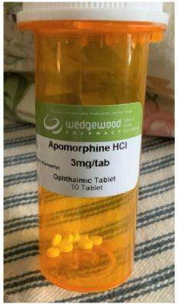

YARD DESIGN WITH DOG-FRIENDLY FEATURES
Page 6
(Submitted by Donna Richards)
Here are a few ideas gleaned from the Internet as well as personal experience...
- Synthetic grass is useful if you just cannot get grass to grow naturally and need a spot for play or elimination.
Synthetic grass can be washed and dried. XGrass is a brand I see being advertised a lot.
- Ground covers are a nice alternative to grass. I find that mazus spreads readily and greens quickly in spring, blooming in April. Shown here with my first Sheltie Max.
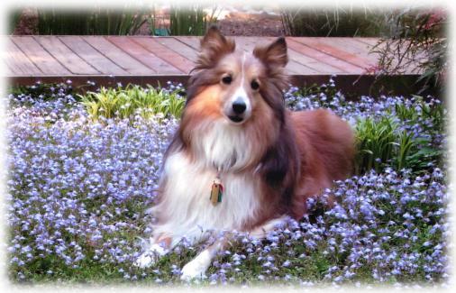
- Fragrant plants can be used to mask odors. In addition to flowering bulbs, perennials and shrubs, think about evergreens such as juniper and pine. Juniper has many uses and juniper berry oil used in diffusers may even repel insects. https://www.rootwell.com/blogs/juniper-bush
- If you have a lot of flowering plants and shrubs in your yard then bees (the good kind) can be a problem. Be prepared to avoid those areas when necessary. I read on a bee forum that foraging is most active from 11 am to sunset. I visited the Bluebell Trail at Bull Run Park with Prince around 10 am one morning and noticed that the bee activity (lots of flowers!) increased a lot as the air warmed. We finished our walk before noon, so the timing was good even if not intentional for that reason!
- Unfortunately, yellow jackets are also common in our area and those stings hurt a lot. They are known to make nests in the ground but also wood piles, dense vegetation, utility sheds and other enclosed spaces. If you think there is a problem, do the research carefully or get professional help.
- Ticks can be reduced by creating a 3-ft wide barrier of wood chips or gravel between lawns and wooded areas. The “Tick Management Handbook” by Connecticut Agricultural Experiment Station has good advice and ideas for yard planning. https://portal.ct.gov/-/media/CAES/DOCUMENTS/Publications/Bulletins/b1010pdf.pdf?la=en
- Shade and cool surfaces will be appreciated in summer. If you have ever seen outdoor “cooling stations” for people at public events, the same thing is available for pets. This article reviews 5 different mist cooling systems for dogs (and larger animals.) https://topdogtips.com/best-misting-cooling-systems-for-dogs/
- Ground covers with a lot of leaves also promote “evaporative cooling”. I have English ivy in my yard and know that the temperature in the ivy is several degrees cooler than over other surfaces such as wood chips. The University of Florida says that strategically placed trees and shrubs can create areas 9 degrees cooler than surrounding air temperature.
- You will also want mosquito protection so you can enjoy your yard also. Commercial garden centers are offering monthly mosquito control services. But I don’t want my yard treated with chemicals and just want to cover a small area for occasional sitting or dining. I am using Mosquito Guard repellent teal light candles with citronella and other ingredients as well as an older Thermacell mosquito lantern. Thermacell has introduced a lot of new products that may be even more effective but at higher cost. There are also economical mosquito “coils” which are basically incense shaped as a coil to be burned in a ceramic dish and last for hours. These are readily available in summer at stores such as Home Depot.
- Don’t forget the water. Some dogs prefer running water, and pet fountains are available. Bowls and fountains should be cleaned regularly.
Enjoy your yard!

GROOMING YOUR SHELTIES

Shelties are not as high maintenance as you may think, considering they are a double-coated breed. But it’s important to brush them correctly.
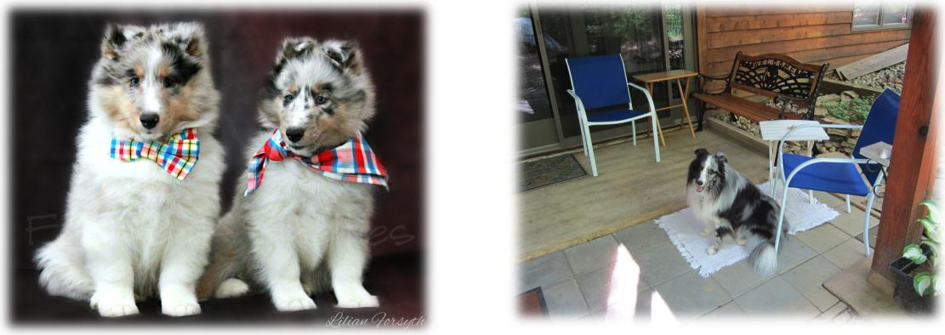
Page 7
Here are some YouTube videos on how to make your Shelties look their best!
Line-brushing Video: https://youtu.be/TRmsuoe6z6s
The following video links are Grooming & Trimming Show Shelties, but you can also apply some of techniques (and skip others) for your pets:
Part 1 https://youtu.be/3eZYZh6qL8w Part 2 https://youtu.be/L-0XTyT3Lk8 Part 3 https://youtu.be/CVCnvu2kks4
Nail maintenance and oral hygiene are also very important! There are different products in the market to help against the formation of plaque and tartar buildup. Here’s a product that was mentioned in the last Club meeting...Naturel Promise Fresh Dental Teeth Clean Gel, but there are other brands as well:
Prince (owned by Donna Richards) watching over “his” under-deck patio...he has been enjoying playing with Jordan (GCH Kell Right now, owned by Lilian Yeh Forsyth), who has been “on vacation” at Prince and Donna’s place (see Photo on Page 9).
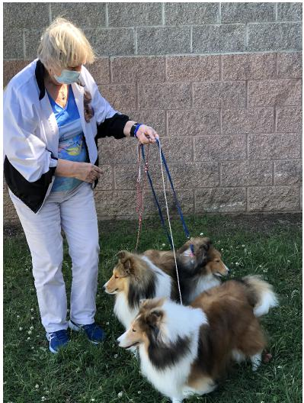
Front to back: GCH Milestones Cool Summer Wind “Windy” (who won Veteran 9 year and under 12 Bitches Class at the ASSA National this year) with her grandson CH Milestone Winslow Skywalker “Jedi” and her daughter Milestones Can’t Touch This “Envy” (pointed) with Diane Miles, their breeder. Jedi is owned by Debbie Lauritzen, our Club’s former member and Specialty show chairman.

In Memory of Carol Howell
JadeMist Shetland Sheepdogs
Page 8
It is with a sad heart that we learned of the passing of Carol Howell on May 11, 2021. It is no exaggeration that Carol brought joy to thousands of people through her shelties. She was a premier breeder of sheltie champions and for the longest time, it seemed every sheltie in the Metro DC area was from Carol’s breed bloodline, JadeMist.
For those of us who have been around for a while, you would always see Carol in the front row at the PVSSC Specialty Shows and at the ASSA National. She knew all of the breeders and handlers and watched the shows with great interest.
Carol was a member of PVSSC and later received an Honorary Membership for her years of contributions to PVSSC and its members. Every year she assisted with judge selections for our shows. And she mentored hundreds of people who wanted to enter the world of breeding shelties, including PVSSC member and breeder, Linda McClure.
Carol Howell, from a posted
photo on Facebook

Linda recalls, “I met Carol through a phone call I made nearly 30 years ago while searching for a local sheltie breeder. By chance I found “Jade Mist” listed in the Nichols book on shelties that had a section devoted to various breeders. We didn’t meet her until we came out to select a puppy and take Sandy home. I found her to be very approachable, friendly, and extremely willing to share her vast knowledge about shelties that she had accumulated after many years of being a breeder and a champion of the breed.”
Carol found joy in making people happy through her beautiful dogs and once you owned a JadeMist sheltie, you were part of Carol’s family. She truly wanted to find the perfect match between new owner and puppy – she didn’t want to just “make the sale.”
Carol had high standards but was very fair and could easily size up people. She was an extremely loyal friend of several PVSSC breeders and sheltie owners. She had a real problem telling people “no” even if they sometimes took advantage of her kindness and generosity. There were times when breeders fell “in love” with one of her dogs and even though she wanted to keep the dog she would end up co-owning or selling it out right because she wanted to make people happy.
Carol was willing to sell Linda Jade Mist Vangard (Vandy) so she could take the next step in her development as a sheltie owner. Vandy was Linda’s first show quality dog. Carol encouraged Linda and cheered her on and when Linda was ready for the next step, Carol was there to mentor her as a breeder.
Linda said “Carol guided me by imparting knowledge as to what dogs would be a good match and took care of the actual breeding. The help didn’t stop there as she was always at the ready to help with any pregnancy or whelping questions. I could always call in the middle of the night to have her assist me with a whelping ‘misadventure’ and was happy to do so.”
Carol had 1,968 Facebook friends. And she knew every one of them and would send out “congratulatory” notes when someone posted a success, even if the dogs weren’t from the JadeMist bloodline. And, she sent words of comfort when a “friend” lost a dear sheltie. Carol cared about everyone.
In my mind I can see thousands of shelties running to meet Carol at the Rainbow Bridge. And Carol acknowledging each one by name and she gives each a big hug.
She will be truly missed by the entire sheltie community, but never forgotten, for she has left a legacy through her JadeMist Shelties - her love of the
breed and the joy of seeing others succeed. The JadeMist Signature Logo

Trick Evaluations

Contact Cathie Skoog if you are interest in being evaluated for the AKC Trick Titles or Virtual Home Manners, or if you have questions regarding the CGC or AKC S.T.A.R. puppy program. Cathie is a CGC, AKC S.T.A.R. Puppy, Trick Title and Virtual Home Manners evaluator.
- CGC and AKC S.T.A.R. Puppy is NOT tested virtually. These two programs require in-person testing.
o In the CGC test, the evaluator needs to pet and examine the dog, and there needs to be a crowd and distraction dog.
o STAR requires observations from classes where puppies have been socialized with people and other dogs.
- AKC Trick Dog titles may be tested in-person or virtually. PVSSC does have Trick Dog Rosettes.
- Virtual Home Manners (VHM) titles are tested virtually by CGC Evaluators. Please note, one of the requirements for dogs 4 months and older is they must be able to demonstrate appropriate behavior when someone rings a doorbell or knocks on the door.

Jordan (left) and Prince practicing a “trick”. And last, but not the least...one more brag...
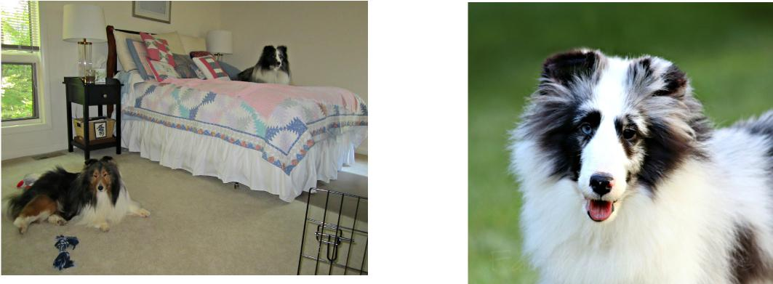
Page 9
Obi (Blue Heavens The Force Is With Blu) was RWD (Reserve Winners Dog) both days at the Shawnee Kennel Club shows (April 10-11). Shown by handler Zana Friend, that was only his second weekend out. Obi is owned by Lilian Yeh Forsyth and is pictured at 6 months-old.

