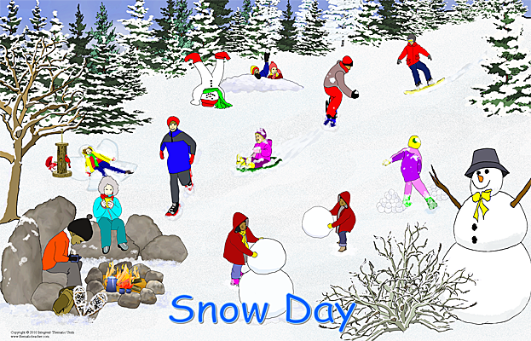

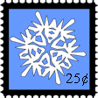
Good news in the wind!
Replace these words with your own message, OR delete the words and write it by hand.
Good news in the wind!
Replace these words with your own message, OR delete the words and write it by hand.
Good news in the wind!
Replace these words with your own message, OR delete the words and write it by hand.
Good news in the wind!
Replace these words with your own message, OR delete the words and write it by hand.

