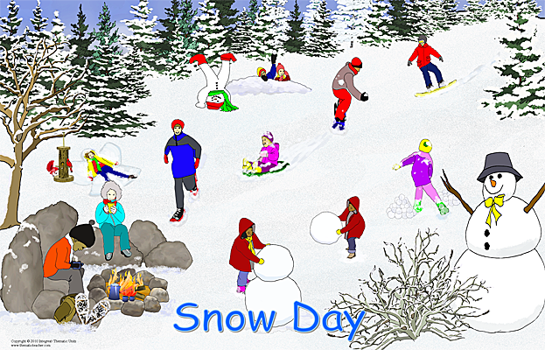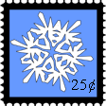

*Good news in the wind!*

Replace these words with your own message, OR delete the words and write it by hand.



*Good news in the wind!*

Replace these words with your own message, OR delete the words and write it by hand.



*Good news in the wind!*

Replace these words with your own message, OR delete the words and write it by hand.

*Good news in the wind!*

Replace these words with your own message, OR delete the words and write it by hand.

