READING BINGO!
Depending on age and reading stamina, checking off a box could mean reading one book, one chapter, or for a certain period of time.
Read to a pet   | Read by the pool   | Read on an airplane   | Read in bed 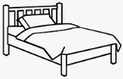 | Read to a sibling
Read to a parent | Read in a restaurant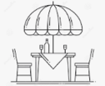 | Read to a cousin | Read in a fort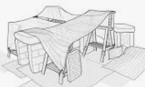 | Read under a tree  
Read by the beach   | Read to a baby   | Read in a robot voice   | Read at a library  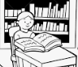 | Read at the mall  
Read with a flashlight in the dark   | Record yourself reading  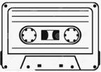 | Read in a car   | Read to a friend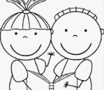 | Read to a grandparent
Read to a great -grand parent | Read in the woods | Read at the park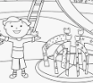 | Read in a sleeping bag | Read at the airport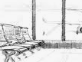

Prizes for:
** Five in a row
** Four corners
** Blackout

