Solo/Ensemble Ratings Monitoring
The TexasMusicForms.com website now supports monitoring your student results as the contest sheets are scanned. In order to monitor scores from your school, follow these instructions:
- Open a browser window on an Internet connected device.
- Navigate to TexasMusicForms.com.
- Click on the button labeled “Directors”
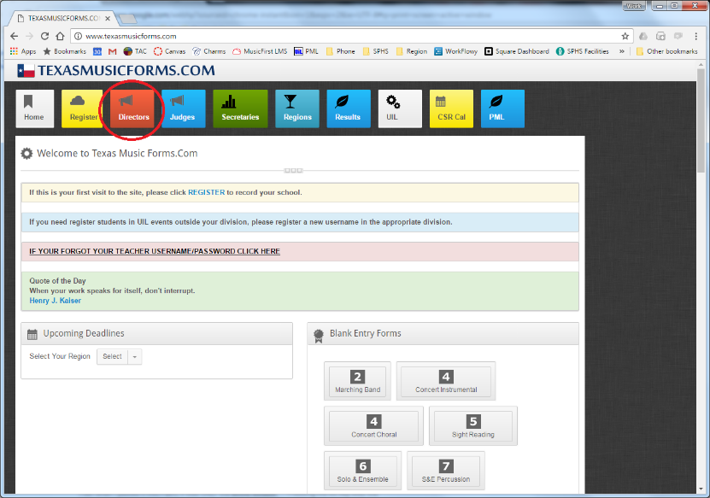
Enter your login information. Charms users – use your Charms login.
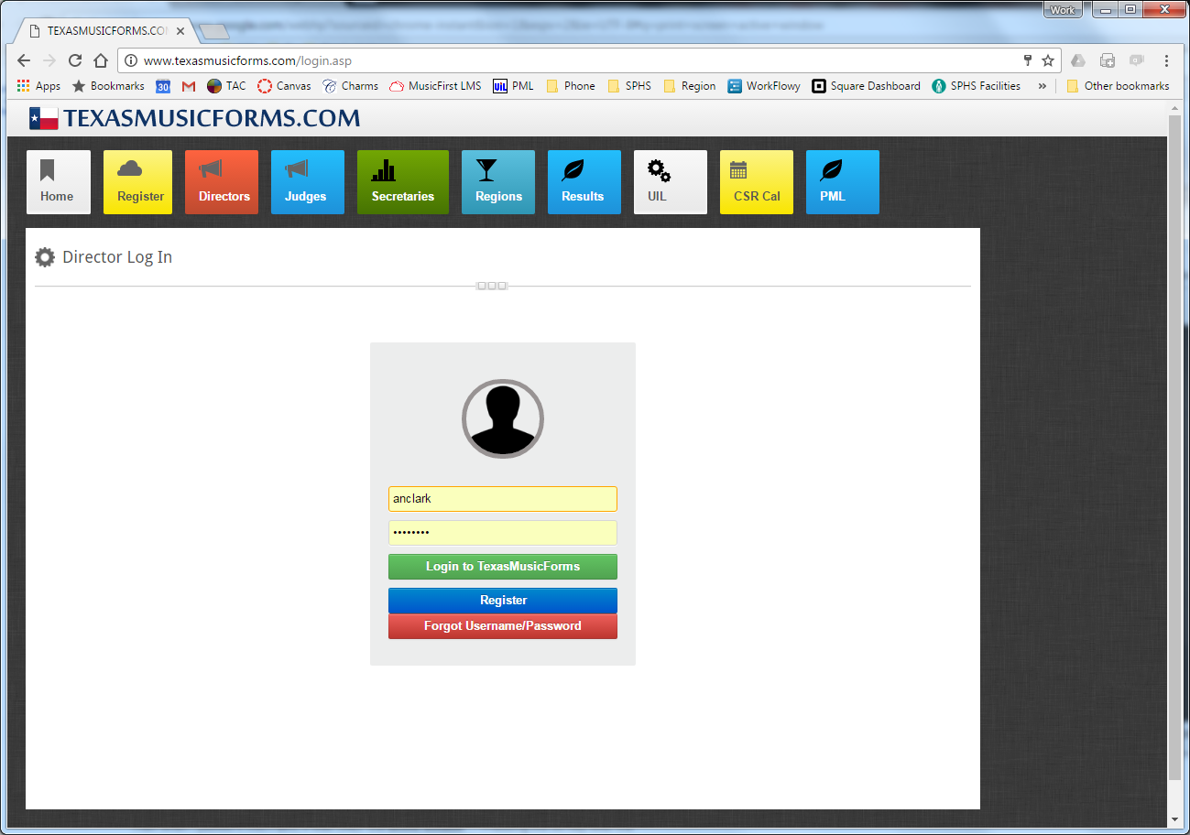

After you login, click on the button labeled, “S & E Ratings”
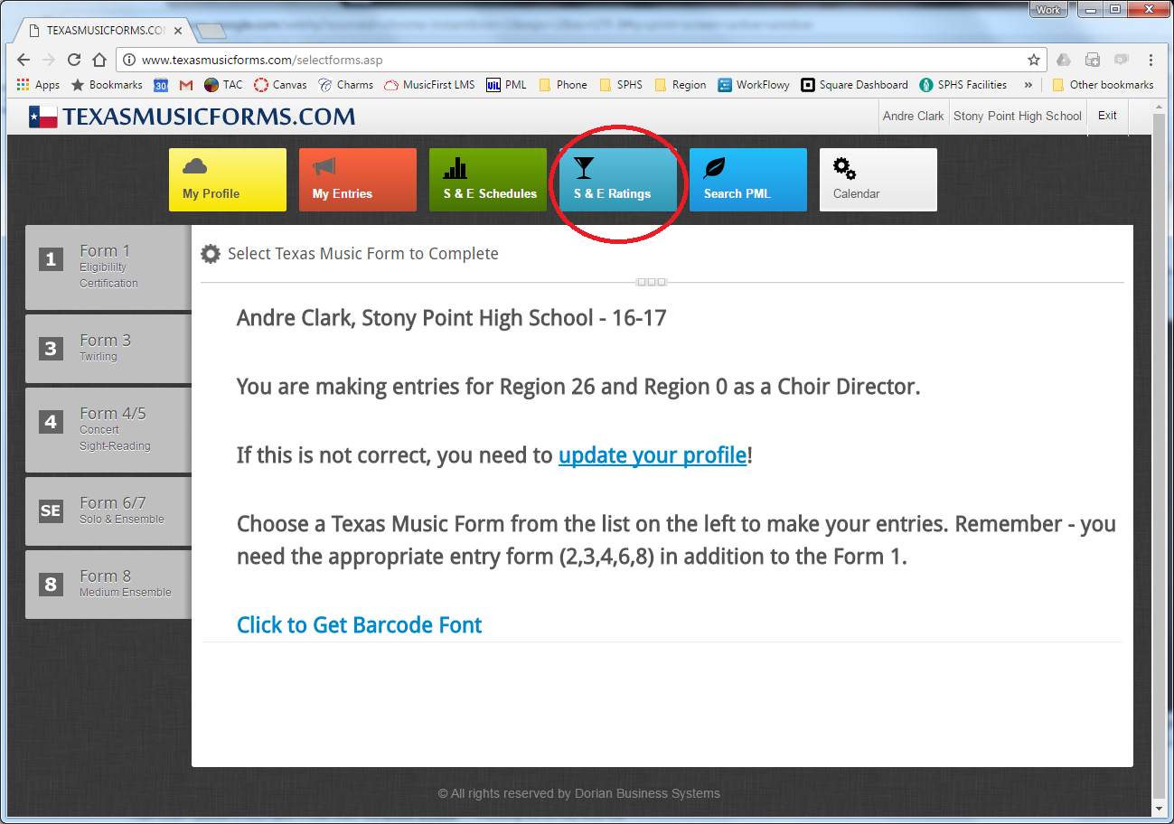
On the S & E Ratings page, select the contest from the dropdown menu. If you have entered LATE entries, they will have been moved to the main contest by the contest date. Check to ensure that they have been moved.
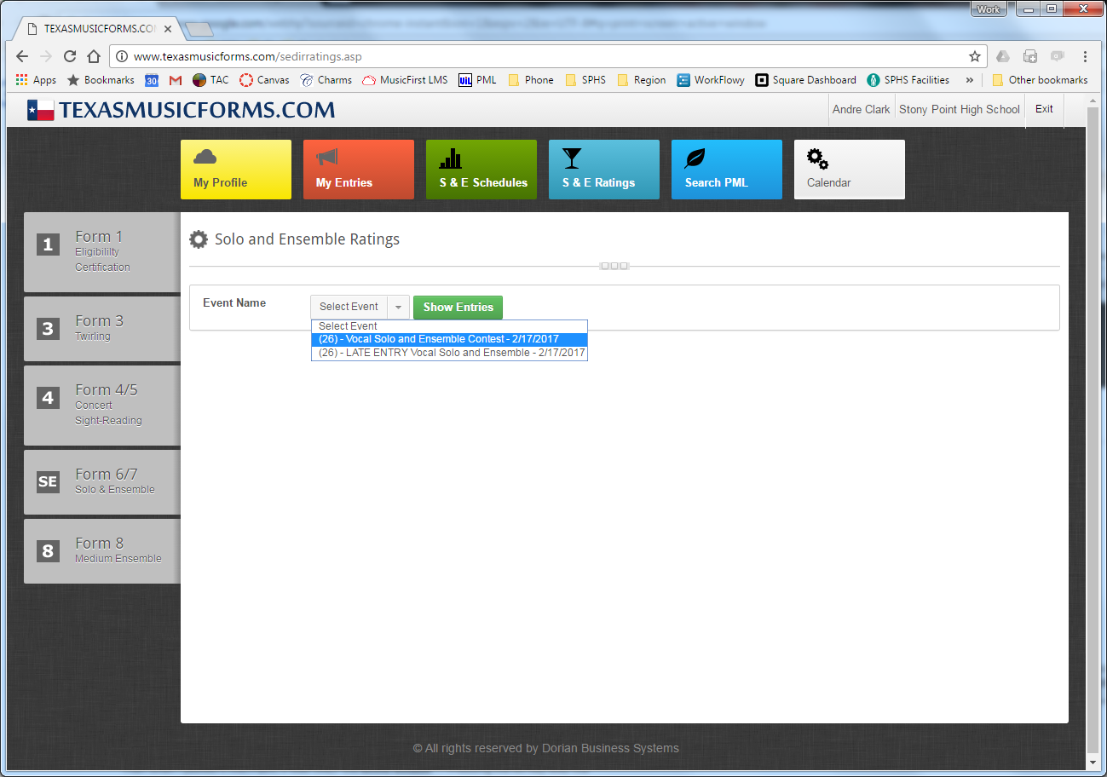

As score sheets are scanned, ratings will replace the __ lines on the right side of the screen.
You must refresh your browser screen (push F5 on a Windows PC) to capture the latest information.
At the top of the page, there is a link that you can share out – assistant directors, your group website, your call – as scores are entered, they are accessible. If you are in the contest office, I would recommend using this page to keep up with scores. On the bottom of the page, a medal count is listed. Use this medal count to cross check the assigned rating on the bottom of the score sheets as they are placed in your stack. In the event of an error, take it back to the scanning station to be re-scanned.
