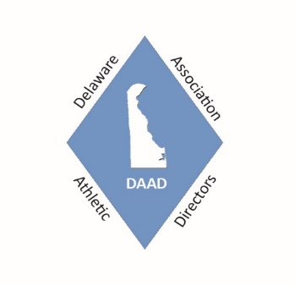
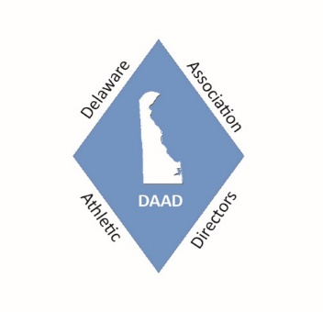
Delaware Association of Athletic Directors
(DAAD)
Send application to:
Michael Wagner
DAAD Executive Director
80 Greenview Drive
Dover, DE 19901

Membership Application / Renewal and Invitational Payment Form

Please print or type; make sure you include school address and your e-mail address. Complete all information for each individual AD or School as well as the Invitational Events your School plans on attending and send in all completed forms attached to one check.

Name: __________________________________________ School: _________________________________________

E-mail Address: ____________________________________ School Address: __________________________________

Cell Phone: ________________________________ Cont. School Address: __________________________________ City State Zip Code
_______ Number of Years as an AD: (Include 2017 – 2018)

*************************************************************************************
DAAD Dues and Professional Day Fee – Please Check all that apply

________$150.00 High School (If you are both the high school and middle school AD the fee is still $150.00)

________ $50.00 Middle School AD only or Assistant AD (For all active athletic directors, assistant athletic directors, and other athletic administrators in public and private schools, and state agencies.)

________$80.00 NIAAA (National Interscholastic Athletic Administrators Association)

________$45.00 Registration for Field Maintenance Staff to attend the 12th Annual Sports Field Management Day
October 3, 2018 – Name(s) of staff Attending- $45 per person ______________________________

DAAD Invitational Events for 2018 – 2019 - Please check the ones that your school plans on attending.

_____ $ $250.00 Varsity and JV or $150.00 Varsity only – HS only event Upstate Downstate Boys Soccer Challenge (September 2018)
___ - Varsity and JV ($250.00) ___ - Varsity only (150.00)

_____ $ 150.00 DAAD Middle School XC Invitational (October 2018) 20 Middle Schools attended in 2017

_____ $ 200.00 DAAD Middle School Volleyball Invitational (November 2018) 20 Middle Schools attended in 2017

_____ $ 300.00 Varsity Bracket, 260.00 for the JV Bracket – HS DAAD Christmas Basketball Tournament (December 2018)

Teams being entered - ___ Boys Varsity ___ Boys JV ___ Girls JV (2 Games over 2 days – 12/27 and 12/28)

_____ $ $250.00 Varsity and JV or $150.00 Varsity only – HS only Upstate Downstate Girls Soccer Challenge (March 2019)

********************************************************************************************************

$ _______________ Total Amount Enclosed for the 2018 -2019 School Year
Please send a copy of this form and your check to the address at the top of this page.
Make checks payable to DAAD (Sorry – No Credit Cards)
(DE Vendor ID # - 0000034342)

