How To Be Able to Log Meetings and Evaluations for Kids Who Don’t Have Related Services

1. Pull the student up in Easy Trac. Click on Related Services.
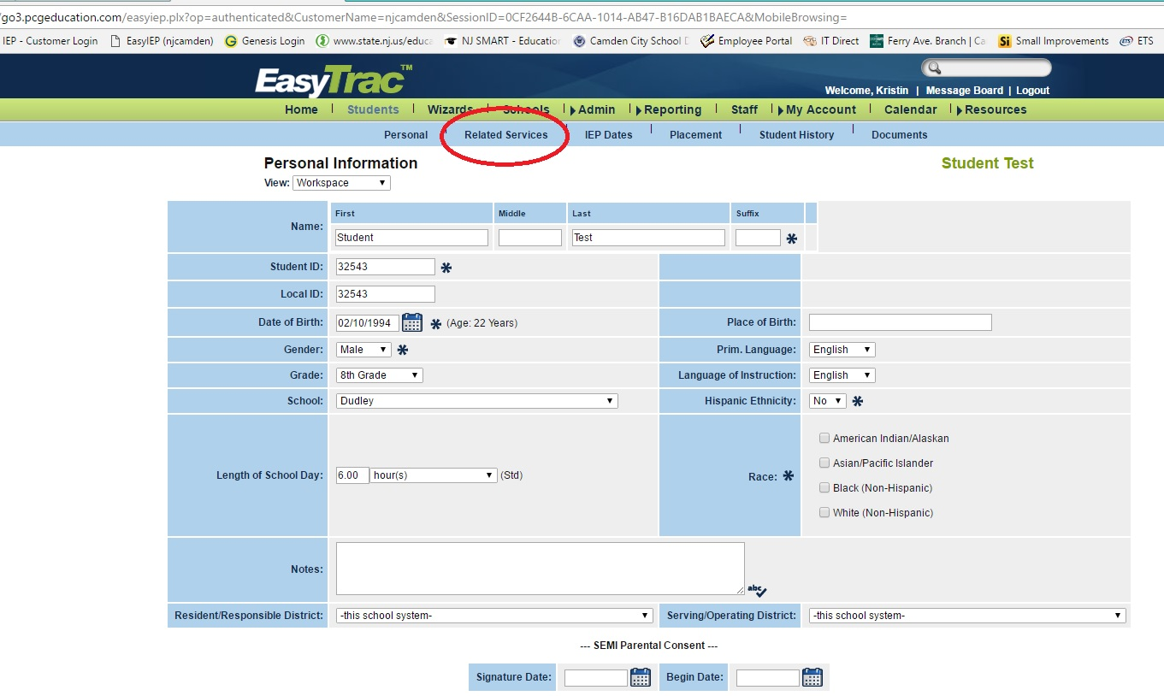

2. Click Add Related Services.
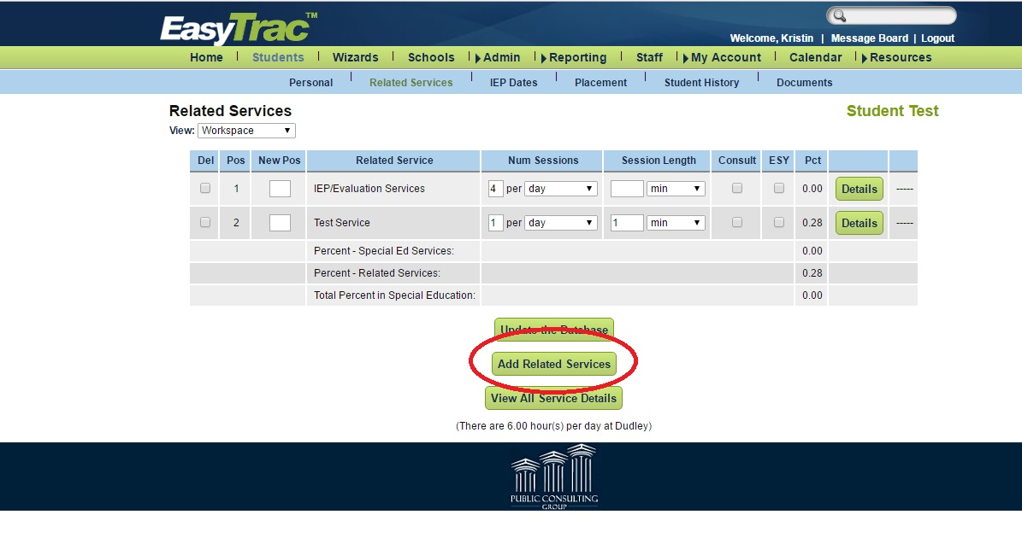

3. Choose your Discipline and click Update Database.
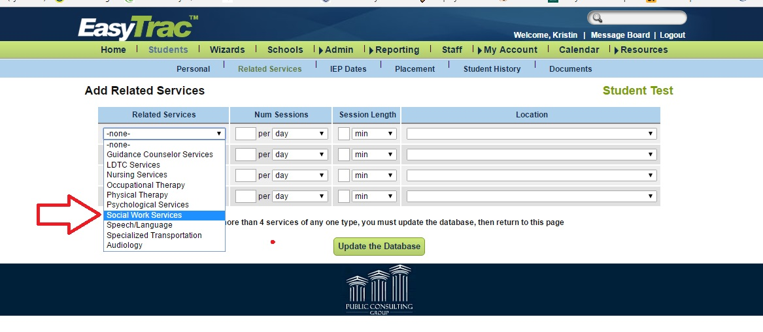

You don’t have to fill anything else out. This will not place your discipline as a Related Service on the student’s IEP, and you will not be expected to provide your discipline’s related service (ie counseling.) This allows a person of your related service to review health-related information such as previous evaluations and make IEP decisions.

