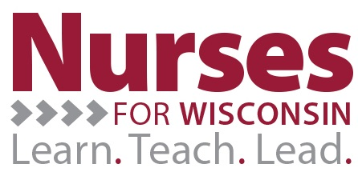
Verification of Lenders Form
This Verification of Lenders Form should be completed and mailed to:
Grant Accountant
Nurses for Wisconsin Project
Schofield 102
105 Garfield Avenue
University of Wisconsin-Eau Claire
Eau Claire WI 54702-4004
by the January 31st following the completion of every year as part of the Nurses for Wisconsin Program. Along with this form, please attach a copy of a statement from each outstanding loan that you held within the past calendar year (January 1st – December 31st) that is not associated with any UW-System Incentive Granting institutions. It is imperative that all loans that were originally reported during the application phase of the Nurses for Wisconsin Program be included. If a loan that you hold has changed into the hands of a different lender (i.e. if another institution purchased the loan from the institution you originally reported,) please include a statement from both of the institutions that held that loan within the time frame. If sufficient backup documentation is not included with the submission of the Verification of Lenders Form, the Nurses for Wisconsin Program has full authority to request additional information related to the Loans held, as well as withholding any future payments related to further loan payments. By signing below, you acknowledge that you have attached all necessary backup documentation and agree to the terms and conditions set within the Verification of Lenders Form.
__________________________________ _____________________________
Participant Signature Date

__________________________________ _____________________________
Assigned Manager’s Signature Date

__________________________________ _____________________________
Institutional Financial Representative Date

