Breast disease and its management.
By Rick Linforth MD FRCS(Ed) FRCS(Gen Surg)
Consultant Oncoplastic Breast Surgeon Bradford Teaching Hospitals NHS Foundation Trust.

Diagnosis
Women who attend a breast clinic in the UK are usually assessed by:
• Clinical examination
• Imaging with mammograms (if aged >40 years) and ultrasound if a mass /asymmetric nodularity felt.
• Core biopsy (if palpable mass or image abnormality).

This collectively is known as triple assessment.

More than 90% of referrals will have benign problems of the breast and most will require only reassurance.
With the increased use of ultrasound and guided core biopsies, it is much easier to make a confident diagnosis of benign disease of the breast in the UK than it was ten years ago. This has lessened the need for diagnostic excision biopsies of symptomatic lumps, unless the pathology is unusual or it is not possible to make a precise diagnosis on a small core biopsy.
Breast development
At puberty, the female breast develops under the influence of the sex hormones oestrogen, progesterone and others including growth hormone, cortisol and insulin. This complex process typically begins between ages 8 and 14 and spans about 4–6 years.
The breast contains mostly fatty tissue thus is related to body fat, and also connective tissue and glands that following pregnancy, will produce milk. The milk is collected in the ducts and transported to 15–25 openings through the nipple. Asymmetrical breast growth during adolescence is the rule rather than the exception. Reassurance is given that the asymmetry usually evens out by the time of full maturation. Mammary hypertrophy can be a distressing symptom, but because growth and development continues for a long time, surgical intervention, if contemplated, should be delayed until the breasts are fully mature.
During the menstrual cycle, the breast is smallest on days 4–7, and then begins to enlarge, under the influence of estrogen and later progesterone and prolactin. Maximum breast size occurs just prior to the onset of menses. The breast is not round, but has a ‘tail’ of breast tissue extending up into the axilla. This is clinically significant because abnormalities can arise there just as they can in other areas of the breast. During breast examinations, this area should be palpated.
The breast is divided into quadrants to better describe and compare clinical findings. The upper outer quadrant is the area of greatest mass of breast tissue. It is also the area in which about half of all breast cancers will develop.
Right breast
Upper outer
Quadrant
Upper Inner
Quadrant
Lower inner
Quadrant
Lower outer quadrant
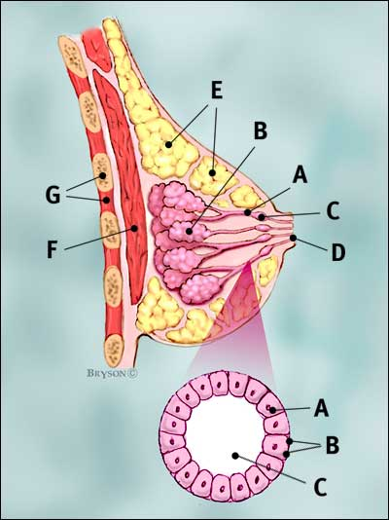
Breast profile:
A ducts. B lobules.
C dilated section of duct to hold milk.
D nipple. E fat. F pectoralis major muscle
G chest wall/rib cage
Enlargement:
A normal duct cells
B basement membrane
C lumen (center of duct)

Imaging
Mammography is most often used as a screening technique for breast cancer. Breast examinations detect most cancer, but will miss some, particularly the very early cancers that are too small to feel.
Mammograms are good at detecting some of these early cancers, but will miss others. This means that breast exams and mammograms are complementary, each detecting problems the other might miss. Mammography looks for radio-opaque densities, microcalcifications and disruption of the normal breast architecture (parenchymal asymmetry). For women without strong risk factors for breast cancer, screening mammography is performed every 3 years between ages 50 and 70. In 2009, extension of the NHSBSP to start from age 47 and continue to 73 will begin. Those women over 73 can request mammography via their GP every 3 years.
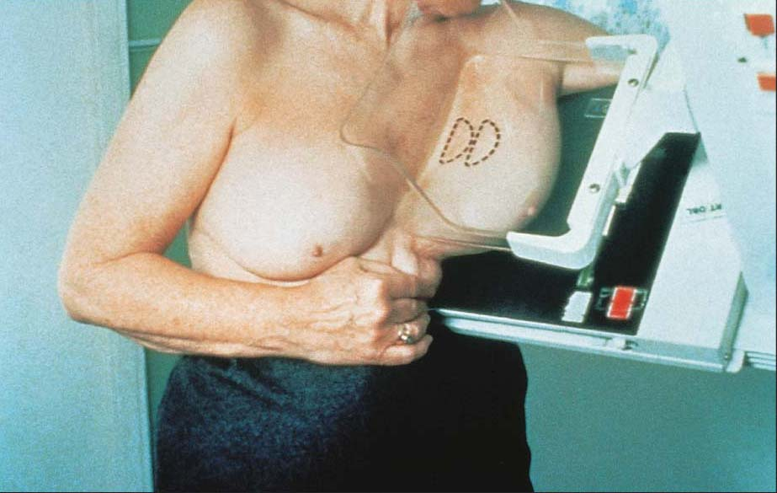

Ultrasound

While mammography is very good at detecting radio-opaque changes, such as calcifications or architectural distortion from a mass effect, ultrasound, in contrast, is very good at distinguishing cystic from solid masses. This is probably most useful following mammographic findings of a benign-appearing, non-palpable density, although it can also be used with palpable masses.

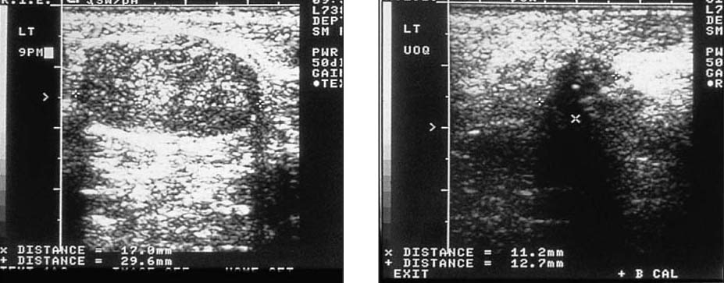
Fibroadenoma Breast cancer
Pregnancy changes
During pregnancy, a number of changes occur over time which prepare the breast for lactation. Early in the first trimester, the breasts and nipples become tender. The tenderness persists until the end of the first trimester, at which time the tenderness disappears. By the end of the first trimester, enlargement of the breast and nipple is noticeable. By the third trimester, the breast and nipple have experienced further enlargement and the Montgomery’s glands around the periphery of the areola become more pronounced. The nipples gradually darken, becoming dark brown or black by full term.

Nipple discharge
This is a common finding in most women who have given birth. The only worrying discharge is that that contains bright red blood or single-duct serous discharge.
White, yellow, green and brown discharge can be seen in many benign conditions such as duct ectasia and is usually physiological. Blood stained nipple discharge or single duct serous discharge may represent serious breast disease and needs urgent referral. However the commonest cause of blood stained discharge is a benign papilloma, but breast cancer needs to be excluded.

Galactorrhoea
is a copious bilateral discharge of milk from multiple ducts that is not associated with breast feeding; this is not a symptom of breast disease. A detailed drug history must be taken to exclude the use of preparations that may cause hyperprolactinaemia (e.g. dopamine antagonists). Less common causes of galactorrhoea are endocrine disorders (classically a functioning pituitary adenoma causing hyperprolactinaemia). A homonymous hemianopia and menstrual irregularities may suggest a pituitary adenoma, but often the only finding is a raised level of prolactin in serum. Imaging (CT, MRI) of the pituitary gland is indicated and a neurosurgical opinion should be sought.
Other endocrine disorders that may cause galactorrhoea are hypercortisolaemia (Cushing’s disease) and hypothyroidism. Correction of the underlying abnormality leads to cessation of galactorrhoea.
Persistent galactorrhoea after correction of any causative factor may respond to a dopamine receptor stimulant (e.g. bromocriptine, cabergoline), which inhibits the release of prolactin by the pituitary gland. Rarely, surgical intervention (duct ligation) is necessary.
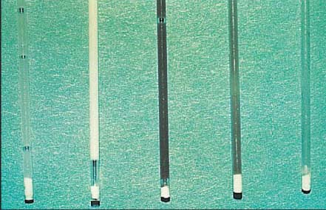

Normal nipple discharges.

Lumps of the breast
ABC of lumps
A: Abscess and fibroAdenoma
B: Benign fibrocystic change (sclerosis and adenosis)
C: Cysts and Cancer
Commonest cause of a lump in a women depending on age.
Abscess
The first stage in the development of an abscess is inflammation of the breast (mastitis) and has the following symptoms:
painful localized swelling of the affected breast, localized redness
tenderness and the breast feels very hot. Another sign of infection is flu-like symptoms, including aches and pains, headache and a raised temperature. The infection occurs in the parenchymal (fatty) tissue of the breast, causing swelling just outside the milk ducts. This swelling presses on the milk ducts and the result is pain and swelling of the infected breast
Management: ‘If there is pus, let it out’. Topical anaesthesia such as EMLA cream can be applied, and needle aspiration (19G) or mini incision and drainage, with antibiotics is the treatment of choice. If there is a large amount of necrotic skin, then excision under anesthesia is required. Most patients should be able to avoid hospitalization
Expressing pus after small incision under local anaesthetic.

Fibroadenoma
These common, benign, solid, round or oval breast lumps are most common among women aged 15–35. They are rubbery in consistency, mobile and non-tender. They rarely grow larger than 2–3 cm.The diagnosis is usually suspected on physical exam and confirmed with ultrasound and fine needle aspiration or core biopsy. When found in teenagers, they are often simply watched, but may be removed if it starts to enlarge. If they are over 4 cm in size or newly diagnosed in the over 40s, then excision is usually recommended to exclude malignancy.
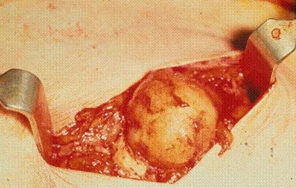
Fibroadenoma at excision.

Benign fibrocystic change
Fibroadenosis or fibrocystic disease is the most common cause of breast lumps in women of reproductive age. It should be regarded as normal rather than a disease.The peak incidence is between 35 and 50 years of age. It is rare before 25 years. The term embraces a spectrum of histologic changes and may encompass many patients who have cystic lesions detected clinically or sclerotic breast lesions detected on mammography as discussed elsewhere. Histologically, it is characterized by overgrowth of both fibrous stroma and epithelial elements, that is ducts and lobules, in differing proportions. These changes may be considered as aberrations of normal breast development and involution and not part of a disease process. The condition may be due to a disordered or imbalanced response to endogenous sex hormones. Typically, patients present with one or more lumps in the breast which may be painful and, frequently, bilateral. The size and pain usually vary with the menstrual cycle. One or more of these elements may be absent.Patients with diffuse, bilateral nodularity can be reassured and managed symptomatically.Solitary asymmetric nodularity should be triple assessed with imaging and biopsy.
Breast cyst
Breast cysts present as smooth, well-defined masses which occasionally are tender if tense. They will often disappear over the course of the menstrual cycle, but those that persist will need further evaluation. They tender to occur in the perimenopausal women aged 45–55. Ultrasound confirms the diagnosis and cyst aspiration is attempted, using a small green needle and syringe. After aspiration of the cyst, most physicians discard the cyst fluid unless it is bloody as cyst fluid cytologic examination is felt to be of little value. Recurrent cysts in the same location may need to be excised, as below.
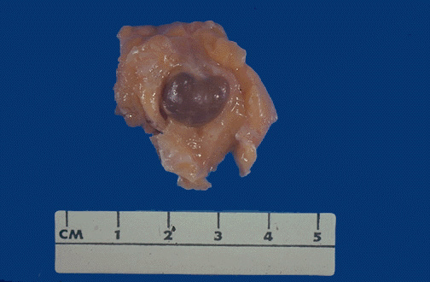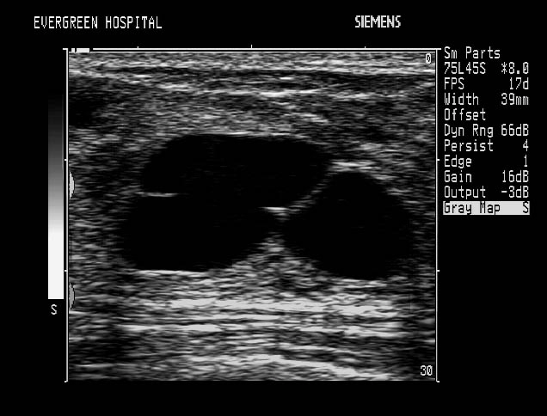
Simple cysts are aspirated to dryness .
Bloody fluid is sent for cytology

Duct ectasia is due to ductal involution; it is most common in women in their fourth and fifth decades. The normal ducts become ectactic (dilated), characteristically associated with a slit-like or pillar box retraction of the nipple. This change is often bilateral and the discharge can be from one or many ducts, with a coloured appearance which may be watery or of a more viscous consistency. Surgery is reserved for cases with copious problematic discharge that can stain clothing and cause embarrassment.

Periductal mastitis: 15% of periductal mastitis cases (see below) will describe nipple discharge that may affect one or both breasts. The discharge is usually offensive and purulent in keeping with the underlying periductal bacterial sepsis. An association with cigarette smoking has been suggested.
The discharge should be cultured and the underlying organism treated with an appropriate antibiotic. The patient should be encouraged to stop smoking.

Intraductal papilloma is a benign neoplasm of the ductal epithelium which imparts an increased risk of developing breast cancer of 1.5- to 2-fold. Intraductal papillomas are very common and may be an aberration of normal development rather than a true neoplasm. Intraductal papillomas cause nipple discharge when they arise in the large subareolar ducts, where they may be palpable. Nipple discharge associated with a papilloma is serous, arises from a single duct and may be bloodstained. Radiographic investigation may show a dilated duct on mammogram; an intraductal lesion may be visible on ultrasound. Excision by microdochectomy (see below) is diagnostic and curative.
Mastalgia
Mastalgia (severe breast pain) is a common symptom that will affect about 70% of women at some point in their life. Twenty-five percent of referrals to the breast clinic will be for breast pain. Two-thirds of these have cyclical mastalgia (mean age of 33) and one-third non-cyclical mastalgia (mean age of 43) which includes pain of the chest wall (see below).
Less than 0.5% of patients with breast cancer will present with pain alone. After exclusion of significant disease and reassurance, about 85% of patients can be discharged. In about 15% of patients, the pain is sufficiently severe to affect their lifestyle and warrant drug therapy.
A simple tool in the evaluation of mastalgia is the breast pain chart. If completed over a period of at least two menstrual cycles, it can demonstrate if the pain is cyclical or non-cyclical, as well as indicating severity.
Treatment

Lifestyle changes: a supportive brassière should be used to minimize discomfort, (it may also be worn in bed). Other lifestyle changes include a diet low in saturated fats or sodium, reduced caffeine intake, weight reduction if obese, and decreasing levels of stress.

Evening primrose oil is the mainstay of treatment for mastalgia. The active component of evening primrose oil is gammalinolenic acid, a fatty acid that is thought to modulate hormone-receptor interaction in breast tissue. Despite its recent removal from the British National Formulary, gammalinolenic acid remains a well- tolerated natural dietary supplement.
A therapeutic dose of 240–320 mg of gamma linolenic acid each day for a period of four months is required before benefit can be assessed(=2gms a day of EPO). Improvement in severity of cyclical and non-cyclical mastalgia is 58% and 38% respectively. If symptoms are lessened, treatment should continue for up to 12 months.
Hormonal treatments are used for pain refractory to more conservative therapy. Danazol and bromocriptine are the only licensed medications for use in severe mastalgia.

Danazol inhibits pituitary gonadotrophins, combining androgenic with anti-oestrogenic/anti-progestrogenic activity; but its action is probably through local effect on the breast tissue. Danazol has a rapid onset of action, but the side-effects of weight gain, hirsutism and menstrual irregularity in 22% of patients limit its use. A starting dose of 100 mg b.d. should be prescribed until response is achieved; the dose is then reduced to 100 mg once a day. The need for continued treatment should be assessed after six months. Improvements in severity of cyclical and non-cyclical mastalgia are 80% and 40% respectively.

Unlicensed drugs for mastalgia: tamoxifen, goserelin, testosterone, gestrinone and cabergoline are effective in the treatment of mastalgia, but are not licensed for use. Tamoxifen 20mg daily is effective.

Breast cancer
Breast cancer is one of the commonest cancers in UK with more than 44 000 people diagnosed each year. Breast cancer represents about 30% of all cancers in women. In broad terms, treatment is successful in 75–80% of patients controlling or eliminating the disease. In about one of four, the cancer proves fatal.

The risk of developing breast cancer increases steadily with increasing age. It is rare among women under age 25 but affects nearly one in nine of those women reaching age 90. Although women are predominantly affected by the disease, it is estimated that 300 men per year are diagnosed with breast cancer. Breast cancer rates have shown a rising trend over recent years. The increase in the reported incidence of the disease may be the result of increased detection through the NHS screening programme, increasing body mass index, earlier menarche, late menopause, the tendency for women to delay having children, the use of hormone replacement therapy and other lifestyle factors such as alcohol consumption and reduced exercise.

However, more effective treatments and earlier detection have caused a fall in breast cancer mortality rates, with 10-year survival statistics for people diagnosed with breast cancer estimated at 80%, compared to 52% for women diagnosed between 1971 and 1975. Of the risk factors for breast cancer, approximately 5–10% of breast cancers are thought to be traced to a family history of breast disease and the most common implicated genes are BRCA1 (BReast CAncer 1), BRCA2 and P53. Female sex and old age are the most significant risk factors. More than 80% of breast cancers occur in women over the age of 50 and the risk steadily increases with age. Earlier breast screening is available for high-risk patients.
Risk factors

High risks
1.Female gender: Remember women are 200 more times likely to get breast cancer than men!!
2.Old age: Its older women that get cancer!!

These first two risk factors should be the first to mention in any viva. Its amazing how often they are not said!!

3.BRCA1, 2 genes (family history)
4.Previous exposure to radiation. (Hodgkin’s lymphoma, etc.)
5.A history of benign breast conditions with atypia, for example ADH and lobular carcinoma in situ (LCIS). LCIS causes an 8 fold increase of risk.
Moderate
Obesity, high alcohol intake
Hormone replacement therapy after the age of 50 years for more than 5 years
Low risk
Nulliparity early menarche or late menopause
Use of the oral contraceptive.

Grade
Histologic tumour grade (sometimes called the ‘Bloom–Richardson grade’) is based on the arrangement of the cells in relation to each other: whether they form tubules, how closely they resemble normal breast cells (nuclear grade) and how many cancer cells are in the process of dividing (mitotic count). This system of grading is used for invasive cancers but not for in situ cancers.
Grade 1 (well-differentiated) cancers have relatively normal-looking cells that do not appear to be growing rapidly and are arranged in small tubules.
Grade 2 (moderately differentiated) cancers have features between grades 1 and 3.
Grade 3 (poorly differentiated) cancers, the highest grade, lack normal features and tend to grow and spread more aggressively.
Common types of breast cancer
The most common types of breast cancer originate in either the ducts (Invasive Ductal carcinoma of no specific type NST) or lobules (Invasive lobular carcinoma). The point of origin is determined by the microscopic appearance of the cancer cells from a biopsy.

Invasive breast cancer
Invasive (infiltrating) breast cancers are those that break free of where they originate, invading the surrounding tissues that support the ducts and lobules of your breast. The cancer cells can travel to other parts of your body, such as the lymph nodes.
Invasive ductal carcinoma
IDC accounts for the majority of invasive breast cancers (80%). If you have IDC, cancer cells form in the lining of your milk duct, break free of the ductal wall and invade surrounding breast tissue. The cancer cells may remain localized—staying near the site of origin—or they can metastasize, carried by the lymphatic system.
Invasive lobular carcinoma (accounts for 5–10% of beast cancer)
Although less common than IDC, this type of breast cancer acts in a similar manner. Invasive lobular carcinoma (ILC) starts in the milk-producing lobule and invades the surrounding breast tissue. It can also spread to more distant parts. With ILC you may perceive only a general thickening—or a sensation that the breast tissue feels different. ILC can be harder to detect by touch, and it is also less likely to appear on a mammogram.
Ductal carcinoma in situ
Ductal carcinoma in situ (DCIS) refers to abnormal cells in the lining of a duct that have not invaded the surrounding breast tissue. This is early-stage breast cancer. Some experts consider DCIS a ‘precancerous’ condition. Almost all women with DCIS can be successfully treated, and no evidence suggests that DCIS affects a woman’s lifespan. However, if left untreated, DCIS may eventually develop into invasive breast cancer.

Lobular carcinoma in situ
LCIS means that abnormal cells are contained within a lobule of your breast, but they have not invaded the surrounding breast tissue. Whether LCIS is an early form of breast cancer or is just a marker for the future development of cancer remains a point of controversy in the medical community. However, experts do agree that if you have LCIS, you are at an increased risk of developing breast cancer in either breast in the future. In the breast that had the LCIS, you are more likely to develop invasive lobular breast cancer. If cancer develops in the other breast, it is equally likely that it could be invasive lobular or invasive ductal carcinoma (IDC).
Less common types of breast cancer
Not all types of breast cancer originate in a duct or lobule. Less common types of breast cancer include:
Inflammatory breast cancer
This is a rare but aggressive type of breast cancer. The skin on the breast becomes red and swollen and may take on a thickened, pitted appearance—similar to an orange peel. This results from cancer cells blocking lymph vessels in the skin of the breast.
Medullary carcinoma
This is a specific type of invasive breast cancer in which the tumour’s borders are clearly defined, the cancer cells are large, and immune system cells are present around the border of the tumour.
Mucinous (colloid) carcinoma
With this type of invasive breast cancer, the cancer cells produce mucus and grow into a jelly-like tumour. The prognosis for mucinous carcinoma is better than for other, more common types of invasive breast cancer.
Paget’s disease of the breast
This rare type of breast cancer affects the nipple and occasionally the areola. It starts in the duct, as either an in situ or invasive cancer. If associated with carcinoma in situ, the prognosis is very good.
Tubular carcinoma
This rare type of breast cancer gets its name from the appearance of the cancer cells under a microscope. Though it is an invasive breast cancer, the outlook is more favorable than it is for IDC or ILC.
Phyllodes tumour
A large, bulky tumour may be an indication of a phyllodes tumour. Phyllodes tumours develop in the connective tissue of the breast rather than in a duct or lobule. The outlook for a phyllodes tumour is variable, most are benign, but can reoccur locally.
Metaplastic carcinoma
Metaplastic carcinoma represents less than 1% of all newly diagnosed breast cancers. This lesion tends to remain localized and contains several different types of cells that are not typically seen in other forms of breast cancer. Prognosis and treatment is the same as for IDC.
Treatment
Surgery is the mainstay of breast cancer treatment and takes the form of either a wide local excision removing just the tumour and a rim of healthy normal tissue or a full mastectomy. Indications for mastectomy include tumours over 4 cm or a small breast, multicentric or multifocal tumours and patient choice. Patients requiring mastectomy should be offered reconstruction either immediate or delayed.
Any patient having a wide local excision will go on to have breast radiotherapy. Radiotherapy is not usually required after mastectomy, except in patients with large tumours (>5cm) lymph node involvement, lymphovascular invasion, deep margin involvement.

Surgery for breast cancer
Breast clinics in the UK should diagnose >90% of breast cancers preoperatively. There is no role for frozen section biopsy. After assessment, the results of imaging and biopsies should be discussed at a multidisciplinary (surgeons, radiologists, pathologists, oncologists, specialist breast care nurses) meeting. If breast cancer is diagnosed the surgeon, with the help of a specialist breast care nurse, will discuss the treatment options with the patient. Many women can be given a choice of treatment and their involvement in the decision-making process is beneficial to their psychological well-being.
Until the early 1980s, a modified radical (Patey) mastectomy (which included axillary clearance) was standard treatment. Randomized controlled studies from Veronesi (Italy) and Fisher (USA) showed that a quadrantectomy and radiotherapy compared with radical (Halsted) mastectomy made no difference to long-term survival, but that there was a higher rate of local recurrence. Subsequent studies of tumourectomy versus quadrantectomy followed by radiotherapy showed that:
• the cosmetic result was better with a Wide local excision.
• there was a higher rate of local recurrence (13.5% Wide local excision versus 5.3% for quadrantectomy)
• there was no effect on survival.
Twenty-year follow-up of the patients in these studies have confirmed these findings.
Breast conservation treatment: wide local excision and radiotherapy
When a wide local excision is performed, a skin crease incision is made that can be incorporated into a mastectomy (if needed later). If there is skin involvement, a small ellipse of skin is excised. Radial incisions are avoided unless they follow the skin creases in the medial and lateral aspects of the breast. If the abnormality is impalpable, a hooked wire is used to localize the abnormality (as for the diagnostic procedure). The skin is elevated above and below the incision using skin hooks, and a cylinder of tissue (which incorporates the malignant lesion and a 1–2 cm margin of palpably normal tissue) is removed to the level of the pectoral fascia. The edges of the specimen are marked with sutures or clips to aid orientation and pathological assessment of the margins. If the lesion was impalpable, a specimen radiograph is taken. Haemostasis is ensured, but drains are not inserted because they cause distortion of the breast.
Following wide local excision for invasive cancer or ductal carcinoma in situ, the margins are assessed to ensure there is no known residual disease. All patients with an invasive carcinoma and those with moderate- and high-grade ductal carcinoma in situ require radiotherapy to the breast to lessen the risk of local recurrence. Local recurrence rates should be <5% over five years.
Factors that increase the risk of local recurrence are:
• young age (<35 years)
• multifocality
• poorly differentiated tumours (grade III)
• lymphovascular invasion
• extensive ductal carcinoma in situ (especially at the margins).
Patients should be warned that further surgery (re-excision or mastectomy) may be required if the margins are not clear.
After breast-conservation treatment, careful follow-up is required for up to ten years. Annual mammograms are performed; if local recurrence is diagnosed, a mastectomy is needed.
Mastectomy
Mastectomy is needed to treat recurrence after breast conservation treatment and may be requested for prophylaxis by women with a high-risk family history. It is the first-line treatment for 30–40% of breast cancer cases in the UK. It may be combined with immediate reconstruction of the breast (see below).

Indications for mastectomy: not everyone is suitable for breast-conservation treatment.

A mastectomy may be advised if there is:

• multifocal or multicentric disease
• widespread ductal carcinoma in situ >4 cm in diameter
• breast cancer in a male.

Relative indications include:
• a central tumour in a small breast.
• if the tumour size is >3 cm in a small or moderate-sized breast
• if wide excision would remove >15% of the breast volume (which significantly affects the cosmetic appearance and glandular remodelling is not available due to small breasts).

Operative procedures:
A simple mastectomy without axillary surgery
is performed for widespread ductal carcinoma in situ or for recurrent disease after previous axillary surgery.
Transverse elliptical incisions are made incorporating the carcinoma and ensuring removal of any involved skin. Thin flaps of skin that preserve the subcutaneous vessels are elevated to the midline level of the clavicle superiorly, rectus sheath inferiorly and latissimus dorsi laterally. The breast is removed from the chest wall, cauterizing the internal thoracic perforating vessels emer-ging via the second to fourth intercostal spaces and preserving the pectoralis fascia (unless it is involved with the tumour). The axillary tail (i.e. the breast tissue that extends into the axilla to the level of the intercostobrachial nerve) should be removed. Two drains are usually placed underneath the flaps and most patients are discharged with one drain in situ.
A skin-sparing mastectomy is removal of the breast tissue with preservation of the skin envelope. It is usually combined with a reconstructive technique (see below).
A periareolar incision is usually made, with removal of the nipple–areola complex and the breast tissue from within the skin envelope. A separate incision may be needed to allow access for a full axillary clearance. This technique produces a better cosmetic result if combined with reconstruction because breast shape and skin are maintained. This technique is often used for women requesting prophylactic mastectomy; it is particulary useful for small invasive cancers or extensive ductal carcinoma in situ.
The main disadvantage of skin-sparing mastectomy is the increased risk of skin necrosis of the breast envelope if the skin flap is too thin.
Complications: the common immediate complications of mastectomy are:
• haematomas
• infections
• necrosis of the skin flaps
• seromas.
After all mastectomies, there is a long-term risk of local recurrence in the skin flaps especially if the tumour is >4 cm in size, grade III and associated with lymphovascular invasion. This risk is predominantly in the first three years after surgery.
Axillary surgery
Axillary surgery is a controversial area in the management of breast cancer. The status of the axillary node is the most important prognostic factor and should be assessed in all cases of invasive cancer, but not for ductal carcinoma in situ. Axillary nodes may be assessed in a variety of ways.
Axillary node clearance is the traditional method of assessment. The operation can be performed at the same time as a mastectomy, via the same incisions or through a separate axillary incision when combined with breast-conservation treatment. The borders of the axilla (pectoralis major, latissimus dorsi muscles, axillary vein) are identified.
All of the tissue below the axillary vein is removed, with preservation of the long thoracic nerve and thoracodorsal pedicle. The intercostobrachial nerve may be preserved, but is often sacrificed. The extent of the surgery is divided into levels I, II and III (Figure 2). If there are pathological nodes, a level-III clearance should be performed because this is the best method for control of local disease. This operation is, however, associated with significant morbidity, including:
• seromas
• lymphoedema (30–40%)
• shoulder stiffness
• paraesthesiae due to sacrifice of the intercostobrachial nerves.

Axillary node sampling should remove at least four nodes; this should provide sufficient information to guide adjuvant treatment (see ‘Adjuvant therapy for breast cancer’, page 161). Studies of axillary node clearance versus axillary node sampling and radiotherapy for positive nodes have shown no difference in long-term survival, but there is a slight increase in local recurrence rates after axillary node sampling.
Axillary node sampling is performed via an axillary incision or with a mastectomy. Four palpable nodes are dissected from the axillary fat. The dissection is not extensive and there are fewer side-effects compared to axillary node clearance. If positive nodes are identified, axillary node sampling should be followed by axillary node clearance or radiotherapy to the axilla.

Sentinel node biopsy: most breast cancers present early or are detected by screening; up to 60% of axillae may be node negative. An axillary node clearance would be too extensive and be associated with significant morbidity. The sentinel node technique has been developed and evaluated in Europe and USA. It has been evaluated by a randomized controlled trial in the UK (ALMANAC study), and is now the standard of care for a clinically and radiological node negative axilla.
The sentinel node is the first node to which cancer cells will spread. A radioisotope (e.g. technetium-labelled colloid Tc⁹⁹) is injected around the tumour and a lymphoscintiscan is performed. At the time of the operation, Patent Blue dye is also injected around the areolar. A small incision is made in the axilla and the sentinel node is identified by detecting a ‘hot’ radioactive node using a gamma counter or by following a blue lymphatic channel to a blue lymph node. The sentinel node is currently assessed by conventional histological techniques. Frozen section, touch imprint cytology and immunohistochemical methods that can be used intraoperatively are being developed.
If the sentinel node is negative for metastatic disease, no further axillary surgery is necessary. If the sentinel node is positive, axillary node clearance should be performed or radiotherapy given. Sentinel nodes may be multiple and all should be removed and assessed.
Using radioisotope and blue dye, several studies have shown a >95% detection rate. There is, however, a learning curve associated with this technique. Surgeons should aim for a <5% false-negative rate, otherwise patients will be downstaged.
After Surgery
Hormone therapy
Oestrogen receptor-positive patients will be offered adjuvant hormone therapy with tamoxifen or an aromatase inhibitor such as anastrozole, letrozole or exemestane.
Tamoxifen is the only effective drug in premenopausal women, whose oestrogen comes from the ovary. In postmenopausal women, oestrogen is manufactured in the muscle, liver and breast via the aromatase enzyme. Aromatase inhibitors block this enzyme and are therefore effective only in postmenopausal women.
Five years of hormone therapy is given as standard.
This may be 5 years of tamoxifen or 5 years of an AI. Alternatively, a switching strategy may be used where after 2–3 years of tamoxifen, 5 years of an aromatase inhibitor can be given in postmenopausal women. This lengthens the duration of treatment which may have an advantage over 5 years of tamoxifen. The ideal hormone treatment regime is still subject to trials and debate but should include an aromatase inhibitor in the postmenopausal women. The author’s preference is 5 years of an aromatase inhibitor.
Side effects of hormone treatment include hot flushes, arthralgia, occasional pv bleeding and rarely stroke or deep vein thrombosis. Tamoxifen is associated with more PV bleeding and stroke, whereas aromatase inhibitors cause more joint pains and bone loss. A DEXA scan is recommended before starting aromatase inhibitors.
Herceptin The HER2 receptor is another growth factor receptor overexpressed in about 25% of breast cancers. It is associated with a poorer prognosis. Patients undergoing chemotherapy who are HER2 positive will be offered a year‘s treatment of Herceptin costing about £15,000
Chemotherapy is given to most patients who have involved lymph nodes or grade three tumours. Hormone receptor status is assessed on the tumour and if oestrogen receptor negative, again chemotherapy will be recommended.

The Nottingham Prognostic Index (NPI)
The NPI score stratifies patients into prognostic groups, i.e.
good (<3.4) intermediate (3.41–5.4) poor (>5.41)
The NPI is calculated as:
(0.2 x tumour size (cm)) + tumour grade + node status.
where:
1: lymph nodes uninvolved
2: 1–3 axillary lymph nodes or one internal mammary lymph node involved
3: 4+ axillary lymph nodes or an axillary and an internal mammary lymph node involved.

Breast reconstruction
Reconstruction can be performed as an immediate or delayed procedure by oncoplastic surgeons (i.e. breast surgeons trained in reconstructive techniques) or in conjunction with plastic surgeons.
Reconstruction does not increase the risk of recurrence. Reconstruction is usually chosen by women who have been advised to have a mastectomy because of the extent of breast cancer (e.g. ductal carcinoma in situ) or if they choose to have a prophylactic mastectomy because of increased risk
Before embarking on any reconstructive surgery, the procedure should be discussed in detail with the patient, with emphasis on the likely cosmetic results and the possible associated complications. Women should have realistic expectations of what can be achieved. This is aided by showing clinical pictures and letting the patient discuss the operation with breast care nurses and women who have undergone similar surgery. Many women will also need surgery to the opposite breast (e.g. reduction mammoplasty, mastopexy, augmentation) to achieve symmetry. There are also techniques for reconstruction of the nipple areola.

Subpectoral tissue expander: the simplest surgical technique is a subpectoral tissue expander placed beneath the pectoralis major muscle. It is suitable for small and moderate-sized breasts. Saline is added to the expander (via a subcutaneous filport) at regular intervals in outpatient clinics. Fluid is added until there is about 1.5 times more fluid than the final volume needed. Excess fluid is removed after about three months. Some double-lumen expanders (e.g. Becker) can be left in situ or they can be replaced by a shaped silicone implant.
The advantage of this technique is that it does not produce other scars and the recovery time is short. The disadvantages are that it often requires further surgery to produce good cosmetic results and it cannot be used if the woman has previously had radiotherapy (because skin will not expand). Complications include capsule formation, haematoma and infection. However, this technique does not produce ptosis.

The latissimus dorsi myocutaneous flap is very reliable (<2% risk of loss of partial flap) and uses the thoracodorsal pedicle. It can be used with or without implants or expanders.
The muscle can be harvested from the back via vertical or transverse incisions (depending on the skin folds and how much skin is needed). If it is performed as an immediate reconstruction with skin-sparing mastectomy, skin requirements are minimal; if it is for a delayed reconstruction after mastectomy, a skin paddle is required. The flap is swung anteriorly and placed to cover the implant. Occasionally, if it is a small-volume reconstruction, the muscle with overlying skin and subcutaneous fat may give sufficient volume without recourse to an implant.
The advantages of a latissimus dorsi myocutaneous flap are a good cosmetic result and a reliable flap. This is a useful method if the patient has developed recurrence after previous breast-conservation treatment and has had adjuvant therapy. The disadvantages are:
• implants are usually needed
• the colour of the skin of the back may be a different shade
• back scar
• risk of seromas.
Autologous tissue techniques: implants are associated with problems (e.g. contractures) and do not last indefinitely. Although they are considered safe, there is much interest in reconstructive techniques that use autologous tissue.
Transverse rectus abdominis myocutaneous flap is the most common method. The technique involves mobilization of the skin and subcutaneous fat of the lower abdominal wall around the umbilicus which receives its blood supply from the perforators emerging from the rectus abdominis muscle (perforators of the superior and inferior epigastric arteries, Figure 4a). The rictus muscle is mobilized and is swung superiorly so that the attached subcutaneous fat is placed within the skin envelope of a skin-sparing mastectomy, or the skin and fat can be used to recreate the shape of the breast (Figure 4b).
The main advantage of this technique is a good cosmetic result because the reconstructed breast feels soft and natural. There may be some contraction if adjuvant therapy is used.
It is associated with morbidity due to the long operation time and recovery period. Relative contraindications are smoking, previous surgical scars in the lower abdomen, diabetes mellitus and hypertension. Other disadvantages include a risk of complete (1%) or partial (10%) loss of flap or skin and fat necrosis, risk of abdominal weakness/herniation after mobilization of the muscle.
Other techniques include a transverse rectus abdominis myocutaneous flap with microvascular anastomosis of the deep inferior epigastric artery and vein to vessels on the chest wall; or flaps based on the superior gluteal vessels. These tend to be the province of plastic surgeons. They are complicated techniques, but they reduce the morbidity associated with the mobilization of muscle pedicles.

More information

ABS at BASO guidelines.
www.Ricklinforth.com

