Salko Farm and Stable
Lesson Packet

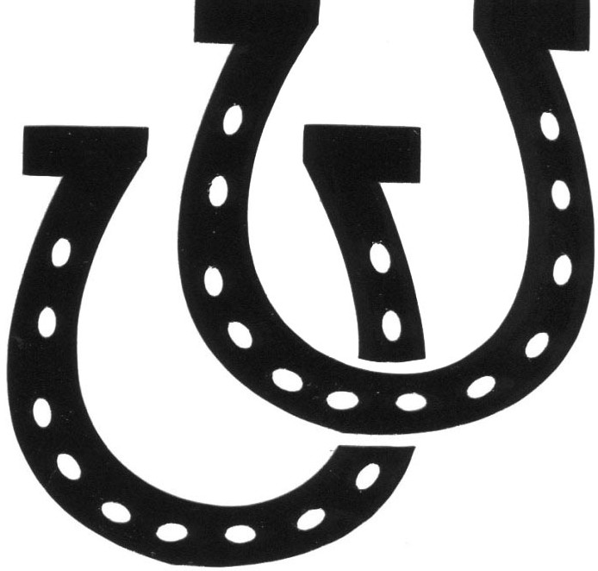

Includes:
-Waiver
-Credit Card Authorization
-Medical Form
-Rate Sheet/Guidelines

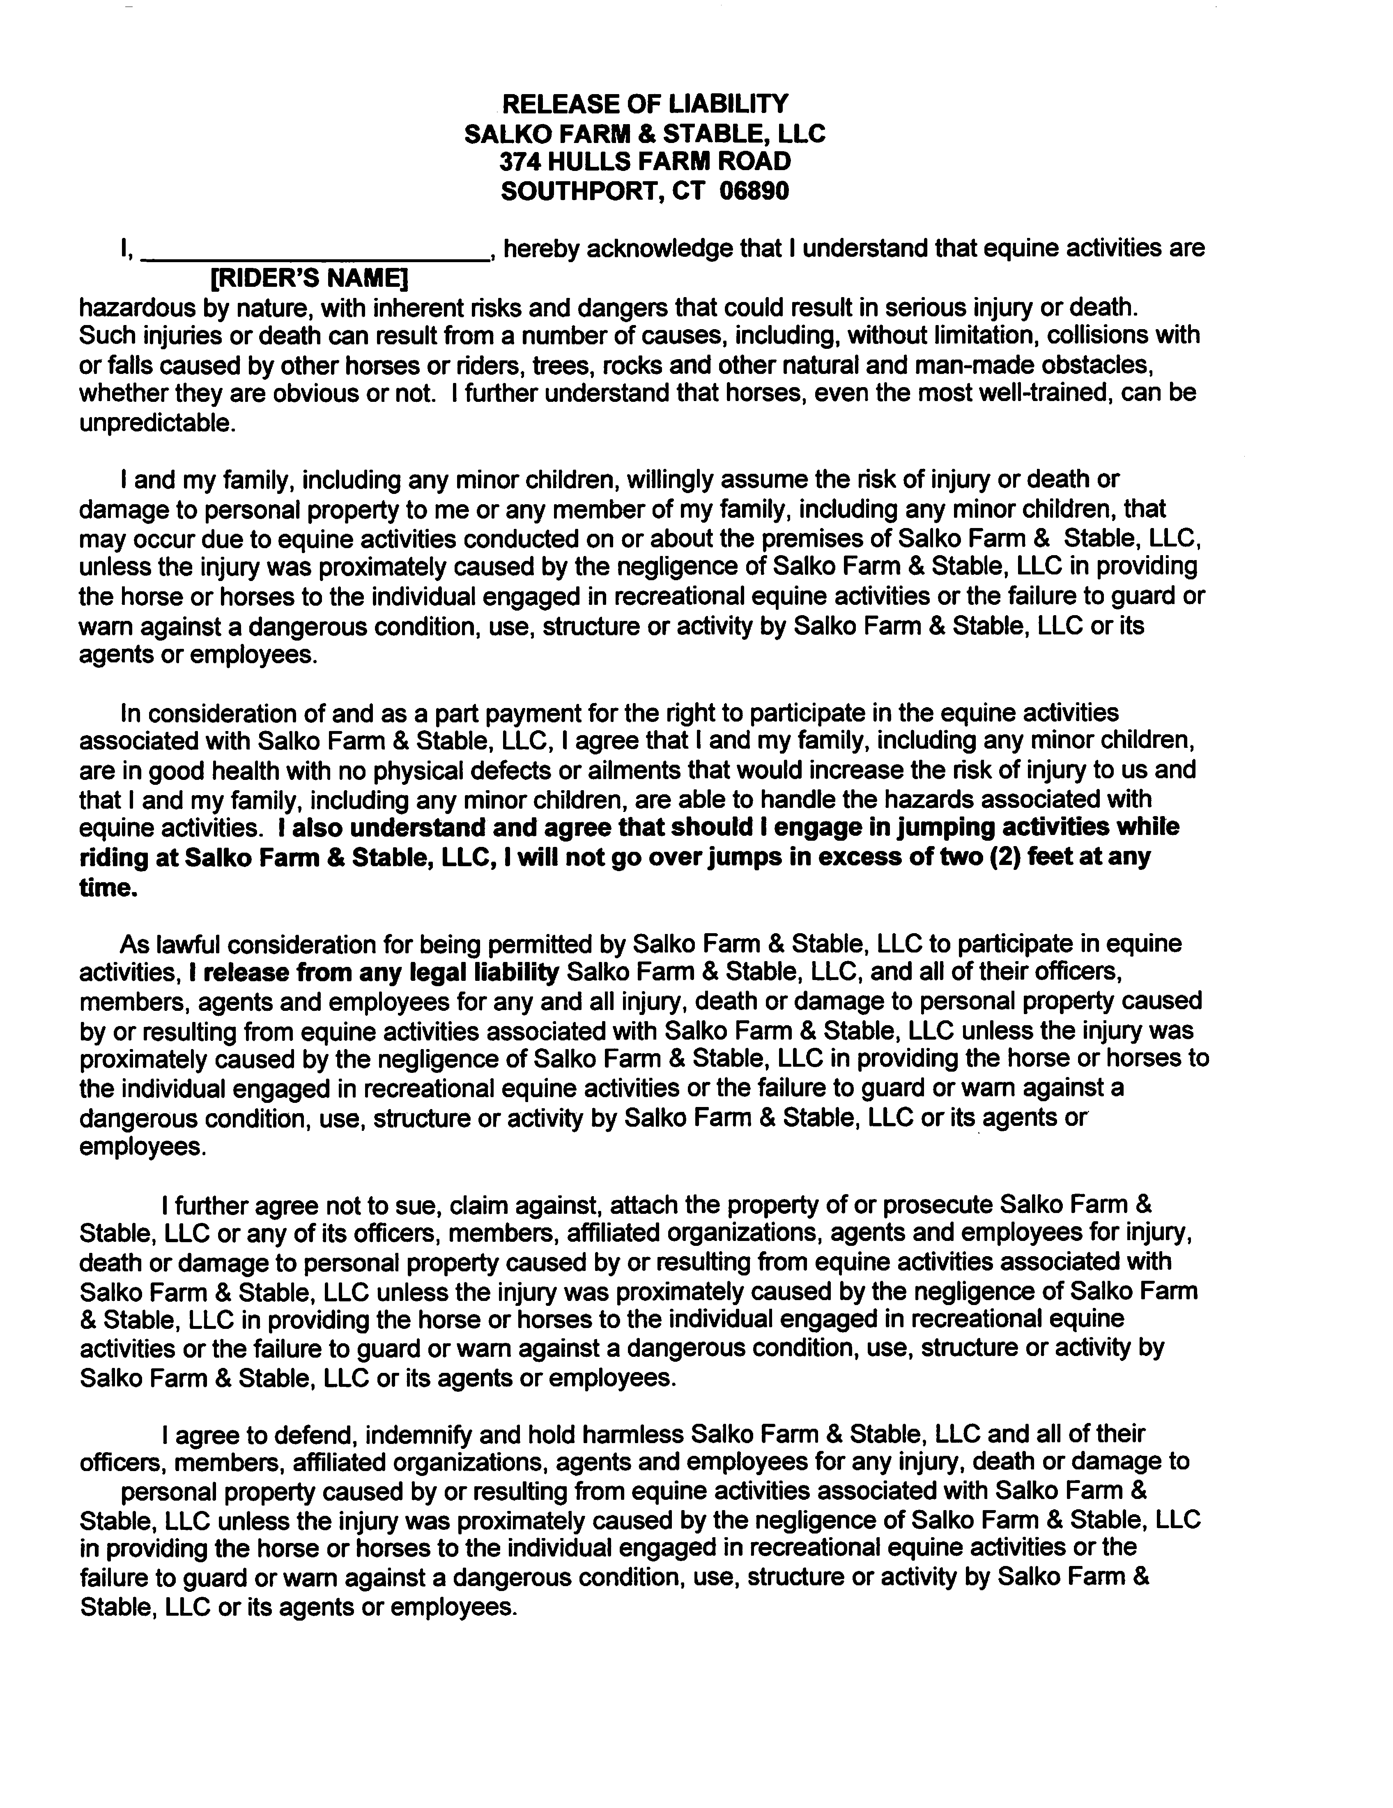
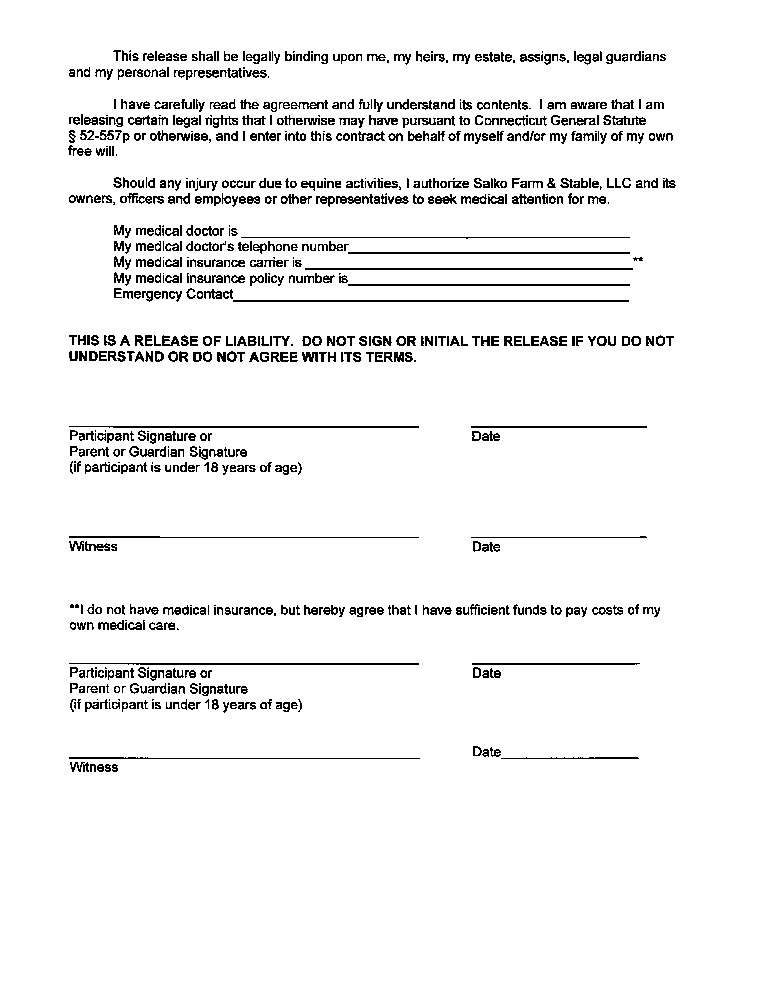
SALKO FARM & STABLE, LLC
374 HULLS FARM ROAD
SOUTHPORT, CT 06890
Email: salkofarmandstable@msn.com

CREDIT CARD AUTHORIZATION FORM

Rider’s Name _____________________________________________________

Circle One: VISA Mastercard

Cardholder’s Name_______________________________________________

Billing Address_____________________________________________________

Billing Phone No.__________________________________________________

Credit Card No.___________________________________________________

Exp. Date _________________________________________________________

CVV ______________________________________________________________

Please Check One Box Below

_________I authorize Salko Farm to charge my credit card, I understand all credit card transactions will receive a 5% processing charge.

_________I will pay via check for all lessons.

Emergency Contact
Child’s Name |  |  |  | Date of Birth
Parent’s/Guardian’s Name |  |  |  | Parent’s/Guardian’s Name
Home Phone |  | Work Phone |  | Home Phone |  |  |  | Work Phone
Cell Phone |  |  |  | Cell Phone
E-Mail |  |  |  | E-Mail
Address

City, ST ZIP Code |  |  |  | City, ST ZIP Code

Alternative Emergency Contacts
Primary Emergency Contact |  |  |  | Secondary Emergency Contact
Home Phone |  | Work Phone |  | Home Phone |  |  |  | Work Phone
Address |  |  |  | Address
City, ST ZIP Code |  |  |  | City, ST ZIP Code

Medical Information
Physician’s Name |  |  |  |  |  | Phone Number
Insurance Company |  |  |  |  |  | Policy Number
Allergies/Special Health Considerations
I authorize all medical and surgical treatment, X-ray, laboratory, anesthesia, and other medical and/or hospital procedures as may be performed or prescribed by the attending physician and/or paramedics for my child and waive my right to informed consent of treatment. This waiver applies only in the event that neither parent/guardian can be reached in the case of an emergency.
Parent’s/Guardian’s Signature |  |  |  |  |  | Date

Salko Farm & Stable LLC
374 Hulls Farm Road
Southport, CT 06890
203.256.8450
www.salkofarmandstable.com
email: salkofarmandstable@msn.com

1. Please email salkofarmandstable@msn.com to schedule a day and time for your lesson. This will be your time every week.

2. We strictly enforce a 24 hour cancellation policy – ESPECIALLY DURING SCHOOL BREAKS – since we have so many riders from so many different schools, it is up to each parent to cancel during their school breaks – NO EXCEPTIONS!!!!! .

3. THE ONLY WAY TO CANCEL A LESSON IS TO EMAIL salkofarmandstable@msn.com. NO OTHER CANCELLATIONS WILL BE ACCEPTED – NO EXCEPTIONS!!! DO NOT TELL YOUR INSTRUCTOR OR CHRIS -- if you do so, you will be charged for the lesson.

4. We require that everyone pay per session (cash, check, or credit card). All lessons MUST be used within the session dates. If lessons are not made-up within the session all remaining lessons will be forfeited.

5. After a session is completed, the majority of our students ride all year long, so we will assume that you are keeping your lesson time. BUT, if you do stop riding you must notify by email, otherwise you will continue to be charged. Our spaces are limited; so should you decide to stop riding we cannot guarantee that your riding time, if any, will be available at a later date.

Our rates are as follows:
Single Lesson Price
Private ½ hour $85.00 each
Semi Private 1 hour $105.00 each
Private 1 hour $150.00 each
Group 1 hour $85.00 each
Intro to Riding (3-5 yr olds only) $65.00 each
(***PLEASE NOTE THERE IS A $25 RETURNED CHECK CHARGE)

8. All riders must wear an ASTM approved safety helmet, long pants or chaps and hard shoes (ankle paddock boots or field/dress boots). Sneakers and Hiking Boots are not permitted. These rules are strictly for safety, as it is far too dangerous to ride without proper footwear and helmet.

9. We are closed on major holidays, i.e., New Years Day, Easter, Memorial Day, 4th of July, Labor Day,Thanksgiving and Christmas. All dates are listed on our website salkofarmandstable.com

