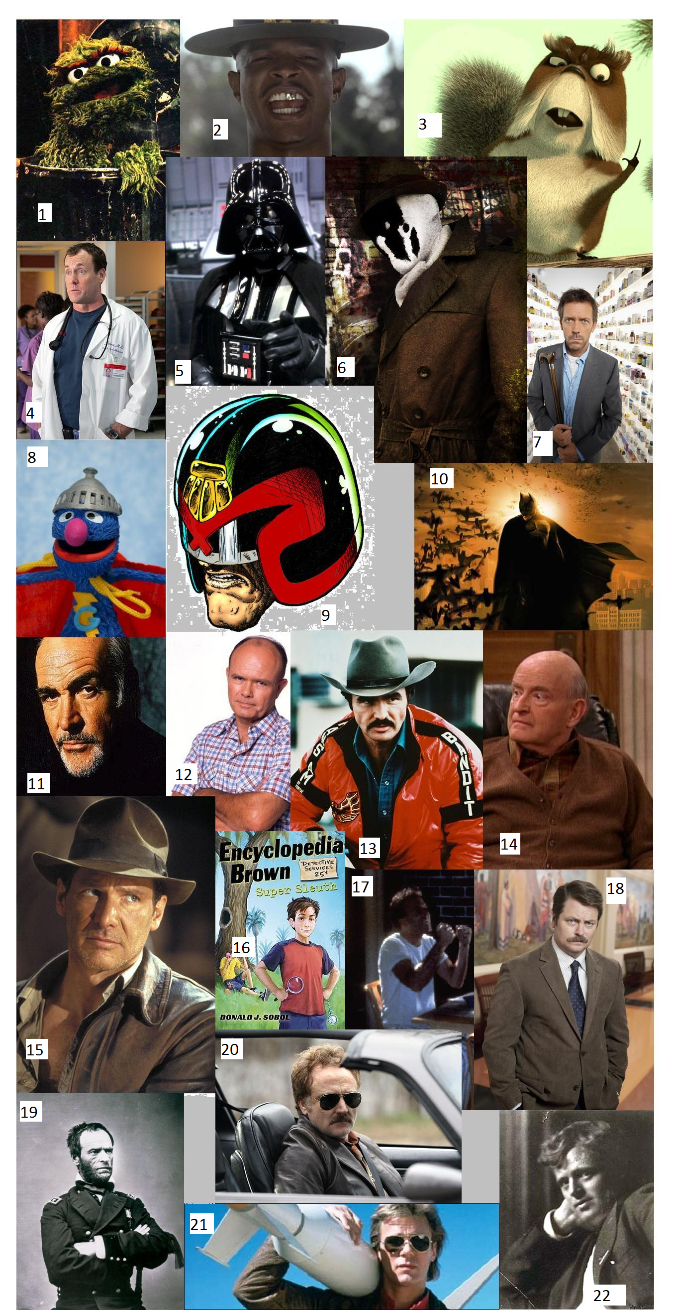
U.S. History with Mr. Brown Name _______________________________ Period _____
Cool Test
Directions: Name as many of the people or characters that you can, in the space provided below. The more you know the cooler you are!
1
2
3
4
5
6
7
8
9
10
11
12
13
14
15
16
17
18
19
20
21
22
For extra credit you can make a Heroes collage on your time and turn it in this week.

