Sammys

First Communion Day Prix Fixe
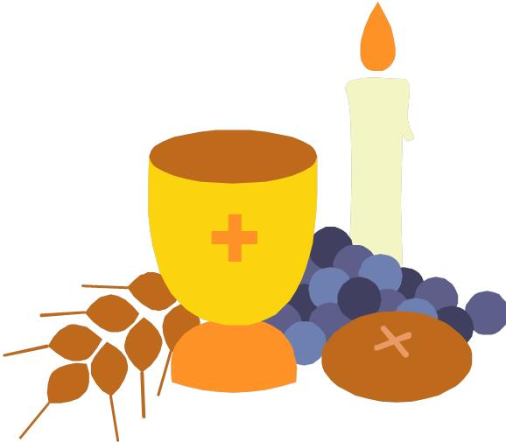
12noon to 5 PM
$21.95

Starters
Spring Garden Salad
Caesar Salad
Soup of the Day

Entrées

Sammy’s Famous Lobster Burger with French Fries and Cole Slaw
Grilled Lobster Tails with Lobster & Seafood Stuffing with
Pesto Potatoes and Vegetable ($6 extra)
*NY Steak Sandwich with Au Jus, French Fries and Cole Slaw
Panko Crusted Fish & Chips with French Fries and Cole Slaw
Fried Chicken Breast over Waffles with Country Gravy and Cole Slaw
Buttered Lobster Roll – Chunks of Lobster Meat with Drawn Butter on a Toasted Buttered Roll and served with Fresh Cut French Fries and Cole Slaw

Dessert
Holy Doughnut Sundae
Heavenly Hash Brownie
Devil’s Food Chocolate Cake

Kid’s Menu
$15 includes Drink and Dessert
Chicken Fingers & Fries Pizza with Watermelon
Fish and Chips Cheeseburger & Fries
Macaroni and Cheese with Watermelon

