

**Health and Safety Policy:**

**PWSG will take all the necessary steps to ensure the health, safety and welfare of all individuals in the pool area.**

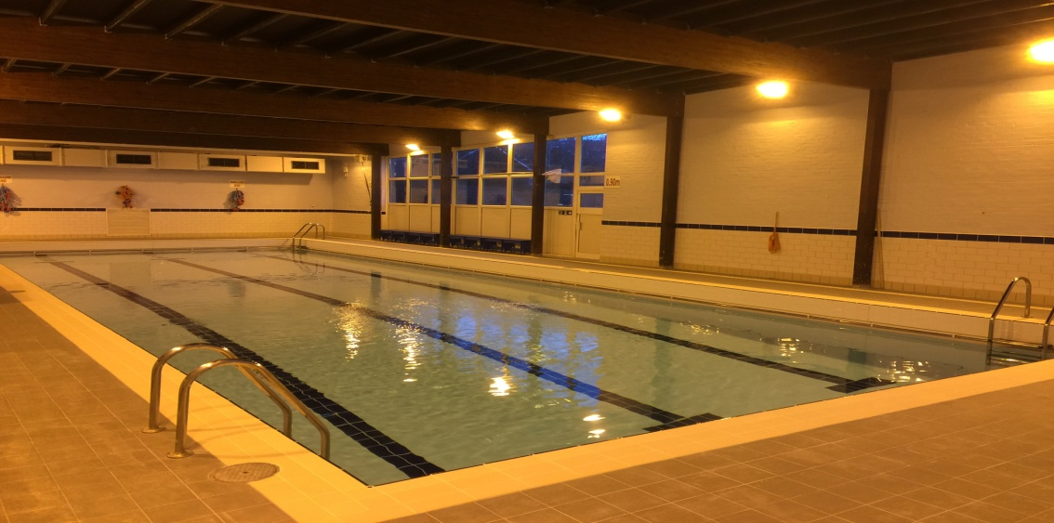**Pool Layout:**

**Dimensions of the pool:**

Length – 20 metres

Width – 7 metres

Shallow Depth (shallow end) - 0.9 metres (3’0’) up to half way.

Maximum Depth (deep end) – 1.7 metres (5’6’) slopes off to this depth.

* At each corner there are steps for access.
* There is a metal handrail close to the water and the pool perimeter.
* The pool is illuminated by floodlights.
* There is emergency lighting should an electrical power cut occur.
* The pool has disabled access.

**Chemicals, water & air temperatures:**

* School support staff are trained to monitor and record the pool chemicals and temperature levels three times a day. The water temperature controls are set at a minimum of 29deg C and a maximum of 31deg C.
* The heat reclamation unit is set to allow the air temperature to stay within 1 deg C of the water temperature.

*PWSG are advised by the school before 3pm on the day, if there is a problem with the pool. We will not use the pool if we feel the health and safety standards are not met.*

**General Health & Safety:**

* No outdoor shoes are allowed on poolside, please take shoes off or use the shoe covers provided.
* Pool users with long hair must have it tied back. We do keep a supply of hair bands on poolside if needed. Please ask a member of staff before the start of your child(ren)’s lesson if one is required.
* If your child wears goggles, please ensure they are able to put them on and remove them safely.
* In case of emergency, and if an evacuation is necessary, please stay calm and follow the guidance of the staff.
* During the course of the term, if your child suffers from any gastric illnesses you should keep them off swimming for a minimum of 48 hours after their last episode.
* For all contagious illnesses, please do not attend until symptom free.
* Smoking is not permitted within the school grounds.