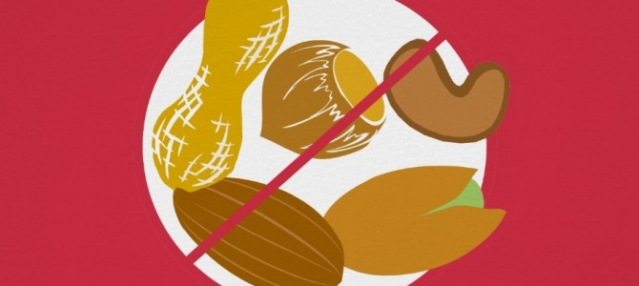
Moss Hall Nursery School is
NUT FREE
Do not bring nuts or sesame products onto the school site. This includes the snacks that families donate such as biscuits and bread sticks etc.

