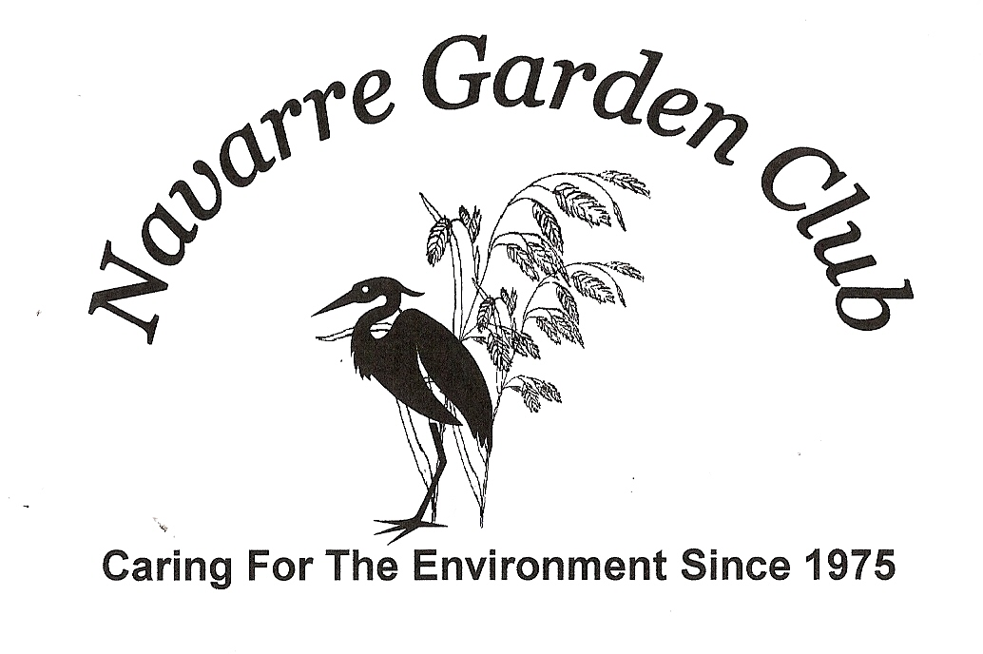
Scholarship Application 2023
Return to: Navarre High School Guidance
Department no later than March 4th.

Personal Data (PRINT)
Last Name
First Name Middle Init.
Home Address

Contact Phone Number
Contact Email
U.S. Citizen Yes No
Education
Fulltime Student or have enough credits to graduate Expected Graduation Year
Your Cumulative grade point average
Name Address of college/institution of higher learning you plan to attend

Degree/Credential you are pursuing AA BA AS BS Certificate

Financial
Have you applied for the Bright Future Scholarship? Yes No
Have you been accepted for the Bright Future Scholarship? Yes No
Have you applied for financial aid (student loans, grants, work-study, etc.) ? Yes No
Are you a recipient of any other scholarships? Yes No
If yes, please list

Are you currently employed? Yes No
If Yes how many hours per week do you work?

Family Information
Parent(s)/StepParent(s)/Guardian(s): Name
Address
Occupation(s)
Telephone Home # Number of family members living at home (Optional)
Please list any volunteer work, leadership positions, extracurricular activities, honors or awards you may have received within the last two years.

Please list your employment history.

Please explain why you chose horticulture and/or environmental studies and why you should be the recipient of this scholarship.

I hereby declare that I meet minimal eligibility requirements to be considered for this scholarship. The information provided on this application is complete and accurate to the best of my knowledge.
I hereby authorize and request the release of academic and financial information to scholarship review committee members. I understand that this information will be used for the purpose of determining eligibility for the Navarre Garden Club Scholarship only.
Signature Date

