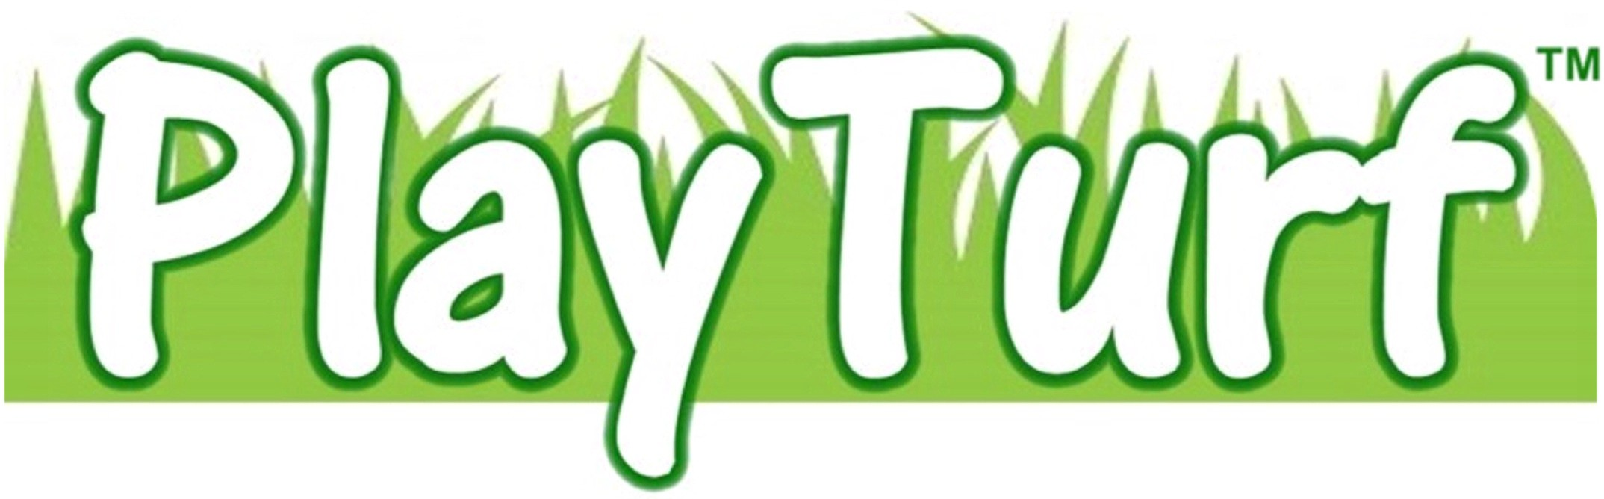
SECTION 02791 / 32 18 16 13
Revision 7 / 2015

ARTIFICIAL TURF SURFACING FOR PLAYGROUNDS

PART 1 – GENERAL

TURF AND RUBBER PLAYGROUND SURFACING

1.1 Section includes: Resilient playground turf and rubber playground system.

1.2 Related work: Playground equipment and turf and rubber surfacing sub-base.

1.3 Description: Provide all necessary materials, labor, tools and equipment to perform the work included in the section for the installation of the turf and rubber playground surfacing.

1.4 Quality Assurance: Crew chiefs shall show evidence of installing installed playground similar surfacing systems for a minimum of 5 years, and be subject to annual IPEMA project safety audit. Manufacturer shall meet current ASTM F-1292-13 Test Criteria and Consumer Product Safety Commission (CPSC) Publication 325.

1.5 The installation of the turf and rubber playground surfacing system shall be completed by Manufacturer Certified Contractors or by direct employees of the Manufacturer's Installation Division. Manufacturer's detailed installation procedures shall be submitted to the Architect and made a part of the Bid Specifications.

PART 2 – SUBMITTALS

2.1 Manufacturer's Product Literature and Specification Data.

2.2 ASTM F1292-13 Impact Attenuation Test Certification for the turf and rubber system to be installed in compliance with the Critical Fall Height as determined by the Playground Equipment to be installed in conjunction with the turf and rubber surfacing system.

2.3 ASTM F1551-03 Water Permeability

2.4 ASTM F1951 Wheelchair Accessibility

2.5 IPEMA Certification

2.6 Statement of Warranty for a with detailed Warranty Claim requirements of the owner and specific procedures to be followed by the manufacturer in terms of response and repair of warranty claims.

PART 3 – PRODUCTS

3.1 Product: PlayTurf™ Safety Surfacing by PlayMax or approved equal. Equals shall be submitted for review no less than 10 days before bid. No exceptions to this 10-day prior approval requirement are allowed.

Contact: Chris Wolf at PlayMax Surfacing, Inc., (“PlayMax”) phone (951) 250-6039 or fax (951) 356-6550 cwolf@playmaxsurfacing.com , or visit PlayMax on the web at www.playmaxsurfacing.com .

3.2 Description: An artificial turf playground surface, utilizing an underlying single-durometer poured-in-place impact attenuation cushion layer. The finished surface shall be porous and the system capable of being installed at varying thickness to comply with Critical Fall Height requirements of playground equipment installed in conjunction with the surface.

3.3 For optimal appearance, playground excavation and sub-base preparation is to be set uniformly at one depth, based on the maximum fall height of the playground system. This is to ensure as visually flat a playground surface as possible. Multiple depths, or modulating base layer depth is not advised unless the depth difference is made up in the sub-base. ALL EFFORTS must be made to allow a flat-top to the cushion layer before applying PlayTurf™ top layer to the system. Sub-base preparers are advised to consult with PlayMax or a PlayMax authorized installer as to the depth of excavation required for the equipment CFH, as determined by ASTM F1292-13.

[Specifier Note: (Remove before publishing) Because of the nature of artificial turf, some limitations on design exists (wrapping compound angles using artificial turf is not possible). On projects requiring compound turns in the surfacing, specifiers are reminded to use either PlayMax™ or PlayMax™ Supreme instead, which are formable into these angles. PlayTurf™ use is generally limited to flat-top applications, or projects which have linear “turn-downs into loose fill surfacing” (turn-downs in one straight plane only.) The analogy to remember would be “you can’t wrap a sheet of paper around a globe.”]

3.4 Materials: The PlayTurf™ play surface (top layer) shall be manufactured from high quality, synthetic turf designed for indoor or outdoor application. Pile height (new) is 1.5”. Please note that the pile height will flatten down to approximately ½” total top layer thickness with use. Owners may rake up the turf periodically to provide a more natural appearance.

3.5 Accessory items shall be provided by PlayMax for the PlayTurf™ installation. This shall include PlayTurf™ bonding adhesive, seam tape, seam adhesives and stainless steel turf to wood perimeter fasteners. Other items, depending on application are to be provided by PlayMax, including pressure-treated lumber to attach perimeters, and perimeter fasteners and/or spikes to secure the perimeter treated wood nailing strips. Perimeter treated lumber shall be pressure-treated for ground-use and below-grade contact. Adhesive application rates and perimeter nailing patterns shall be provided by PlayMax.

3.6 PlayTurf™ cushion course (bottom layer) shall be a precise blend of PlayMax™ SBR rubber particles of heterogeneous distribution bonded by PlayMax™ aromatic polyurethane binder applied to 100% of the rubber and installed to a designated thickness as required by the Consumer Product Safety Commissions Guidelines and ASTM F1292-13 Test Criteria.

3.7 PlayMax™ Geotextile Fabric by Mirafi, shall be used on systems installed directly over Type 2 road base similar sub-base materials. PlayMax™ Geotextile Fabric by Mirafi is not used over concrete or asphalt substrates.

3.8 Finish Texture: Artificial Turf

3.9 Color: Standard PlayTurf™ green color

SUB-BASE REQUIREMENTS

PART 1 – GENERAL

1.1 Preparation: The sub-base of the entire area to be surfaced shall be cleared of any foreign materials and treated to eliminate growth of grass, weeds, shrubbery, trees, etc.

1.2 The native sub-base shall be graded to allow for proper water drainage that will prevent sub-base erosion.

1.3 The native sub-base shall be compacted to a 90% rating.
1.4 Curbing shall be installed at the perimeter of the area to be installed and may be concrete or other acceptable system that will not deteriorate over the anticipated life of the system. Curbing shall be set at an acceptable grade level to permit proper drainage and contain the area.

PART 2 - SUB-BASE SURFACE OPTIONS

2.1 Asphalt/Concrete: A minimum three (3) inch layer may be applied over the sub-base materials to a finished tolerance of (+/-) 1/8" when measured with a ten foot straight edge. The concrete surface shall cure a minimum of twenty eight (28) days. Asphalt cure shall be a minimum of six (6) weeks prior to application of surfacing.

2.2 Aggregate Sub-Base: Installation of a minimum four (4) inch layer of aggregate crushed rock or road base shall be completed and compacted to a 90% rating and a (+/-) ¼" tolerance when measured with a ten foot straight edge in any direction. The compaction shall be completed in two-inch lifts after the area has been water sprayed. The entire area shall be graded at a minimum of 1.5 - 2% for drainage in compliance with existing site conditions. Aggregate base other than Type 2 road base must be submitted to PlayMax for approval.

2.3 Compacted Aggregate Sub-Base: PlayMax™ Geotextile Fabric by Mirafi shall be applied over the compacted and graded stone sub-base. The application of the poured-in-place system shall be applied over the PlayMax™ Geotextile Fabric.

PART 3 – CORRECTIONS

3.1 Any portion of the above stated work shall be inspected by PlayMax prior to application of the safety surfacing materials.

3.2 Any corrections deemed necessary by PlayMax or the Architect shall be completed by the parties responsible for the appropriate portion of the work prior to the installation of the Safety Surfacing system.

3.3 Under no circumstances shall PlayMax assume responsibility nor warranty cost for any failure of work completed by others (see Statement of Warranty.)

