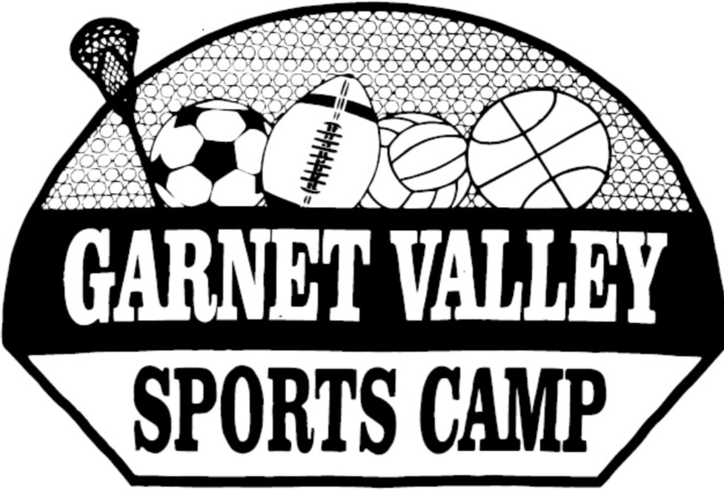

Counselor Application

Thank you for expressing an interest in being a counselor for the Garnet Valley Sports Camps. It is a priority for us that our campers receive quality attention, instruction, and direction. We feel that it is important that the people who send their children to us get the best experience possible for their children. That is why we place an emphasis on finding the best counselors to provide a great summer experience for our campers.
We help our counselors by providing training sessions before each camp. We look to hire counselors based on their background and qualifications. We have been fortunate to attract many wonderful counselors through the years. We search for quality counselors using the following order:
certified teachers
qualified adults
college athletes
qualified college students
high school athletes – entering their Junior year
qualified high school upperclassmen – entering their Jr. year

If you have a background of success in one or more sports and have the ability to inspire, instruct, and lead others to success then please complete the application and send it back to the address at the bottom of the application.

Thank you again for your interest and best of everything throughout the year.
Mr. Rapczynski and Mrs. Stec
Camp Co-Directors

CAMP APPLICATION

NAME_________________________________AGE_____________ Grade _________

ADDRESS______________________________________________________________

EMAIL ______________________CELL________________HOME______________

SOCIAL SECURITY NUMBER _______-_______-_______

WORK EXPERIENCE: Supervisor- Phone or Email

1.

2.

ATHLETIC BACKGROUND: pro, college, high school, honors/ awards

1.

2.

OTHER –

REFERENCES:
1.

2.

Please return to Mr. Rapczynski, 911 Lamberhurst Close, Chadds Ford, Pa. 19317

SOME CURRENT AND FORMER COUNSELORS

Joe Rapczynski – former HS, D-I athlete/coach – current teacher/camp co-director
Eileen Stec – former high school athlete and coach - current teacher/camp co-director
Mike Ricci – former HS, college star athlete – current teacher/football coach GVHS
Dan Vandenberg – former high school athlete/coach - current teacher
Katie Tarr – former star GVHS, college athlete – current college coach/AD
Erin Fitzgerald – former star GVHS, D-1 athlete – current college coach/asst. AD
CJ Robinson – former GVHS star athlete – current Moravian star student/athlete
Terence Archer – former star HS, college athlete – current college football coach
Beth (Rapczynski) Archer – former star GVHS athlete – currently in workforce
Greg Sheets – former HS, college athlete/coach – current HS administrator
Steve Christiansen –former HS, college athlete – current HS teacher/coach
Jerry Doemling – former HS varsity starter – current teacher/coach Marple -Newtown
Lauren Ferry – former GVHS varsity starter athlete – current Pa. State student
Fab Schivatchio – former GVHS star athlete – current college student
Kristen Babiak – former GVHS star athlete – currently in work force
Eric VanWyk – former star GVHS and college athlete – current a GV teacher
Tim Lang – former star GVHS and college athlete – currently in workforce
Simone Seal – former Padua star athlete – current Villanova student
JJ Rapczynski – former star GVHS and college athlete – current college coach
Lauren Krol – former GVHS student-athlete – current St. Joseph’s college student
Drew Kravitz – former GVHS and college star athlete – currently in workforce
Rich Shea – former HS athlete – current HS Athletic Director
Alicia Babiak – former GVHS star athlete – currently in workforce
Evan Babiak – former star GVHS athlete – current Pa. State student
Shane Eachus – former star GVHS and college athlete – currently in workforce
Lori Rapczynski – former GVHS athlete – currently in workforce
Ray Kuderka – former Salasianum star athlete – currently serving in Iraq
Alex Portali – former GVHS star athlete – current Temple student
Megan Goodwin – former HS athlete – current GVMS teacher
Ryan McGraw – former GVHS varsity starter athlete – currently in workforce
Steve Todak – former GVHS varsity starter athlete – current college student-athlete
Shannon Gilolley – former GVHS varsity starter athlete – current Pa State student
Wil Putman – former GVHS varsity starter athlete – current Kutztown student

