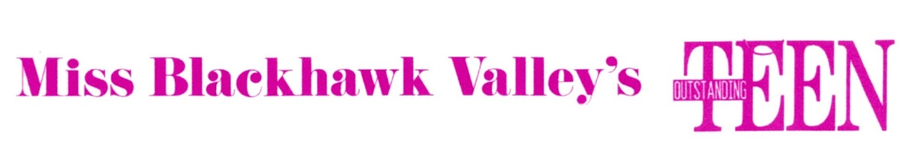

Miss Blackhawk Valley’s Outstanding Teen Competition Guidelines Pageant Year 2020

Platform
Miss Blackhawk Valley’s Outstanding Teen contestants are required to select a platform that has relevance in her community or society at large and about which she deeply cares. She should research this subject and seek out at least one community service project and one not-for-profit organization with whom she could work to address or make an impact on this issue. She will write a one-page essay about this issue, the reason she chose it, how she has been involved in making an impact on the issue and how it has changed or improved her community. The essay must be typed and will be included in the Judges’ Books.

National Platform
The National Platform for Miss America’s Outstanding Teen is the Children’s Miracle Network Hospitals. A local contestant must register at www.MAOTeen4kids.org in order to be eligible to compete. This is done when the Application is complete. Select Miss Illinois as the State and 2020 as the pageant year. Select one of the 3 Illinois hospitals to receive your donation. It is the choice of the contestant to set a fundraising goal at the local level, however is not required to raise any money at the teen level.

Resume
The contestant will prepare a resume in a style recommended by the Miss America’s Outstanding Teen Organization containing information about her education, career goals, scholastic achievement, leadership roles and other facts. This is the second document included in the Judges’ books along with her contestant photo.

Sponsor
Each contestant must have a sponsor who will pay the sponsor fee of $100. We encourage the
contestant to seek one or more businesses to sponsor her rather than just her family. The
sponsor form with the fee is due as soon as possible.

Phases of Competition

Interview
There will be a 6 minute interview with the contestant standing behind a podium before the panel of judges. There will be no opening, no close. One third of the interview will concern her platform. The judges will evaluate her ability to communicate, express her views, and the passion that she displays about her platform. Attire for interview should be what she would choose for a job interview. Business suits are prohibited. The contestant should look and dress like a teen. The interview accounts for 25% of the total points.

Talent
The talent portion of the competition is a performance of the contestant’s choice lasting 1½ minutes (90 seconds). Music, costume, and choreography must be age appropriate. The only props allowed with talent are those that can be carried on by the contestant. Then, the prop must be used in greater than half the performance. Recommend no props be used at all. Talent accounts for 35% of the total points.

Lifestyle and Fitness in Sportswear
The attire for the physical fitness competition will be plain color Sofee shorts and a tee shirt with a school logo. She will wear white tennis shoes with no show socks. She will perform an aerobic routine during this phase of competition that she will be taught during the Miss Blackhawk Valley rehearsals that meets criteria set by MAOTeen. The contestant will be evaluated on how she maintains good physical health as well as her energy, on-stage personality and expression will be considered. This accounts for 15% of the total points.

Evening Wear and On-Stage Question
The contestant will model a formal that could be worn to a school dance, wedding or semi-formal party. The dress must be age appropriate. She will be evaluated on her ability to model the dress, how well the dress suits her personality, not the dress itself. The contestant will be asked one question; this question may concern these topics: teen issues, general knowledge and your platform. She will be evaluated on her ability to answer the questions, her charisma and expression. This accounts for 25% of the total points.

The contestant with the highest number of total points shall be named
Miss Blackhawk Valley’s Outstanding Teen.
Eligibility
A Miss Blackhawk Valley’s Outstanding Teen contestant must be a citizen of the United States; resident or full-time student of the Western Illinois Counties of Rock Island, Henry and Mercer.
Must be at least thirteen (13) years of age on the first day of the State Competition in which she competes; and must not be older than seventeen (17) years of age as of July 31st in the calendar year of the State Competition in which she competes, unless she is 18 years old and has not graduated from high school as of July 31st in the calendar year of the State Competition in which she competes.
For the avoidance of doubt, 13 to 17-year-old high-school graduates, as well as 18- year-old non-graduates as of July 31st, must compete at MAOTeen level.
Miss Blackhawk Valley’s Outstanding Teen contestants may not compete for or hold any other pageant titles at the time of the local competition and during her year of service.
Miss Blackhawk Valley’s Outstanding Teen will compete for Miss Illinois’ Outstanding Teen June 2020. The Miss Blackhawk Valley Preparation Team will be responsible for her preparation and will assist in the paperwork, wardrobe selection, interview and other areas of preparation. She will sign a contract with the Miss Blackhawk Valley Scholarship Program as well as with Miss Illinois.
The contestant named Miss Blackhawk Valley’s Outstanding Teen will make personal appearances as arranged by the Miss Blackhawk Valley staff throughout her year of service. Much of the first months of her year of service will be spent working on her platform and in preparation for Miss Illinois’ Outstanding Teen competition in June, 2020. She will represent Miss Blackhawk Valley with her other pageant sisters and she will be a role model and mentor to Miss Blackhawk Valley’s Princess.

The winner of Miss Blackhawk Valley’s Outstanding Teen will receive a cash scholarship to be paid to a college or talent instructor, wardrobe allowance in preparation for Miss Illinois’ Outstanding Teen competition, and other gifts. Scholarships are awarded to all the contestants in the competition and they will have the opportunity to compete for additional scholarships such as Academic Excellence.

The oldest continuous pageant in the Miss Illinois system, Miss Blackhawk Valley has 71 years of providing scholarships to the young women of the Western Illinois Counties of Rock Island, Henry and Mercer.
Revised 10/19/2019

