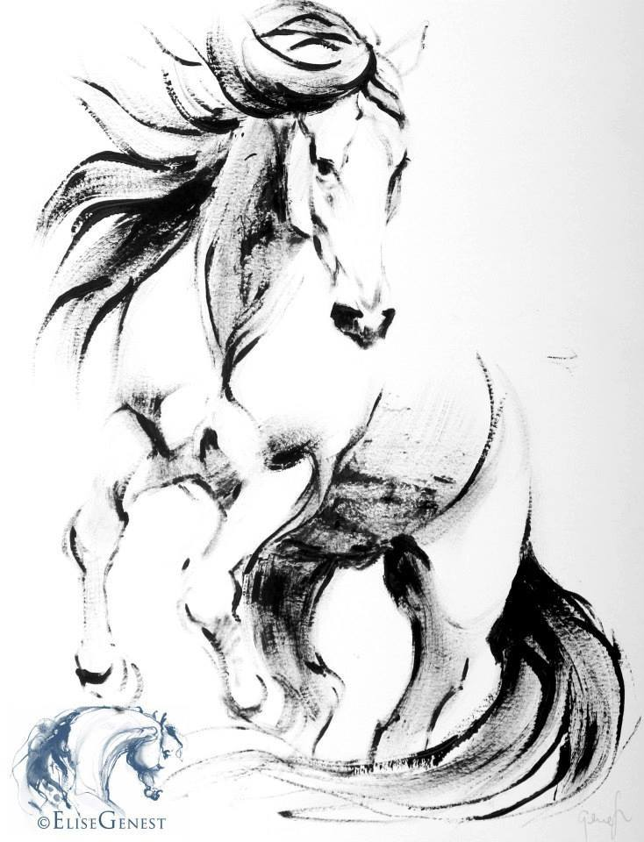 Transitions Equestrian Center
HORSE BOARDING AGREEMENT
WITNESS THIS AGREEMENT this _____ day of _____________, in the year _________, by and between
_________________________________, hereinafter referred to as "Stable," and
____________________________________ hereinafter referred to as "Owner."
The following equine identified by NAME___________________________________,
REGISTRATION NUMBER ______________, AGE_________, GENDER___________,
COLOR ____________________________________will be applicable to this boarding agreement.
DESCRIPTION OF EQUINE:
_________________________________________________________________________
SPECIAL NEEDS OF EQUINE:
_________________________________________________________________________
Stable will keep the above mentioned equine in a stall and daily turnout. It is agreed between Stables and Owner(s) that hay will be fed twice per day only. All Purina grain products will be provided by stable, any other grains products, vitamins, minerals and/or supplements of other nature shall be supplied solely by the Owner(s). It is also agreed that training of the equine(s) by Stables is not required or requested. All annual shots must be up to date and given on an annual schedule (i.e. Tetanus, Influenza, Rhinopneumonitis and West Nile Virus). Worming will be given bimonthly. Horse will be trimmed every 6 weeks at owners expense. Initial ____
All rules posted within the barn(s) shall be adhered to with no exceptions.
PERSONAL INFORMATION (Information will not be released without Owner approval):
Home Phone Number: _________________ Work Phone Number: _____________________
Home Address: _______________________________________________________________
Email Adress:__________________________________________________________________
Cell: _____________________ 2nd (Emergency) Contact: ______________________________
Veterinarian: _______________________________________ Phone: __________________
Address: _____________________________________________________________________
Farrier: ______________________________________________________________________
Horse Insurance Company and Phone (optional): _____________________________________
Horse is Currently Eating:
A.M. _______________________________________________________________________________
P.M.________________________________________________________________________________
Supplements: ________________________________________________________________________

1. FEES, TERM, AND LOCATION. Owner acknowledges and accepts those terms set forth in the rate schedule applicable on the date above as issued by Stable, whether said rates are daily, weekly, or monthly. Payment shall be issued in accordance with that rate schedule on a timely basis. Any charges not paid in a timely manner shall be subject to finance charges set forth in the rate schedule. In the event the subject animal is removed from the premises for any reason and returned, this agreement shall be deemed reinstated at rates applicable at the time of said return. Stable reserves the right to notify Owner within fifteen (15) days of the horse's arrival if the horse, in Stable's opinion, is deemed to be dangerous or undesirable for Stable's establishment. In such case, Owner shall be solely responsible for removing the horse within seven (7) days of said notice and for all fees incurred during the horse's presence upon the premises. This Contract shall be deemed terminated and concluded upon the payment of all fees.
The boarding fee is due upon the first of the preceding month. In the event said payment is overdue by ten (10) days, Stable shall be entitled to exert a lien against said horse, and the property upon the premises as more further described below, for any amounts due, and shall be entitled to enforce said lien and foreclose its interest against said horse and/or equipment for the amount due in accordance with the laws of the State of _____________________.
A security deposit of _________, payable with this Contract, shall be refunded to Owner within thirty (30) days of the date of completion of this Contract. The initial monthly / weekly / daily (circle one) charge applicable to the services as set forth below shall be ___________ per day / week / month (circle one).
2. DESCRIPTION OF HORSE(S) TO BE BOARDED. Owner agrees to submit a fully completed Owner Information Sheet for each horse boarded upon execution of this agreement. The terms and conditions set forth herein shall be applicable to each and every animal boarded by Owner.
3. FEED, FACILITIES, AND SERVICES. Stable agrees to provide adequate feed and facilities for normal and reasonable care required to maintain the health and well being of the animals. Owner acknowledges Owner has inspected the facilities and finds same in safe and proper order. The standard services to be provided herein and the charges therefore are as posted in the office of Stable and are subject to change at Stable's discretion.
4. RISK OF LOSS AND STANDARD OF CARE. DURING THE TIME THAT THE HORSE (S) IS/ARE IN CUSTODY OF STABLE, STABLE SHALL NOT BE LIABLE FOR ANY SICKNESS, DISEASE, ESTRAY, THEFT, DEATH OR INJURY WHICH MAY BE SUFFERED BY THE HORSE (S) OR ANY OTHER CAUSE OF ACTION, WHATSOEVER, ARISING OUT OF OR BEING CONNECTED IN ANY WAY WITH THE BOARDING OF SAID HORSE (S), EXCEPT IN THE EVENT OF NEGLIGENCE ON THE PART OF STABLE, ITS AGENTS, AND/OR EMPLOYEES. THIS INCLUDES, BUT IS NOT LIMITED TO, ANY PERSONAL INJURY OR DISABILITY THE HORSE OWNER, OR OWNER'S GUEST, MAY RECEIVE ON STABLE'S PREMISES.
The Owner fully understands that Stable does not carry any insurance on any horse(s) not owned by it for boarding or for any other purposes, whether public liability, accidental injury, theft or equine mortality insurance, and that all risks connected with boarding or for any other reason for which the horse(s) in the possession of, and on the premises of Stable are to be borne by the Owner. Stable strongly recommends equine mortality insurance be obtained applicable to the subject horse(s) by Owner.
5. HOLD HARMLESS. Owner agrees to hold Stable harmless from any and all claims arising from damage or injury caused by owner's horse(s) to anyone, and defend Stable from any such claims. Owner agrees to disclose any and all hazardous or dangerous propensities of horse(s) boarded with Stable.
6. EMERGENCY CARE. Stable agrees to attempt to contact Owner should Stable feel that medical treatment is needed for said horse(s), but, if Stable is unable to contact Owner, Stable is then authorized to secure emergency veterinary, and blacksmith care required for the health and well-being of said horse(s). All costs of such care incurred shall be paid by Owner within fifteen (15) days from the date Owner receives notice thereof, or Stable is authorized, as Owner's agent, to arrange direct billing to Owner.
STABLE SHALL ASSUME THAT OWNER DESIRES SURGICAL CARE IF RECOMMENDED BY A VETERINARIAN IN THE EVENT OF COLIC, OR OTHER LIFE-THREATENING ILLNESS, UNLESS STABLE IS INSTRUCTED HEREIN OR ON OWNER'S INFORMATION SHEETS, BY OWNER THAT THE HORSE (S) IS/ARE NOT SURGICAL CANDIDATES.
Owner agrees to notify Stable of any and all change of addresses, emergency telephone numbers, itineraries or other information reasonably necessary to contact Owner in the event of an emergency. In the event Owner departs for vacation or is otherwise unavailable, prior to departure Owner shall notify Stable as to what party is authorized to make decisions in the Owner's place with regard to the health, well-being, and/or medical treatment of the horse(s).
7. LIMITATION OF ACTIONS. Any action or claim brought by Owner against Stable for breach of this Contract or for loss due to negligence must be brought within one (1) year of the date such claim or loss occurs.
8. SHOEING AND WORMING. Owner agrees to provide the necessary shoeing and worming of the horse(s) as is reasonably necessary, at Owner's expense. Owner agrees to provide Stable with all health records with regard to the horse(s). Owner agrees to have the horse(s) wormed and vaccinated on a regular schedule, and in the event same is not accomplished and proof of same presented to Stable within thirty (30) days from the date of such services or veterinary treatment, Stable is authorized to arrange for such treatment, but not obligated to do so; such expense shall be the obligation of Owner, and upon presentation by Stable of the bill for such services rendered, including service charges, any bill shall be paid within fifteen (15) days from the date the bill is submitted to the Owner.
9. OWNERSHIP-COGGINS TEST. Owner warrants that he owns the horse(s) and will provide proof satisfactory to Stable of the negative Coggins test upon request.
10. CHANGES OR TERMINATION OF THIS AGREEMENT. It is agreed by the parties that this Agreement may be changed or terminated upon thirty (30) days notice, regardless of the rental period. All notices must be issued in writing unless otherwise agreed upon by the parties. The posting of updated rate schedules in a conspicuous or open place in Stable's office shall constitute notice of any and all rate changes or regulation changes as may be deemed appropriate by Stable.
11. RULES AND REGULATIONS. The Owner agrees to abide by all the rules and regulations of the Stable. In the event someone other than the Owner shall call for the horse(s), such person shall have written authority signed by the Owner to obtain said horse(s).
12. RIGHT OF LIEN. The Owner is put on notice that Stable has a right of lien as set forth in the laws of this state, for the amount due for the board and keep of such horse(s), and also for storage and services, and shall have the right, without process of law, to retain said horse(s) until the amount of said indebtedness is discharged. However, Stable will not be obligated to retain and/or maintain the horse(s) in question in the event the amount of the bill exceeds the anticipated unregistered value of the horse(s). In the event Stable exercises Stable's lien rights as above-described for non-payment, this Agreement shall constitute a Bill of Sale and authorization to process transfer applications from any breed registration as may be applicable to said horse(s) upon affidavit by Stable's representatives setting forth the material facts of the default and foreclosure as well as Stable's compliance with foreclosure procedures as required by law. In the event collection of this account is turned over to an attorney, Owner agrees to pay all attorneys’ fees, costs, and other related expenses for which a minimum charge of $250.00 will be assessed.
13. PROPERTY IN STORAGE ON STABLE'S PREMISES. Owner may store certain tack and equipment on the premises of Stable at no additional charge to Owner. However, Stable shall not be responsible for the theft, loss, damage or disappearance of any tack or equipment or other property stored at Stable as same is stored at the Owner's risk. Stable shall not be liable for the theft, loss, damage, or disappearance of any tack or equipment taken to horse shows or clinics. Vehicles stored upon the premises will be subject to a ______/day storage cost for all delinquent accounts.
14. INHERENT RISKS AND ASSUMPTION OF RISK. The undersigned acknowledges there are inherent risks associated with equine activities such as described below and hereby expressly assumes all risks associated with participating in such activities. The inherent risks include, but are not limited to the propensity of equines to behave in ways such as, running, bucking, biting, kicking, shying, stumbling, rearing, falling or stepping on, that may result in an injury, harm or death to persons on or around them; the unpredictability of equine's reaction to such things as sounds, sudden movement and unfamiliar objects, persons or other animals; certain hazards such as surface and subsurface conditions; collisions with other animals; the limited availability of emergency medical care; and the potential of a participant to act in a negligent manner that may contribute to injury to the participant or others, such as failing to maintain control over the animal or not acting within such participant's ability.
15. ENTIRE AGREEMENT. This contract represents the entire agreement between the parties. No other agreements, promises, or representations, verbal or implied, are included herein unless specifically stated in this written agreement. This contract is made and entered into in the State of _______________________, and shall be enforced and interpreted in accordance with the laws of said State.
16. ENFORCEABILITY OF CONTRACT. In the event one or more parts of this contract are found to be unenforceable or illegal, the other portions hereof shall be deemed in full force and effect. Must be 18 or older to represent as owner of horse.
Signature of Owner (or Authorized Agent) __________________________________
Signature of Owner's Parent or Guardian ___________________________________ (if owner is a minor)
Address: _________________________________________
City/State/Zip: _____________________________________
Telephone: ____________ (Day) Telephone: ____________ (Evening)

Stable Owner: ____________________________________
Authorized Agent Signature of Stable Owner: ____________________________________

