MEDICAL DECISION-MAKING POINT SYSTEM
A casual review of the official rules for interpreting the key component of Medical Decision-Making shows that the criteria for quantifying physician cognitive labor are quite ambiguous. Medicare discovered that auditors were having a hard time nailing down the level of medical Decision-Making during the medical review process. In response to this problem, a more objective Medical Decision-Making (MDM) Point System was developed by CMS. Although not part of the official E&M guidelines, this MDM point System was distributed to all Medicare carriers to be used on a "voluntary" basis. In point of fact, this is the way your medical Decision-Making will be graded in the event of an audit.

Problem Points
The “nature and number of clinical problems” are quantified into Problem Points by referring to the following table:

PROB LEMS | POINTS
Self-limited or minor (maximum of two) | 1
Established Problem, stable or improving | 1
Established Problem, Worsening | 2
New problem, with no additional work-up planned (maximum of 1) | 3
New problem, with additional work-up planned | 4

The above table is fairly self-explanatory. An example of a “self-limited or minor” problem may be a common cold or an insect bite. An “established problem” refers to a diagnosis which is already known to the examiner, such as hypertension, osteoarthritis or diabetes. An example of a “new problem with no additional work-up planned” may be a new diagnosis of essential hypertension. Examples of a “new problem, with additional work-up planned” may include any new clinical issue which requires further investigation such as chest pain, proteinuria, anemia, shortness of breath, etc.

Data Points
The amount and complexity of the data reviewed'' are quantified by referring to the following table:

DATA REVIEWED | POINTS
Review or order clinical lab tests | 1
Review or order radiology test (except heart catheterization or echo) | 1
Review or order medicine test (PFTs, EKG, cardiac echo or catheterization) | 1
Discuss test with performing physician | 1
Independent review of image, tracing or specimen | 2
Decision to obtain old records | 1
Review and summation of old records | 2

The physician should be aware that no double dipping" is allowed. For example, if you review lab results and order labs during the same visit, you only get one point (not one point for ordering and one point for reviewing). This same rules applies to imaging studies or other medicine tests such as EKGs or PFTs. Commonly overlooked points are those garnered for obtaining or reviewing old records. If you do review old records, you must summarize your findings in the chart. It is not acceptable to just say, “Old records were reviewed."
TABLE OF RISK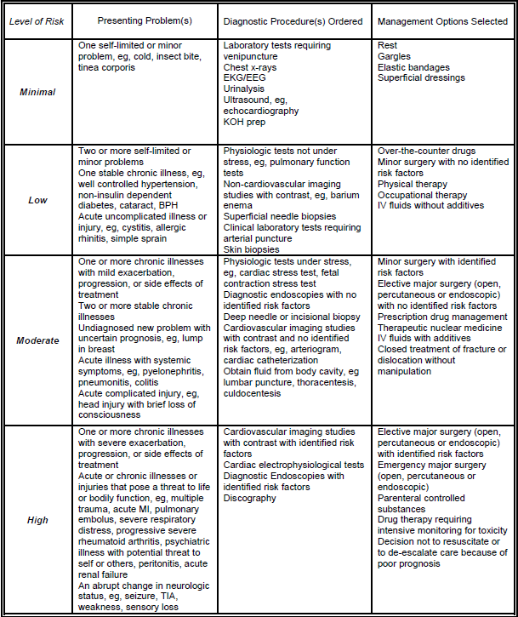
MDM POINT TABLE
E&M LEVEL | COMPLEXITY | PROBLEM POINTS | DATA POINTS | RISK
Level 2 (L2) | Straightforward | 1 | 1 | Minimal
Level 3 (L3) | Low | 2 | 2 | Low
Level 4 (L4) | Moderate | 3 | 3 | Moderate
Level 5 (L5) | Complex | 4 | 4 | High
(Two out of three must be present for a given level of MDM)

