**CURE Yeast PCR Protocol**  
 Two months ago we first exposed our parental yeast to acetic acid. Our yeast strains have been growing and adapting over many, many generations. The yeast growing in our test tubes now is able to withstand and thrive in concentrations of acid that would have killed the yeast we started with. This “adaptation” over time means the yeast has evolved to better handle the stress associated with acetic acid exposure. Evolution can only happen because of mutations in genes.   
  
In this lab, we will use a technique known as **polymerase chain reaction (PCR)** followed by DNA sequencing to try and identify specific mutations that might be helping our yeast strain survive and thrive in high concentrations of acetic acid.

**PCR - General overview and why it’s useful**

PCR, short for “polymerase chain reaction,” is a rapid and inexpensive genetic technique scientists use all the time when trying to answer questions related to genes. This technique can be used to “select” genes of interest from an organism’s genome, and make tons and tons of copies of the gene of interest. This is useful because when studying a specific gene, most experiments require that you have a lot of the DNA that makes up that gene. Essentially, PCR is a method to duplicate DNA you’re interested in studying.

For our yeast evolution experiment, we want to examine the mutations that have developed in our yeast’s genomes over time. In order to find these mutations, we have to have a lot of the Yeast DNA to study because we are going to be **sequencing** the yeast’s DNA.

**Sequencing -** Sequencing, another genetic technique, is how scientists “read” DNA. Remember, DNA is the genetic **code** of life. There are four different “letters” that make up the DNA code. These letters are the nucleotides, A (adenine), T (thymine), G (guanine), and C (cytosine). Sequencing is the method that allows scientists to “read the code” of DNA, and know exactly the combination of letters (A, T, G, or C) which make up the code of specific genes. Sequencing can be used to compare the codes of two different strains of yeast. By comparing the genetic sequences of our parental strain to our evolved strain, we can find exactly if and where any mutations in the yeast genome may have occurred.

So since sequencing requires large amounts of the yeast’s DNA in order to work well and give us accurate readings we’ll use PCR to produce enough copies of the yeast’s DNA in order to sequence it.

**PCR - How does it work?**

So PCR is a technique used to make lots of copies of DNA in order to use that DNA for experiments that require a lot of DNA like DNA sequencing.   
  
To really understand the “how” of PCR, it is very helpful to understand the basics of **DNA replication**. During DNA replication, DNA polymerase makes copies of both sides of the DNA ladder, essentially making two DNA double strands from one double stranded template.  
PCR also makes copies of DNA. PCR replicates DNA.   
PCR cannot replicate ALL of the DNA in a cell’s genome. Instead, we have to **select** a specific region of the genome to make copies of. Just those sequences being studied   
are replicated. Although the PCR can duplicate DNA efficiently and with great accuracy, the reactions do not include all the same molecular/cellular machinery needed to   
duplicate billions of nucleotides worth of DNA. Whole genome replication is a very very  
complex process requiring the machinery of living cells in order to work. However,   
the PCR doesn’t require all of this cellular this machinery to make just sections of the genome’s DNA. PCR can make lots of copies of DNA with only a small handful of basic starting materials ☺

For our CURE yeast project, we will be replicating a handful of genes that are related to yeast cells’ ability to adapt to and withstand highly acidic conditions. These genes may have experienced some mutations as the yeast was slowly exposed to increasing levels of acetic acid.

**Part I:   
What do we need to perform a PCR besides the PCR machine?  
  
1. A DNA template**

PCR makes copies of DNA. This means we need to add the DNA we want to copy. That initial DNA will be extracted from our yeast cells. This yeast DNA will be our DNA template.

1. **Deoxyribonucleic triphosphates (dNTPs)**

Since our goal is to make copies of DNA, we need to add in the nucleotide monomers that will be used to build more of the DNA polymer. These nucleotide monomers include A = dATP (deoxy-**adenosine** triphospate), G = dGTP (deoxy-**guanosine** triphosphate), T = dTTP (deoxy-**thymidine** triphosphate), and C = dCTP (deoxy-**cytidine** triphosphate).   
These A, G, T, and C “letters” /nucleotides make up the genetic code.

1. **Heat-resistant DNA polymerase**

DNA polymerase is an enzyme that makes new copies of DNA. It adds new nucleotides **only** to the 3’ end of a growing DNA strand. Remember we discussed how DNA polymerase is directionally specific…  
Now, the *heat-resistant* requirement for our DNA polymerase is specific to this process. In a living cell, there would be a helicase enzyme that would unzip the DNA to allow the DNA polymerase to do its job. In PCR, we use heat to unzip the DNA (see below). So, the DNA polymerase, which is a protein like any other enzyme, must be able to withstand that heat or else it will denature. The DNA polymerase we use is functional at high temperatures (around 72˚C ≈ 162˚F), and is able to resist temperatures even as high as 95˚C (≈ 203˚F).

1. **Heat**

In order for our DNA polymerase to replicate the yeast DNA during PCR, the DNA double-helix has to be unzipped. In order to do this, the PCR exposes the   
DNA to temperatures near 95˚C. DNA polymerase can then access both halves of the DNA double helix and make new copies of them.   
The process of heating the PCR tube high enough to unzip the DNA double-helix is known as **DNA denaturation**. This is step 1 of the PCR.

1. **Primers**

DNA polymerase cannot start making a copy of DNA from scratch. It needs a head start. This is because it can ONLY add nucleotides to the 3’ end of an *existing,* *double* strand of DNA. Primers are small strands of DNA we add to PCR experiments in order to give DNA polymerase the “head start” it needs.   
 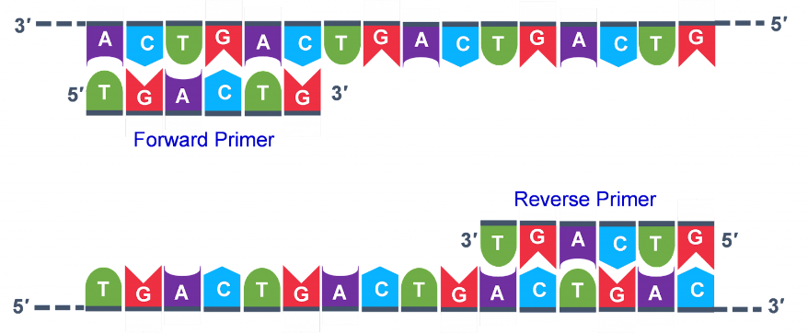

PCR primers are two short strands of DNA, each only about 18 to 24 nucleotides long that match the beginning and end of the DNA sequence of the gene we wish to replicate. One primer is known as the **forward primer** and the other is the **reverse primer**. Because they match the DNA we want to replicate, they interact with and bind to our unzipped, single-stranded DNA at very specific locations along the DNA. The binding of the primers to our template DNA is known as **primer annealing.** This is step 2 of the PCR.  
  
It is important to note that annealing can only happen at certain temperatures, and the specific **annealing temperature** depends on the sequence of the primers.   
  
  
  
Primers give the DNA polymerase the “head start” it needs, because the polymerase can start making new copies of the template DNA by adding the correct dNTPs to the 3’ end of the annealed primers. The process of DNA polymerase adding new dNTPs to the 3’ end of a primer is known as   
**extension** or **elongation** . This is step 3 of the PCR.  
The optimal temperature for extension is usually 72˚C.

The table below lists the names of the specific gene sequences we will be replicating and the primers that will be used to replicate each of these genes.

|  |  |  |
| --- | --- | --- |
| **Table 1. List of genes for PCR amplification and associated primers** | | |
| **Gene Name** | **Forward Primer** | **Reverse Primer** |
| **CCT7** | AATGAACTTTGGAAGCCAAACA | TGATCGTCTCGTCAACAGATAAA |
| **CKA1** | AAATGCAGGGTATGGTCAGAG | CCATCGCTTCCTTAGCAGTTA |
| **HAA1** | GCCTGTGAGAGGTGCATAAG | CAAATCCGCAAATCCTTGATCG |
| **MIG1** | AGTGGAGACGACATACTACCA | AGGGCAACGGTAAACTTCTT |
| **PRR1** | TCGAATTCATCCATACCCACAG | ACGTTGGTTCTTCCTCGTTAG |
| **PRR2** | CATACGGAGTGATGTCGTTGT | TTCGAAGCGATGCCTCATT |
| **SCH9** | CTCTCAACACCAACATCCAAATG | AAAGAAGAGGAAGGGCAAGAG |
| **ACH1** | AAAGCAGAGAGTTAGGTATGCTC | CAGCTGTCGACCTTCATTGTA |

**Part II:  
We have the materials…what next?**

All of the materials listed above will be added to eppendorf tubes. Then, we’ll  
place our tubes into a PCR machine called a **thermocycler**. A thermocycler is a machine that can change the temperatures inside the tubes really rapidly. Changing the temperature inside our tubes is necessary for the three steps of PCR:  
1. DNA denaturation  
2. Primer annealing  
3. Elongation  
  
These steps, the associated temperatures, and a short description of each are listed in Table 2.

|  |  |  |  |
| --- | --- | --- | --- |
| **Table 2. Overview of PCR/Thermocycler Steps** | | | |
|  | **Temperature** | **Duration** | **Description** |
| **Denaturation** | ~94-95˚C | 5 to 30 seconds | During this step, any double-stranded DNA inside the tube is broken apart into two single-stranded DNA molecules. This allows primers to anneal to their targets, and for DNA to amplify the single-stranded template DNA. |
| **Annealing** | ~50-70˚C | 10 to 30 seconds | During this step, the decrease in temperature allows the primers in the tube to bind (anneal) to the targeted DNA |
| **Elongation** | ~72˚C | Depends on length of DNA being copied | During this step, DNA polymerase binds at the 3’ end of the annealed primer, and begins copying the template DNA. |

After one round of these steps are completed, a copy of the targeted DNA is created.  
But sequencing requires MANY copies of the target gene. This is exactly what makes PCR so useful! In order to make even more copies**,   
all that is needed is to set the thermocycler to repeat the three steps above.** Each time the steps are repeated, the DNA is duplicated.   
After one cycle, there are two copies of the target DNA.  
After two cycles, there are 4 copies.  
After three cycles, there are eight…  
After four cycles, there are 24 = 16 copies of DNA.   
After 30 cycles, your tube will contain 230 copies of DNA = > 1 BILLION copies of your   
 target DNA! WHOA!  
  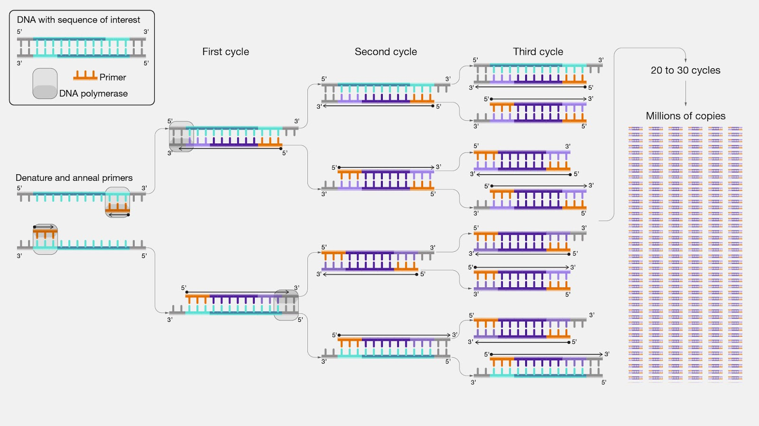

So, now that we have discussed how this works, let’s look at our protocol…

**PCR protocol for yEvo Project  
Step 1: Extracting DNA from the yeast colonies**

(adapted from <https://www.protocols.io/view/yeast-colony-pcr-it-doesn-t-get-any-easier-than-th-e6nvwb82vmkj/v1>)   
  
1. Aliquot 50 µL water per each 0.2 ml PCR tube.  
  
2. Use a small pipet tip to pick a small amount of yeast (less than the size of sesame   
 seed). Avoid touching the agar. Transfer the yeast to the water, swirling to get cells off   
 the tip. Cap tubes. Gently vortex to suspend cells.  
 Check out the photographs showing cells being picked from a colony and making cell  
 suspensions.   
  
  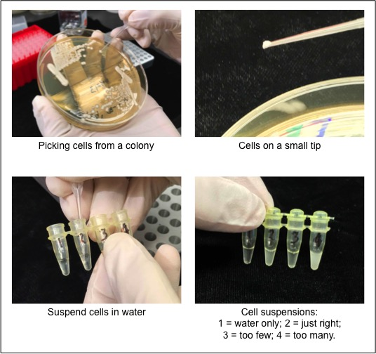  
  
  
  
3. Place the tubes in a PCR machine with the following settings: 99˚C, 5 min; 4˚C, hold. Remove tubes from machine, give a quick spin, and then place the tubes on ice. The yeast cells have been popped open with the heat.

**Step 2: Setting Up and Running the PCR  
  
*Important****:* gently vortex cells into suspension just before adding to PCR reactions. DO NOT use just the supernatant (liquid) from pelleted yeast cells. The DNA template is in the cells. **Use the cell suspension.**

1. Combine the following components:

* **12.5 uL PCR master mix   
  (contains DNA polymerase and free A,T,C & G nucleotides)**
* 2 uL primers
* 2 uL your heat-popped yeast solution
* 8.75 uL H2O

1. Make sure the solution is well mixed (vortex lightly), then spin-down solutions in  
    PCR tubes using a mini-centrifuge.
2. Run a PCR protocol with the following thermocycler settings:

98C, 30 sec denature

         98C, 5 sec      |

         60C, 5 sec   |   35 cycles PCR

         72C, 45 sec      |

         72C, 1 min  final extension

         4C, hold      end

1. After the PCR is completed, your DNA should be amplified. This can be confirmed by running a DNA electrophoresis gel, before using the DNA for other experiments such as DNA sequencing. For now, we will place our tubes on ice so they’re ready for our next step in our CURE protocol…sequencing

**References**

1. <https://iastate.pressbooks.pub/genagbiotech/chapter/pcr-and-gel-electrophoresis/>
2. <https://www.genome.gov/genetics-glossary/Polymerase-Chain-Reaction>

<https://www.protocols.io/view/yeast-colony-pcr-it-doesn-t-get-any-easier-than-th-e6nvwb82vmkj/v1>