JSB Capital Management, LLC
Pro-active Wealth Management

January 26, 2022

Fed Interest-Rate Decision Targeted for March Meeting
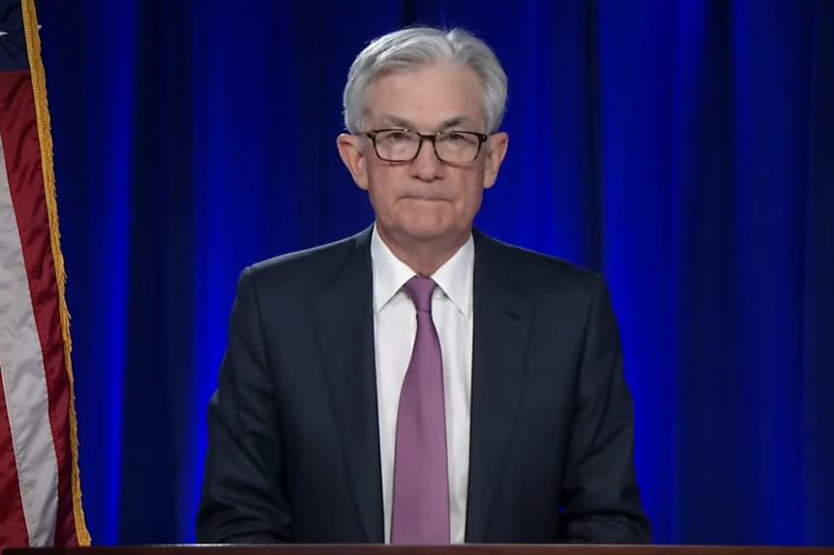

While The Federal Reserve Bank’s Open Market Committee (FOMC) held short-term interest rates steady at the end of its two-day meeting today, they definitively signaled intentions to raise them in mid-March, the latest turn toward removing stimulus to temper elevated inflation. “It will soon be appropriate to raise the target range for the federal-funds rate,” the Fed said in its post-meeting statement.

In addition, Fed Officials continued deliberations at their two-day meeting over how and when to shrink the Fed’s $9 trillion securities portfolio, which has more than doubled since March 2020 in response to the pandemic. As you can see on the chart below, monetary stimulus added to the economy since the 2008 financial crisis has been huge, but the doubling in response to the Covid pandemic in such a short time period is astounding. Walking this back without causing a recession is going to be a delicate balancing act for the Federal Reserve.

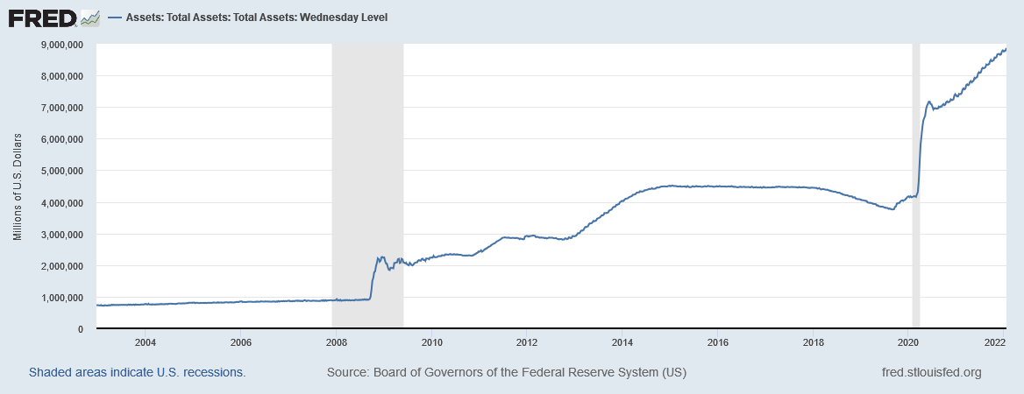

The Fed released a separate one-page statement that spelled out high-level principles to guide a process for “significantly reducing” those holdings.

Stocks sold off during Mr. Powell’s press conference on Wednesday afternoon, and yields on 10-year Treasury securities increased as investors anticipated a more aggressive path of rate rises. Some investors had also hoped Mr. Powell would signal a slower move in view of recent stock market volatility.

Mr. Powell indicated he and his colleagues believe the two goals of higher inflation that appears persistent (they have been unsuccessfully targeting 2% for a couple years) and favorable employment data have been met. Both inflation and employment “are calling for us to move steadily away from the very highly accommodative policies we put in place during the challenging economic conditions that the economy faced earlier in the pandemic,” he said. Declining supply chain constraints and an improving pandemic outlook are expected to temper inflation later in the year.
In the labor market, good job gains, low unemployment and a strong economy provided greater urgency in recent weeks for the Fed to accelerate plans to raise rates much faster than officials anticipated last summer.
Mr. Powell and the FOMC members have indicated they will start the process of shrinking their asset holdings sooner than they did after the central bank stopped buying bonds in 2014. They have also indicated that the process of shrinking those holdings—by allowing securities to mature without reinvesting their proceeds into new ones—is likely to proceed faster than it did the last time the Fed reduced its holdings in 2017.
The prospect of more interest-rate increases and a shrinking Fed portfolio to reduce inflation has led to heightened market volatility in recent weeks, prompting investors to sell shares of some technology companies, cryptocurrencies and other risky assets that enjoyed a boom last year.
We look for The Fed to increase short-term interest rates at least three times during the next three FOMC meetings and then will likely pause to evaluate the corresponding effect on the inflation data. The portfolios are positioned well for this forecast, but there may be a few additions and subtractions as prices become more attractive.

