RSAI Legislative Update
April 6, 2017
Highlights of this week’s action: Budget Targets were released by Republican leaders, setting the size of the state general fund budget at $7.245 billion. That’s a reduction of $311 million compared to the Governor’s initial FY 2018 budget recommendation, $38 million below his revised FY 2018 budget recommendation, yet still $164 million above the adjusted FY 2017 budget. The targets include a two-year pay back of the funds borrowed from the state’s economic emergency fund/cash reserve and the funds for the 1.11% SSA set earlier in the Session. Some key RSAI priorities remain stuck in Appropriations and Ways and Means Committees, pending budget action. Flexibility bills continue forward progress. State Assessment bill is amended in the House. School Board Elections bill, moving elections to November, is approved in the Senate.
Advocacy Opportunities:
- Keep talking to House Way and Means Committee members and all legislative leaders regarding extension of the State Penny. See HF 230 below.
- House Appropriations Committee members and all legislative leaders need reminders of the impact of transportation/formula equality and operational sharing incentives, both stuck in House Appropriations Committee. See SF 455 and HF 508 below.
- This 2017 Session is the first of two in the biennium, so bills introduced this year remain alive for consideration next year. Think of advocacy today as keeping up the urgency for eventual consideration, whether these bills get approved this year or remain viable for next Session action.
RSAI Website: Legislative tab contains weekly reports, position papers, and other information to assist your advocacy efforts. http://www.rsaia.org/

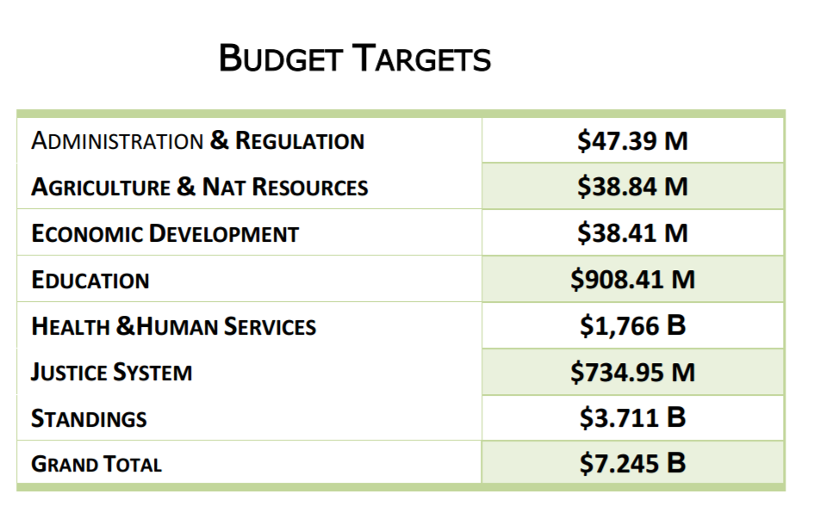
State Budget Targets
The Republican budget targets were published in the IALNS newsletter VOLUME 53, BULLETIN #65, APRIL 5, 2017. Sen. Charles Schneider was quoted in the newsletter, “This budget plan makes additional investments in key priorities like K-12 education and provides resources for essential functions of government. House and Senate Republicans continue to believe that the state budget should be managed just like families and businesses manage their own. This budget takes a responsible and cautious approach to spending in recognition that revenue may continue to come in less than anticipated. The budget plan includes fully funding the additional $40 million passed earlier this session for K-12 schools. This budget plan also includes an initial payment to repay the Cash Reserve Account in FY 2018 and additional payments will be made in FY 2019.”
Democrat Responses: Rep. Hall stated “For the second time this year, the GOP wants Iowa families to pay for corporate tax giveaways that have put the state budget in the red.” Sen. Bolkcom stated “These budget cuts could have been avoided if Republican legislators, Governor Branstad and Lieutenant Governor Reynolds had delivered on their promises to increase family income by 25% and create more than 200,000 new jobs in Iowa.”

The $908.41 million target for Education Appropriations is below the Governor’s original budget recommendation of $940.2 million for FY 2018. The passage of SF 130 already lowered FY 2017 by an additional $3 million for Community Colleges, $18 million for Regents institutions and $4.5 million for the DE. Note: state foundation aid is included in the Standings Appropriations target.
This week’s Legislative Action:
SF 240 Assessments: this bill was amended and approved in the House. The amendment extends the deadline by which the DE must issue the RFP from April 30 to July 30, 2017 and also amends current Code to eliminate the requirement that the state Board of Education make their assessment recommendations to the Legislature. The bill was approved in the House 95 in favor, 3 opposed and now goes back to the Senate. RSAI was registered as undecided on the bill, but has changed registration to support given the amendment.
Bill details follow:
The DE is required to issue a new request for proposals (RFP) no later than July 1, 2017, for the selection of a statewide assessment to measure student growth and student achievement toward the Iowa core academic standards. The selected assessment will be available for grades three through eleven for English language arts and math, grades 5, 8, and 10 for science. All three content areas must be in the same proposal. The bill specifies that providers would be allowed to work together to submit a proposal. The bill limits the DE to only consider the following in the RFP process:
- Feasibility of implementation by school districts
- Cost to the State and school districts
- Costs of acquiring the infrastructure necessary for technology readiness
- Degree of alignment with the Iowa core academic standards
- Ability to measure both growth and proficiency
- Ability to comply with federal law (Every Student Succeeds Act – ESSA).
The bill requires that the DE/state Board of Education implement the selected assessment through administrative rule to be first administered by spring of the 2018-2019 school year. The bill allows but does not require private schools to use the assessment. The bill eliminates the Iowa code reference to the assessment task force and the requirement that the state Board of Education makes recommendations regarding the assessment to the Legislature.
HF 566 Combining Election Dates: this bill was approved without amendment in the Senate, sending it to the Governor. This bill moves school elections to the same day as city elections, in November of the odd-numbered year. Makes changes to various deadlines, school districts in multiple counties and other matters. Although this action would lower election costs to cities and may increase voter turnout, the fiscal note doubts that it will lower election costs for schools. RSAI is concerned about board turnover and the limited time for training and orientation between a December organizational meeting of the board and the deadlines for setting school budgets and bargaining requirements. RSAI is registered opposed to the bill.
HF 472 Teacher Loan Programs: this bill eliminates the ability for teachers to qualify for both loan forgiveness programs simultaneously (Teach Iowa Scholar Grants and Shortage Area Loan Forgiveness), so teachers who receive forgivable loans under the teacher shortage programs are ineligible to receive Teach Iowa Scholar grants, and vice versa. The bill was amended in the senate, to grandfather in current teachers both and approved as amended 50 senators in favor, 0 opposed. The bill now goes back to the House. RSAI is registered as undecided.
HF 295 City/County Authority: this bill restricts the authority of cities/counties to set a minimum wage higher than the state or federal minimum requirement, among other things. The Governor signed the bill on March 29 and it’s effective on 7-1-2017. For those counties with minimum wages above the state minimum, expect to see those minimum wages no longer in effect on July 1. RSAI did not lobby the bill.

Remaining RSAI Priorities: Although this week saw no action on the following bills, they are all alive and pending action anticipated before the end of the 2017 Session:
- HF 564 Categorical Flexibility, on the Senate Calendar. RSAI is registered in favor.
- HF 565 Education Flex Account, on the Senate Calendar. RSAI is registered in favor.
- HF 573 Home Rule, on the Senate Calendar. RSAI is registered in favor.
- SF 475 Education Omnibus, on the House Calendar. RSAI was registered as undecided, but is now registered in favor pending positive changes to the bill.

Stuck Bills: Advocate at forums, call your legislators, send letters and emails on the following RSAI priorities:
HF 230 SAVE Extension still holding in House Ways and Means: this bill extends the SAVE sunset from 2029 to Jan. 1, 2050. See the RSAI web site for a position statement regarding the priority of extending the sunset and talk to House Ways and Means Committee members about moving this bill forward. Position Paper is found here: Position paper found here.

House Ways and Means Members: find links to email addresses here. https://www.legis.iowa.gov/committees/committee?ga=87&groupID=683
SF 455 Formula and Transportation Equity: the bill includes a 10-year phase-in to eliminate the $175 difference in the district and state costs per pupil and 10-year phase in to fund school transportation supplementary weighting, also over 10 years. Formula Equality Position paper found here. Transportation Position paper found here.
SF 508 Operational Sharing Incentives: the bill eliminates the sunset of the sharing incentives and removes the 5-year limitation on sharing any single position. This is a priority for RSAI. Position paper found here.
These two priorities for RSAI members are still in House Appropriations Committee, apparently flummoxed by the REC estimate and budget constraints. Please reach out to your representatives on this committee and reiterate the urgency of continuing the operational sharing incentives and beginning the work of closing these equity gaps in the formula and in transportation funding now.
House Appropriations Members: find links to email addresses here. https://www.legis.iowa.gov/committees/committee?ga=87&groupID=695
Contacts RSAI Professional Advocate, Margaret.buckton@isfis.net 515.201.3755
Senate Switchboard # 515.281.3371
House Switchboard # 515.281.3221

From links above or the legislative page https://www.legis.iowa.gov/legislators , find email addresses, home mailing address and home/work phone numbers for your legislators.

RSAI Leadership Group;
Robert Olson, Chair, Clarion-Goldfield/Dows, Superintendent, robert.olson@rsaia.org
Dennis McClain, Vice-Chair, Clay Central Everly, Superintendent, dmcclain@claycentraleverly.org
Kevin Fiene, Secretary/Treasurer, I-35, Superintendent, kevin.fiene@rsaia.org
Brad Breon, Moravia/Seymour, Superintendent, brad.breon@rsaia.org
Paul Croghan, East Mills, Superintendent, pcroghan@emschools.org,
Dan Smith, Harmony, Board President, dan.smith@rsaia.org
Lee Ann Grimley, Springville, Board President, leeann.grimley@rsaia.org

